
PHYSICS & ASTRONOMY
NEWSLETTER

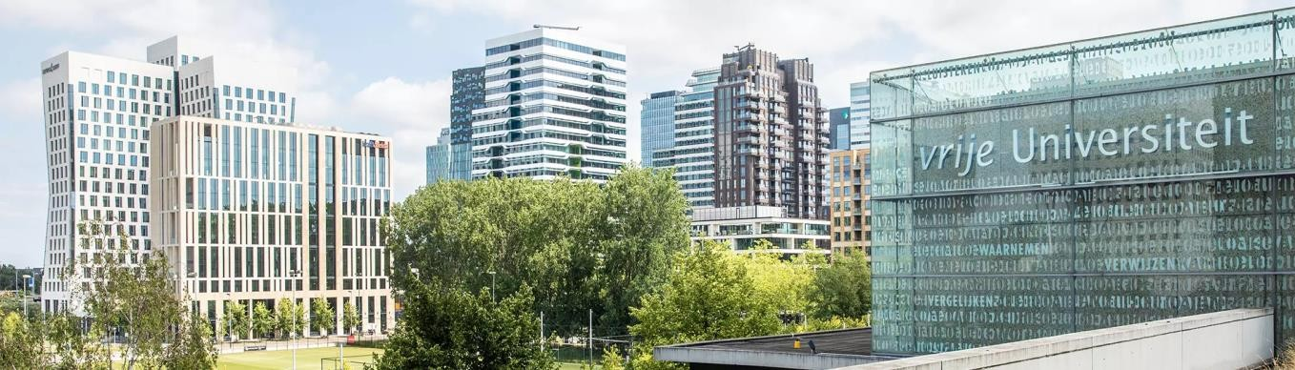

The Faculty of Science
Physics and Astronomy Department
Issue 1
4 March 2024

IN

THIS ISSUE

Grant & Awards
Recent PhD Theses

Interview & Highlighted Papers

THE 2023 TEACHER OF THE YEAR JOHN SHEIL INTERVIEW
John Sheil, Assistant Professor at VU Amsterdam and group leader at ARCNL, has been awarded the 2023 Teacher of the Year prize in the Medische Natuurwetenschappen (MNW) bachelor programme.

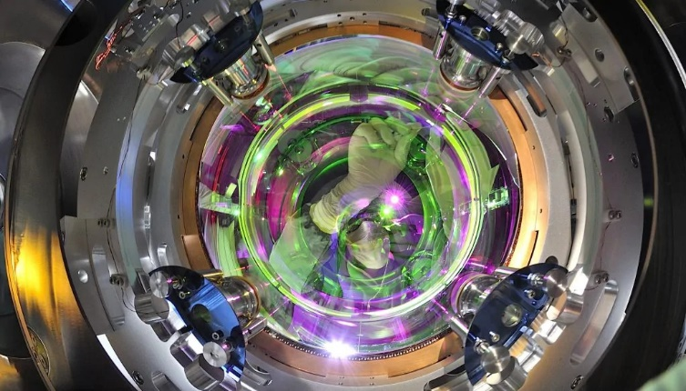
News &
Announcements

Back to Big Bang!





Lets dive into it!
1

NWO grant for cancer research
Dr. Imran Avci and Dr. Mahdi Mozdoor Dashtabi receive NWO grant for cancer research. They recently developed a new measurement method that is ultrasensitive and provides femtometer resolution in real-time. Read more

NWO gRATngo researc
GRANT & AWARDS

NWO perspectives funding for flat optics

On December 13th NWO announced that one of the consortia to receive funding from the Perspectief program is the AWAVE project (Advanced Wave Engineering for Sustainable Optical Applications. VU Amsterdam assistant professor Lyuba Amitonova, amongst others ARCNL group leader, is one of the participating researchers. With the Perspectief program, NWO challenges researchers to establish broad, cross-disciplinary consortia with industry, civil society organizations and governments to conduct research focused on societal challenges and key technologies. Partners: The parties to work on the granted AWAVE project are: VU Amsterdam, Delft University of Technology (principal investigator), ARCNL, Eindhoven University of Technology, University of Twente, ASML, AAC Hyperion, Canon, Demcon, JMO, SCIL, Signify, Sumipro. The budget (including co-funding) is 3.1 million euros. Read more

Prestigious Quantum Delta NL Award for our researchers

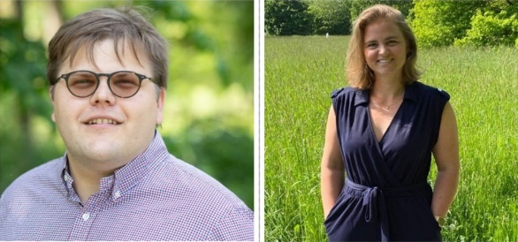
Quantum Delta NL, in collaboration with NWO, announces that 19
Honorees have been awarded €10.4 Million in grants as part of the
second call of the National programme’ s Actionline1 ‘Research & Innovation’. Dr. Maximilian Beyer has been awarded for his project titled 'Quantum for pressure-measuring atomic polarizabilities with molecular
ions for a quantum pressure gauge (QPOL)' which aims to develop a novel method to determine the static polarizability of rare gas atoms spectroscopically. Dr. Laura Dreissen has been awarded for her project titled 'Silencing the Noise: entangled states in trapped ions for accurate quantum sensing and metrology' where she will use quantum entangled states in multiple Ba+ ions that are resistant to environmental noise, making them ideal for measurements with incredibly high accuracy. Read more

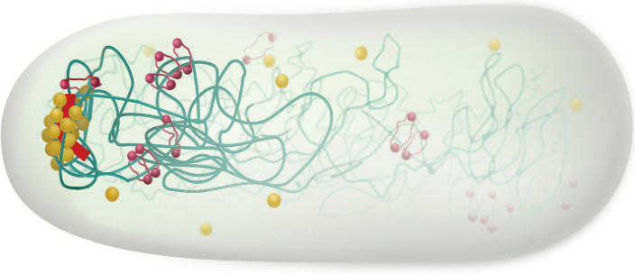

Physicist Chase Broedersz receives ERC Consolidator
Grant
The European Research Council (ERC) awards Chase Broedersz,

associate professor at Vrije Universiteit Amsterdam, a Consolidator Grant for his project “Learn4DChromosome”. Chromosomes contain the genetic information to produce life and wants to understand the physical principles of functional chromosome organization in bacteria. 4D model: The central goal of Learn4DChromosome is to develop a 4D model for the statistical folding of chromosomes and its implications for function. The development of new experimental Hi-C, chromosome, techniques has recently generated a breakthrough in measuring chromosome structure. Unlike a microscope, however, these experiments don’t yield easily interpretable images, but rather a statistical metric for average pairwise interactions between chromosomal regions. Interpreting Hi-C maps at their full quantitative potential remains a major hurdle to overcome. Read more
2
With his research, Dr. Askes aims to challenge the traditional approach for the use of catalytic reactors in the chemical industry. These reactors are typically used to produce essential building blocks for our society, such as raw materials for plastics and fertilizers. Read more
ERC STG Grant Award
Laser cooling of molecular helium. Dr. Beyer’s research is focused on precision measurements of the simplest molecules in our universe - molecular hydrogen (H₂) and its ion (H₂⁺) – to test quantum electrodynamics. Read more
ERC Starting Grant
ARCNL group leader and VU physicist John Sheil receives a Veni grant from NWO for his project “ARIES”. Dr. Sheil will develop a unique laser-plasma simulation capability to guide the design of tomorrow’s more powerful and more sustainable EUV sources for nanolithography. Read more
Lithography light source simulation
GRANT & AWARDS
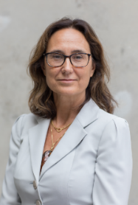

Gold Medal award
Prof. Dr. Roberta Croce has been honored with the Gold Medal award for Excellence in Photobiology. The award is presented during the biennial congress of the European Society of Photobiology to eminent scientists recognized globally for their exceptional contributions to the field of Photobiology and to the ESP activities. Read more
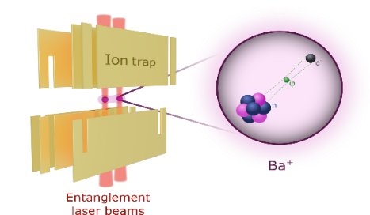

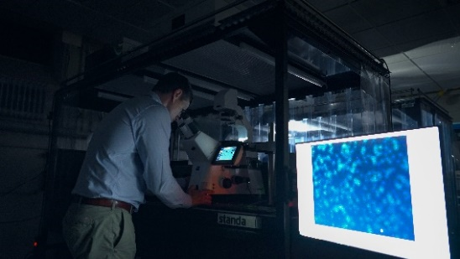
Laura Dreissen develops quantum sensor for dark matter with Veni grant
What is the origin and composition of dark matter? Although 85% of all the matter in our universe consists of dark matter, we still know very little about it. Physicist Dr. Laura Dreissen therefore plans to use her Veni grant to search for signs of this mysterious and remarkable phenomenon.
Read more
NWO funding for Andrea Baldi to study valuable metal nanoparticles features
For his research proposal titled: Selective CO2 photoreduction on
plasmonic nanoparticles, VU Amsterdam physicist Dr. Andrea Baldi, is awarded a NWO Open Competition Domain Science grant. The funding
will be used to study how metal nanoparticles under illumination can
drive CO2 towards specific desired products. The chemical industry relies heavily on carbon-based building blocks such as CO, methanol and other organic reduction of atmospheric CO2, an attractive approach to lower our dependency on fossil fuels and reduce
global warming. Baldi and fellow researchers from Vrije Universiteit Amsterdam will collaborate with scientists at
the University of Twente and will make use of both these characteristics. They will use advanced microscopy and spectroscopy techniques to control chemistry both in space, using single nanoparticles, and in time, with ultrafast spectroscopy. Read more
3

GRANT & AWARDS

VU Physicist and ARCNL group leader, O. Versolato has received a Consolidator Grant from the ERC of two million euro. The grant allows him to investigate the ideas put forward in the research proposal ‘Next-Generation Light Source: Driving plasmas to power tomorrow’s nanolithography’.
Read more

ERC Consolidator Grant
VU physicist Andreas Freise has received funding from the Dutch Research Council (NWO) Scientific Research Infrastructure programme to further improvements to the Advanced Virgo detector for gravitational waves in Pisa. Freise leads the Virgo innovation project at Nikhef. NWO has awarded 2.7 million euros to the project.
Read more
Grant for improvements Virgo detector
Peter Kraus, VU physicist and ARCNL group leader, has received the Vidi grant for his research HIMALAYA, which focuses on super-resolution for ''dancing electrons.'' The researcher also received funding from the NWO Open Competition for a project called "Ultrafast X-ray access to strongly correlated designer materials" (UltraX).
Read more
Vidi & NWO Open Competition Fund
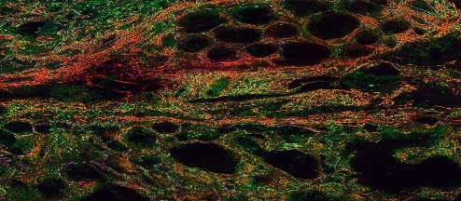
Million grant for early detection and treatment of lung cancer
Can you simply take a biopsy from a lung tumor via the trachea, and then treat that tumor locally in the same procedure? According to the IMAGIO research team, including VU professor of Biophotonics & Medical Imaging Marloes
Groot, this is getting closer. Additional and new technology is being developed that allows a doctor to find lung cancer earlier, results in better identifying and treat the cancer more vigorously. The research is part of the IMAGIO project, which also investigates liver cancer and
soft tissue tumors. A grant of 24 million euros has been awarded to the project by Innovative Health Initiative. The research ensures that major changes can take place. For example, the routine analysis of a biopsy in the Pathology department now takes about three days. However, with the development of a laser microscope, the biopsy can be analyzed in 3D directly in the operating room. When cancer is found, treatment can be started immediately.
Read more
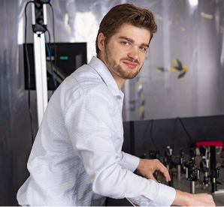

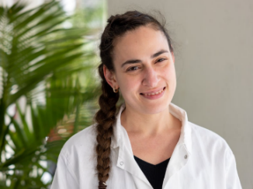
L’Oréal UNESCO For Women in
Science fellowship
Biophysicist Volha Chukhutsina has received a research grant of 30,000 euros. On April 18, the L'Oréal UNESCO For Women in Science Fellowships and Rising Talent Awards were presented for the 11th time in the field of Life Sciences and STEM disciplines. VU biophysicist V. Chukhutsina received one of the research grants.
Read more

NWO grant for visualizing structures in computer
chips
VU physicist and ARCNL group
leader Peter Kraus has received funding from the Dutch Research Council (NWO) Open Technology Programme for the project 'Integrated nanophotonic
and extreme-ultraviolet access to semiconductor metrology'. NWO has awarded 1 million euros to the NANOXUV project. Read more

4
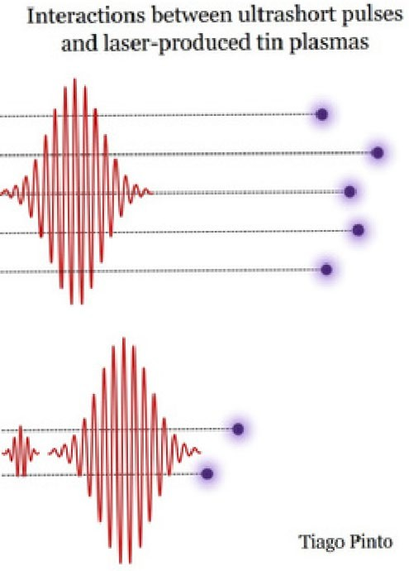
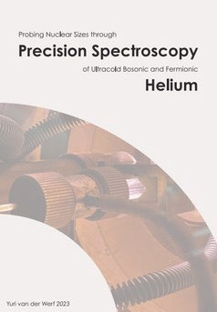

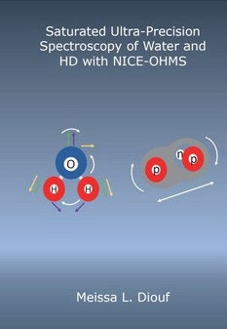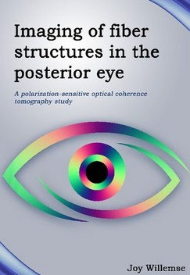

M.L. Diouf
6 December 2023
J. Willemse
29 November 2023
T. Pinheiro de Faria Pinto
27 November 2023
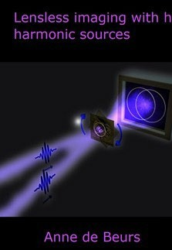
Y. van der Werf
24 November 2023

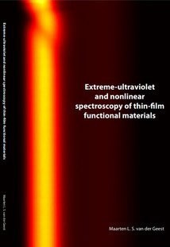
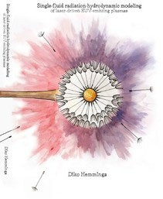
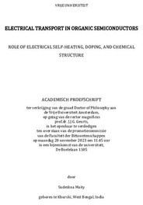

S. Maity
20 November 2023
D. Hemminga
20 November 2023
A.C.C. Beurs
16 November 2023
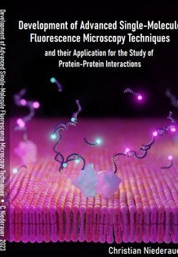
M.L.S. van der Geest
15 November 2023

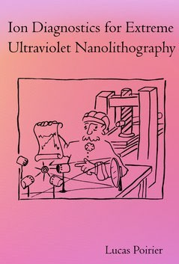
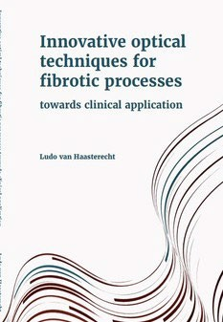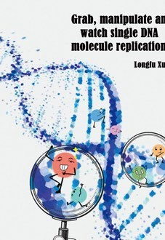

L. van Haasterecht 13 November 2023
L. Xu
9 November 2023
C. Niederauer
19 October 2023
L.R. Poirier
6 October 2023
5

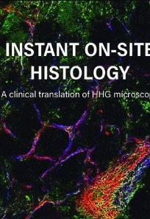
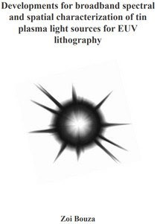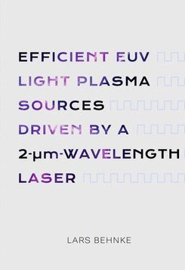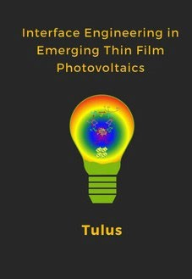

Z. Bouza
6 October 2023
L.P.Behnke
2 October 2023
Tulus
11 September 2023
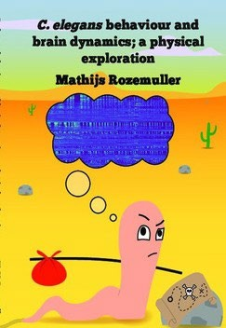
L. van Huizen
6 September 2023

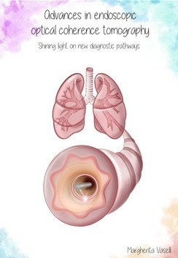
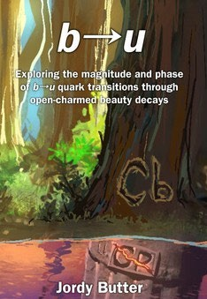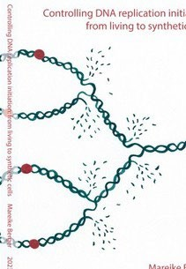

J. Butter
13 Jun 2023
M. Berger
3 May 2023
M. Rozemuller
26 April 2023
M. Vaselli
19 April 2023

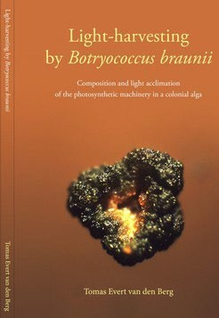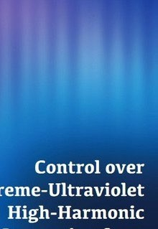

T. van den Berg
30 March 2023
S.D.C.R. Abbing
27 March 2023

6
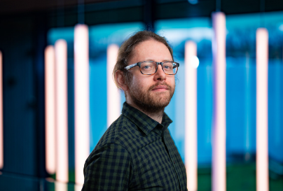
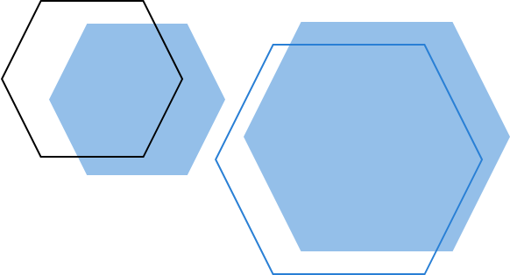
The teacher of the year 2023 John Sheil
[Grab your reader’s attention with a great quote from the document or use this space to emphasize a key point. To place this text box anywhere on the page, just drag it.]
Interview
[Titel van zijbalk]
[Zijbalken zijn ideaal om belangrijke punten uit uw tekst te laten opvallen of aanvullende informatie toe te voegen ter referentie, zoals een schema.
Ze worden normaal gesproken aan de linker-, rechter-, boven- of onderkant van de pagina geplaatst. U kunt deze echter ook naar elke gewenste positie slepen.
Wanneer u uw inhoud wilt toevoegen, klikt u hier en begint u te typen.]

This page is draft now

Om belangrijke punten uit uw tekst te laten opvallen of aanvullende informatie toe te voegen ter referentie, zoals een schema. Ze worden normaal gesproken aan de linker-, rechter-, boven- of onderkant van de pagina geplaatst. U kunt deze echter ook naar elke gewenste positie slepen. Wanneer u uw inhoud wilt toevoegen, klikt u hier en begint u te typen.] [Zijbalken zijn ideaal om belangrijke punten uit uw tekst te laten opvallen of aanvullende informatie toe te voegen ter referentie, zoals een schema. Ze worden normaal gesproken aan de linker-, rechter-, boven- of onderkant van de pagina geplaatst. U kunt deze echter ook naar elke gewenste positie slepen. Wanneer u uw inhoud wilt toevoegen, klikt u hier en begint u te typen.] [Zijbalken zijn ideaal om belangrijke punten uit uw tekst te laten opvallen of aanvullende informatie toe te voegen ter referentie, zoals een schema. Ze worden normaal gesproken aan de linker-, rechter-, boven- of onderkant van de pagina geplaatst. U kunt deze echter ook naar elke gewenste positie slepen. van de pagina geplaatst. U kunt deze echter ook naar elke gewenste positie slepen. Wanneer u uw inhoud wilt toevoegen, klikt u hier en begint u te typen.] [Zijbalken zijn ideaal om belangrijke punten uit uw tekst te laten opvallen of aanvullende informatie toe te voegen ter referentie, zoals een schema. Ze worden normaal gesproken aan de linker-, rechter-, boven- of onderkant van de pagina geplaatst. U kunt deze echter ook naar elke gewenste positie slepen. van de pagina geplaatst. U kunt deze echter ook naar elke gewenste positie slepen. Wanneer u uw inhoud wilt toevoegen, klikt u hier en begint u te typen.] [Zijbalken zijn ideaal om belangrijke punten uit uw tekst te laten opvallen of aanvullende informatie toe te voegen ter referentie, zoals een schema. Ze worden normaal gesproken aan de linker-, rechter-, boven- of onderkant van de pagina geplaatst. U kunt deze echter ook naar elke gewenste positie slepen. van de pagina geplaatst. U kunt deze echter ook naar elke gewenste positie slepen. Wanneer u uw inhoud wilt toevoegen, klikt u hier en begint u te typen.] [Zijbalken zijn ideaal om belangrijke punten uit uw tekst te laten opvallen of aanvullende informatie toe te voegen ter referentie, zoals een schema. Ze worden normaal gesproken aan de linker-, rechter-, boven- of onderkant van de pagina geplaatst. U kunt deze echter ook naar elke gewenste positie slepen. normaal gesproken aan de linker-, rechter-, boven- of onderkant van de pagina geplaatst. U kunt deze echter ook naar elke gewenste positie slepen. normaal gesproken aan de linker-, rechter-, boven- of onderkant van de pagina geplaatst. U kunt deze echter ook naar elke gewenste positie.

7

7
Ultrafast switching with light in correlated materials
Highlighted Papers
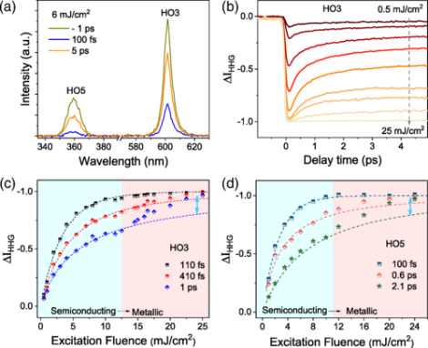
Materials that refuse to fit into theory are often the most fascinating. They challenge researchers to try harder to understand their peculiar behavior, especially when their properties are promising for technological applications. Researchers in the High Harmonic Generation & EUV Science group of Peter Kraus at ARCNL have recently unraveled some of the mysteries of a so-called correlated material and found a way to manipulate its resistivity with light. This paves the way for opto-electronic ultrafast switching in future microelectronics. The study was recently published in Physical Review Letters. Read more

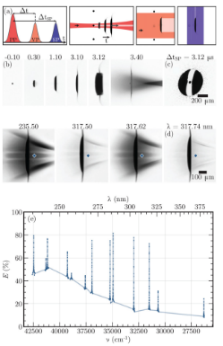
High-resolution spectroscopic imaging of atoms and nanoparticles in thin film vaporization
We introduce a spectroscopic absorption imaging method in the UV regime (225–400 nm) to study tin vapor created by irradiating a thin film with a low intensity 108 W cm−2 nanosecond laser pulse, a case inspired by current developments around “advanced target shaping” in industrial laser-produced plasma sources for extreme ultraviolet light. The 4-ns-time-resolved, 10-μm-spatial-resolution images contain a 10-cm−1-resolution spectrum of the vapor in each pixel 100 ns after the vaporization. The images allow us to reveal a homogeneous temperature profile throughout the vapor of around 3000 K. We obtain a density map of the atoms (with a peak density of 5 × 1018 cm−3) and nanoparticles (1012 cm−3 for the best fitting 20 nm radius case), which both are shown to be present in the vapor. For each free atom, approximately three appear to be clustered in nanoparticles, and this composition is invariant over space and density. The density and temperature maps of the free atoms are combined to estimate the electron density (peaking at 1013 cm−3) in the vapor. Read more
8
The automation of SMEFT-assisted constraints on UV-complete models
By deploying the Standard Model Effective Field Theory (SMEFT) as a bridge between UV-complete models and data, the authors present an automated framework that can indirectly constrain a wealth of New Physics particles and interactions from their matching to the SMEFT. This paper realizes one of the main objectives of the EFT program in particle physics: deploying the SMEFT to bypass the need of directly comparing the predictions of heavy UV models with experimental data. Read more
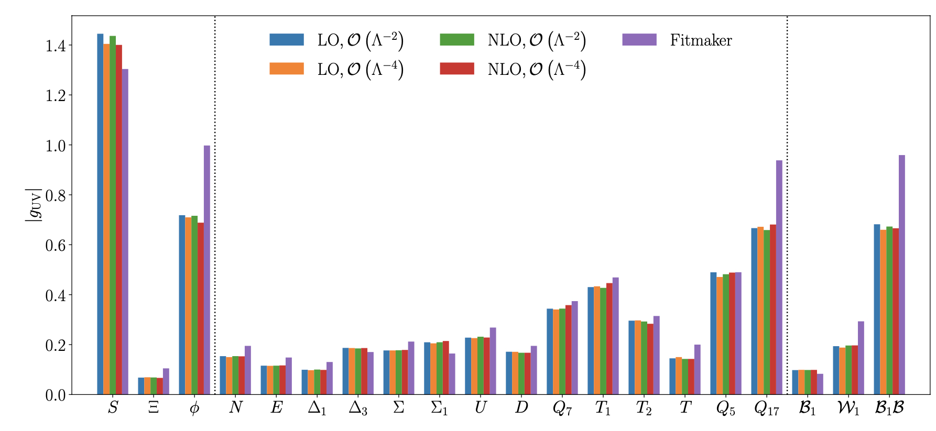

New optical technique for determining
fibrotic tissue in lungs

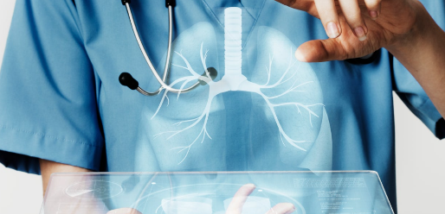
An interdisciplinary research team has developed a new optical technique for determining fibrotic tissue in the lungs of interstitial lung disease patients. This groundbreaking study demonstrates that this new technique has potential to outperform fibrosis detection and quantification in the lung as compared to high resolution Computed Tomography. The team was led by VU Amsterdam physicist Prof. dr. Johannes de Boer and Amsterdam UMC lung specialists Dr. Peter Bonta and Prof. dr. Jouke Annema. The study was recently published on BMJ open Respiratory Research and presented at the European Respiratory Society conference in Milan.

Competitive Charge Separation Pathways in a Flexible Molecular Folda-Dime
Highlighted Papers

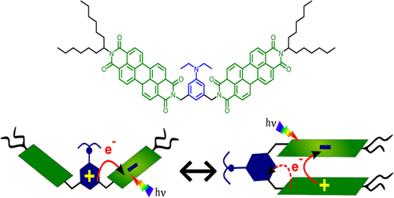
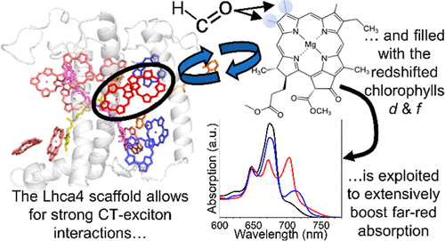
We report the photophysical properties of a molecular folda-dimer system PDI-AnEt2-PDI, where the electron-donating N,N-diethylaniline (AnEt2) moiety bridges two electron-accepting perylene diimide (PDI) chromophores. The conformationally
flexible PDI-AnEt2-PDI adopts either an open (two PDIs far apart) or folded (two PDIs within π-stacking distance) conformation, depending on the solvent environment. We characterized the photoinduced charge separation dynamics of both open and folded forms in solvents of varying polarity. The open form undergoes charge separation to give PDI•–-AnEt2•+-PDI (Bridge electron transfer) independent of solvent polarity. The folded form exhibits two charge separation photoproducts, yielding both PDI•–-AnEt2•+-PDI and PDI•–-AnEt2-PDI•+, the latter of which is formed via symmetry-breaking charge separation (SBCS) between the two π-stacked PDI chromophores. Our results further indicate that the conformational flexibility of the folda-dimer leads to unexpected excimer formation
in some open form conditions. In contrast, no excimer formation is observed in the folded form, indicating that this geometry preferentially yields the SBCS instead. Our results provide insight into how conformationally flexible folda-dimer systems can be designed and built to tune competitive photophysical pathways. Read more

Coloring Outside the Lines: Exploiting Pigment−Protein Synergy for Far-Red Absorption in Plant Light-Harvesting Complexes
Plants are designed to utilize visible light for
photosynthesis. Expanding this light absorption toward the farred could boost growth in low-light
conditions and potentially increase crop productivity in dense canopies. A promising strategy is broadening the absorption of antenna complexes to the far-red. In this study, we investigated the capacity of the photosystem I antenna protein Lhca4 to incorporate far-red absorbing chlorophylls d and f and optimize their spectra. We demonstrate that these pigments can successfully bind to Lhca4, with the protein environment further red-shifting the chlorophyll d absorption, markedly extending the absorption range of this complex above 750 nm. Notably, chlorophyll d substitutes the canonical chlorophyll a red-forms, resulting in the most red-shifted emission observed in a plant light-harvesting complex. Using ultrafast spectroscopy, we show that the introduction of these novel chlorophylls does not interfere with the excited state decay or the energy equilibration processes within the complex. The results demonstrate the feasibility of engineering plant antennae to absorb deeper into the far-red region while preserving their functional and structural integrity, paving the way for innovative strategies to enhance photosynthesis. Read more

9
Highlighted Papers

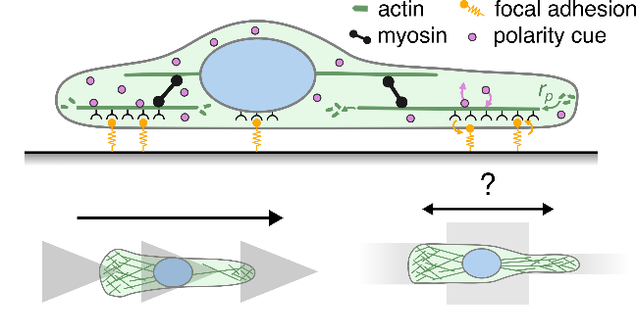
Geometry sensitive protrusion growth directs confined cell migration
The migratory dynamics of cells can be influenced by the complex micro-environment through which they move. It remains unclear how the motility machinery of confined cells responds and adapts to their micro-environment. Here, we propose a biophysical mechanism for a geometry-dependent coupling between cellular protrusions and the nucleus that leads to directed migration. We apply our model to geometry-guided cell migration to obtain insights into the origin of directed migration on asymmetric adhesive micro-patterns and the polarization enhancement of cells observed under strong confinement. Remarkably, for cells that can choose between channels of different size, our model predicts an intricate dependence for cellular decision making as a function of the two channel widths, which we confirm experimentally.

Read more

Improved Measurement of CP Violation Parameters in B0s→J/ψK+K− Decays in the Vicinity of the ϕ(1020) Resonance

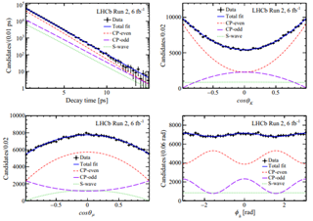
A new “world’s best measurement” by the LHCb Collaboration, with a strong contribution from the VU/Nikhef colleague V. Lukashenko (PhD candidate) and her supervisors Prof. G.Raven and Dr. W. Hulsbergen, is presented in Ref. [1]. The LHCb experiment, at CERN, uses data from proton-proton collisions at very high energies to explore the conditions created right after the Big Bang, that led to a massive the prevalence of matter (and almost complete disappearance of anti-matter) in the universe. Within the Standard Model of particle physics, differences between matter and antimatter are related to violation of the Charge-Parity (CP) symmetry. The comparison between CP-symmetry measurements and theory predictions sheds light into the mechanisms involved in the creation and disappearance of matter and antimatter. B mesons are particles of special interest for the LHCb experiment, since after being produced in proton-proton collisions, they can oscillate into their own anti-particles before disintegrating within the detector. The disintegration of B0 s mesons into J/ψK+K− is a particularly sensitive process, as it provides access to the CP-violating phase φs. Standard model predictions for the φs phase can be accurately calculated from other measurements, and the value is predicted to be close to zero, φs = −0.037 rad. Any deviation, even small, from this prediction, could be indicative of how the large imbalance of matter took place at the early universe. The LHCb Collaboration, led by its Nikhef/VU team, has recently completed the most accurate measurement of φs to this date. The measurement yields φs = −0.039 ± 0.022 ± 0.006, in agreement with the standard model prediction within the current precision. The result represents an important step forward in accuracy, and establishes several novel methods to analyze the even larger data samples that will be collected at CERN in the near future.
Read more

10
Van Heijningen is an assistant professor at the Vrije Universiteit Amsterdam since November 2023. Dr. van Heijningen is hired in the context of the VU/UT collaboration on the Mechanical Engineering BSc program. Read more
Dr. Joris van Heijningen joins the Physics and Astronomy
News & Announcements
Askes is an assistant professor at the Vrije Universiteit Amsterdam since September 2023. He is hired in the context of the VU/UT collaboration on the Mechanical Engineering BSc program.
Read more
Dr. Sven Askes joins the Physics and Astronomy
Muscarella joins the Physics Department as Assistant Professor in the section of PhotoConversion Materials.
Read more
Dr. Loreta Muscarella joins the Physics and Astronomy

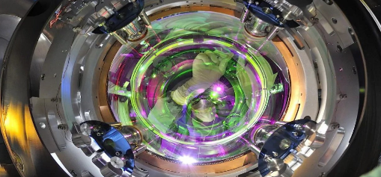
Back to the Big Bang with the Einstein Telescope

“When I started working in this field, there were people saying nobody will ever measure gravitational waves”, says Andreas Freise, project director and professor of Gravitational Wave Physics at VU Amsterdam. “But science succeeded in the first detection of these waves eight years ago, which was fantastic. Now, we want to see more because we’ve only seen the tip of the iceberg – and that alone was already very interesting. The current detectors Virgo and LIGO, however, were built for discovery and not for extensive research. The real stuff happens when you have a better signal – you can see further into the universe and you can see more details. To do that, we need the Einstein Telescope.” Read more
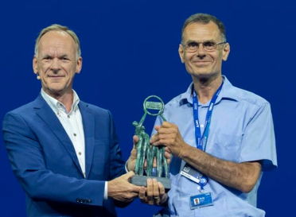
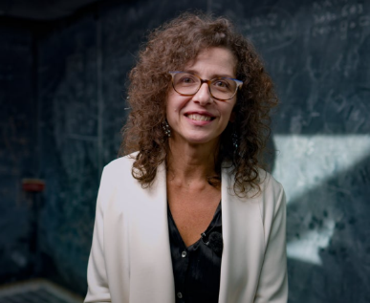

Mara Senghi Soares new program leader LHCb experiment at Nikhef

Assoc. Prof. Mara Senghi Soares has been appointed as the national program leader for the Large Hadron Collider beauty (LHCb) experiment at Nikhef, starting from November 1st. This experiment is one of the four major international experiments at the Large Hadron Collider (LHC) accelerator in Geneva. The experiment is specialized and leading in measuring differences between antimatter and matter.

Read more

Prestigious‘ ASML Corporate Fellow’ for Arie den Boef

At ASML’s Technology conference, ARCNL group leader and VU professor Arie den Boef has been awarded with the title of ASML Corporate Fellow. Only one other person currently working for ASML holds this title, which shows the great appreciation of his work for the company ASML. Arie den Boef is professor of Metrology and Nanolithography at Vrije Universiteit Amsterdam, works at ASML and ARCNL and closely collaborates on Digital Holographic imaging with the VU Physics department.
Read more
11
Science ART
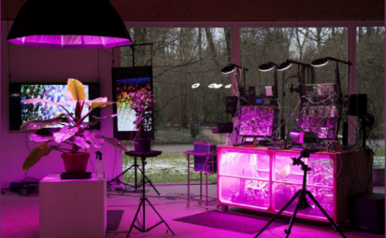
Jamming with plants Lowlands Science lab

Thanks to biophysicist and art science researcher Raoul Frese and artist-researchers Christiaan Zwanikken and Marc Marc, you can experience what it is like to literally be connected to plants in the Lowlands Science Lab. The scientists are investigating the operation of electrical processes in plants and possible applications thereof. To provide insight into these processes, a huge electronic installation has been developed that converts the plant's signals into sound. Read more

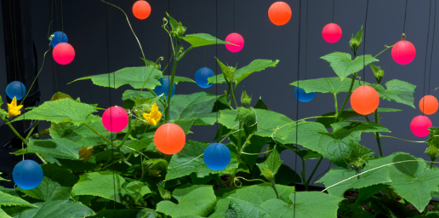
Exciting Innovation at the Intersection of Nature and Technology!

Thrilled to share the ground-breaking project "Smart Hybrid Forms: A plant becomes a machine becomes a plant" led by Dr. Raoul Frese - Vrije Universiteit Amsterdam, at our department and co-applicant Gerrit Rietveld Academy, with partners Waag Society, V2_the lab for unstable media, and Zone2Source. In collaboration with Špela Petrič, a visionary new media artist with a scientific background, the project introduces PL’AI - a plant-centered robot that seamlessly merges nature and technology. This interdisciplinary endeavor involves experts from computer and cognitive science, biology, engineering, design, art, and philosophy. It challenges our perception of plants and machines, offering a fresh perspective on the coexistence of living beings and technology. Read more


VU PHYSICS & ASTRONOMY COLLOQUIUM
14 March 2024
Prof. Dr. Elina Fuchs, CERN, Hannover
Pim America, PhD Candidate, VU Amsterdam

VU Amsterdam Physics and Astronomy department
De Boelelaan 1105, 1081 HV, Amsterdam
Editorial Team: Secretariat
Email: natsecr.beta@vu.nl

For subscriptions or inquiries about the articles and news featured in this newsletter, please reach out to the editorial team. We welcome your interest and look forward to engaging with you.

12

