    - Work Package 1: Measuring anthropogenic emissions

To be completed by the WP1 Team, coordinated by UU and CEA/LSCE

General overview (UU and CEA/LSCE)
….

Task level progress

Task 1.1 Development of a mobile semi-autonomous system for monitoring methane emissions (CEA, UU, INCAS, INOE, CYI; M1-12; D1.1)

In this task we proposed the harmonisation of ground-based measurement systems, including drones and cars, for methane monitoring. This was achieved through a controlled release experiment conducted in Cyprus in Dec 2025 (Figure 1a) as well as with the analysis of a previous controlled released experiment conducted in Pau, France in 2024 for car-based mesurements. The controlled release experiments involved releasing methane gas at a known rate from a known source (with the concentration unknown to participants) while measurement platforms quantified the emissions.
In the IM⁴CA release, four UAV systems and three ground-based vehicle teams were simultaneously deployed and evaluated in terms of their design characteristics, operational procedures, and methane flux quantification capabilities. The UAV teams comprised The Cyprus Institute (CYI) from Cyprus, Utrecht University (UU) from the Netherlands, AGH University of Krakow (AGH) from Poland, and the National Institute for Aerospace Research 'Elie Carafoli' (INCAS) from Romania. Complementing the UAV measurements, three teams conducted car-based measurements with methane gas analyzers mounted simultaneously in the vehicle: the LSCE–CYI team (Laboratory of Climate and Environmental Science in collaboration with CYI), the AGH team, and the INCAS team.
Each team independently quantified methane emissions following their own protocol. Subsequently, a dedicated workshop was organised at EMPA, where participating teams convened to compare their results against one another and against the known release rate. Following the workshop, teams reassessed their quantification methods and presented their updated findings (Figure 1b) at EGU 2026 in four posters.
The findings from the controlled release experiment provided a critical performance benchmark for all participating teams ahead of the IM4CA Romania campaign in June 2026, guiding the methodological corrections needed to ensure comparable and reliable CH₄ emission estimates across platforms. Scientific publications from this experiment are anticipated from the participating teams in the near future.
The measurement and quantification protocols established during the controlled release experiment are documented in Deliverable 1.1 (D1.1), which is openly accessible to non-scientific operators seeking to conduct similar site-level measurements. Furthermore, D1.1 defines the use of aircraft-based measurements and highlights their advantage of providing greater spatial coverage, while also recommending the use of stationary platforms for clusters of sites and for the validation of satellite measurements, all of which are planned for deployment during the Romanian campaign.
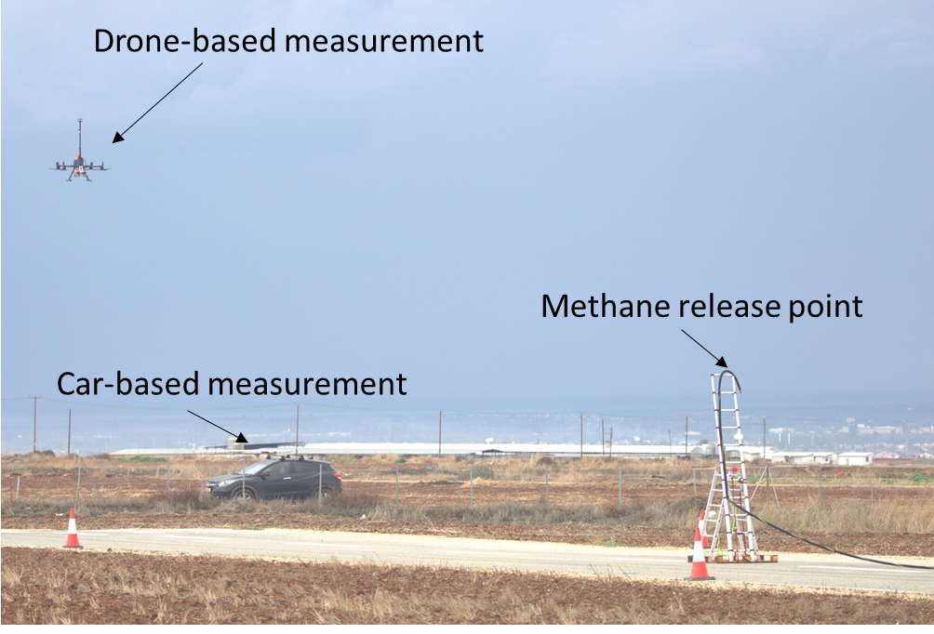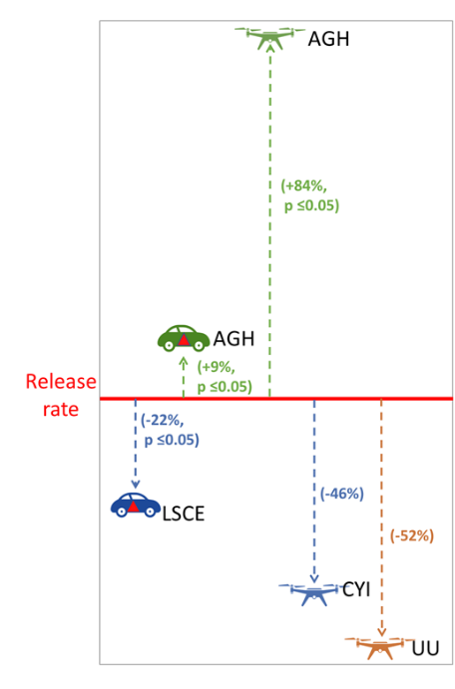
Figure 1. (a) CH4 mole fraction measurements collected by car based and drone-based platforms during the controlled release experiment in Cyprus. (b) A comparison of the teams' measurement approaches, with percentage values indicating each method's bias, derived from the slope between measured and actual release rates, reflecting how far each platform's readings departed from the known true emission rate.

Task 1.2 Preparation of atmospheric models for campaign interpretation (UniVie, CEA, UU, VUA, INCAS, INOE, UBremen, M1-12; D1.2)

The focus of Task 1.2 is the preparation of atmospheric models to interpret the measurements taken during the campaigns in Romania, France and the Netherlands. In particular, the goal is to develop an interactive, web-based quantification tool to support the analysis of measurement campaigns. However, it was decided during the working process of this task that two independent tools should be developed using different methods to support the CH₄ measurement campaigns.

The first tool will visualize the emission sensitivity footprints of the measurements, which will be computed using the Lagrangian particle dispersion model FLEXPART. Since the spatial resolution of the meteorological input data to the FLEXPART simulations is limited, these footprints will only be calculated for larger-scale measurements, such as aircraft campaigns. This first tool is developed by the University of Vienna and will be made available online via the university's server. The second tool will estimate methane plumes from point sources using various Gaussian Plume Model (GPM) methods. This tool is being developed by the LSCE and Utrecht University and should be made available via a web interface on the ICOS-ATC or the server of Utrecht University.

These two tools provide different insights into the sources of methane emissions: while analysing backward trajectories with FLEXPART helps to identify the contribution of different CH₄ sources to a given measurement, GPMs calculate emission dispersion on a small spatial scale from a known source. Both tools are currently under develpment.

Additionally, the high-resolution DALES (Dutch Atmospheric Large-Eddy Simulation) model will be used for ensemble simulations of methane plumes at 50 m resolution, based on measurements taken during the campaigns in Romania. These simulations will support the measurement campaigns but will not be part of the interactive tools described previously.

Task 1.2 also included the deliverable D1.2, which was submitted with a two-months delay in M14.

Task 1.3 Intensive measurement campaigns in Romania (UU, CEA, UVSQ, EMPA, INCAS,
INOE, CYI, UBREMEN; M12-36; D1.4; MS5,9)
The IM4CA-Romania-2026 campaign was conducted in southern Romania during June 2026 and represented the principal field campaign within Work Package 1. The campaign combined satellite observations, airborne remote sensing, airborne in situ measurements, mobile ground-based observations, stationary remote sensing, atmospheric modelling and isotope analyses into a coordinated multi-platform measurement strategy. The primary objectives were to quantify methane emissions from oil and gas production infrastructure and municipal landfills, to intercompare the different measurement approaches developed within IM4CA, and to provide comprehensive datasets for the validation of atmospheric models and satellite observations. Oil and gas facilities were revisited to allow comparison with the previous ROMEO campaign (Stavropoulou et al., 2024), while landfill measurements were designed to provide high-quality validation datasets for satellite retrievals.
Campaign coordination and measurement strategy
The campaign brought together a broad consortium of IM4CA partners, each contributing complementary measurement capabilities. UU, LSCE, AGH, INCAS, CYI and EMPA carried out mobile ground-based measurements using instrumented vehicles and unmanned aerial vehicles (UAVs). INOE, VU Amsterdam and the Technical University of Munich (TUM, collaborator) deployed portable FTIR spectrometers for stationary and mobile remote sensing observations. The University of Bremen operated the Dimona research aircraft for airborne in situ and remote sensing measurements, while EMPA and the University of Zurich conducted airborne imaging spectroscopy using the AVIRIS-NG instrument. EMPA performed in situ isotope measurements, whereas UU, EMPA and LSCE collected whole-air samples for subsequent laboratory isotope analyses. SRON coordinated acquisitions from the GHGSat and Tanager satellite instruments, while the LAMOS group at the University of Bremen provided atmospheric transport modelling and daily meteorological forecasts to support campaign planning and data interpretation.
The mobile ground teams were divided into western and eastern groups to maximise coverage of the southern Romanian production basin. Weather conditions during the campaign were often challenging. Persistently low wind speeds frequently prevented the formation of well-defined methane plumes, complicating both plume detection and emission quantification. Nevertheless, the flexible deployment of multiple measurement platforms ensured that a comprehensive dataset could be acquired throughout the campaign.
Emissions from the oil and gas infrastructure
The majority of field activities focused on the extensive oil and gas production infrastructure in southern Romania. Approximately 200 individual emission quantification experiments were carried out using complementary techniques, including Gaussian Plume Modelling (GPM), OTM-33A, tracer-release experiments and drone-based mass balance methods (Figure 2). The use of multiple independent quantification approaches allows direct comparison of their performance under operational field conditions and provides improved confidence in the resulting emission estimates.
The airborne component played a central role in extending the spatial coverage of the campaign. The Dimona research aircraft carried both in situ and remote sensing instrumentation, enabling regional-scale characterization of methane enhancements over the Romanian production basin. Complementary flights with the AVIRIS-NG imaging spectrometer provided high-spatial-resolution mapping of a large fraction of the production infrastructure at the level of individual facilities (Figure 3). Flight planning was largely dictated by the prevailing meteorological conditions, making it impossible to closely align the airborne and ground-based observation programmes throughout the campaign. Nevertheless, the combined airborne observations provide an important regional context for the detailed ground-based emission measurements.
Landfill measurements and satellite validation
In addition to the oil and gas facilities, measurements were carried out at five major Romanian landfills: Vidra, Pitești, Brașov, Boldești-Scăeni and Roești. These sites were selected primarily to support validation of satellite methane observations through coordinated multi-platform measurements. A comprehensive measurement programme was established at the Vidra landfill, south of Bucharest. Three stationary FTIR instruments were deployed around the landfill to continuously monitor the evolution of the methane plume, while a fourth FTIR instrument was operated as a mobile system to measure methane concentrations across the plume. Vehicle-based transects were simultaneously performed to determine the spatial extent of the plume and optimise the positioning of the stationary FTIR instruments. Several landfills were targeted with differnet measurement approaches, including FTIR, AVIRIS and Dimona flights drone-based emission measurements, and satellites, providing valuable datasets for intercomparison between independent measurement techniques. These coordinated observations provide a unique opportunity to evaluate path-integrated FTIR observations against conventional in situ measurements, airborne observations and satellite retrievals.
Satellite observations formed an integral part of the campaign. Targeted acquisitions from the GHGSat and Tanager satellite instruments were requested for periods offering the highest probability of successful collocated observations with aircraft, UAVs, vehicles and FTIR instruments. These coordinated datasets will provide one of the most comprehensive validation datasets for high-resolution satellite methane observations currently available within the project.
Supporting activities and data management
Throughout the campaign, the LAMOS atmospheric modelling system produced daily forecasts of meteorological conditions and methane dispersion from a large number of potential emission sources. These forecasts guided the measurement teams by identifying favourable measurement periods and expected plume locations and subsequently supported the interpretation of the observations.
To ensure consistency between participating teams, the in situ methane analysers were intercompared before and during the campaign using eight custom calibration cylinders prepared jointly by LSCE, Utrecht University and AGH. All campaign observations, including airborne, ground-based, FTIR, satellite and isotope datasets, have been archived on the IM4CA research data repository, providing a common database for subsequent analysis in the following work packages and for future scientific publications.

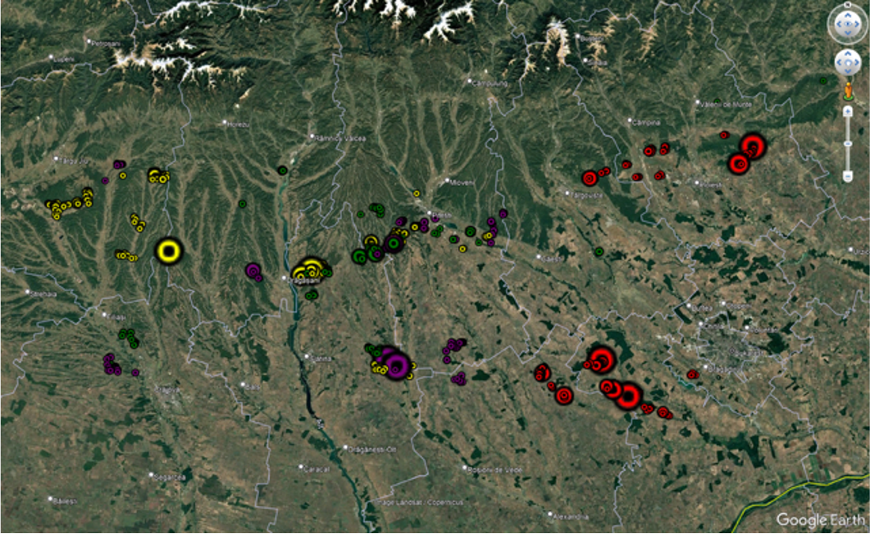
Figure 2. Overview of the methane-emitting facilities visited by the mobile ground teams during the IM⁴CA-Romania campaign.

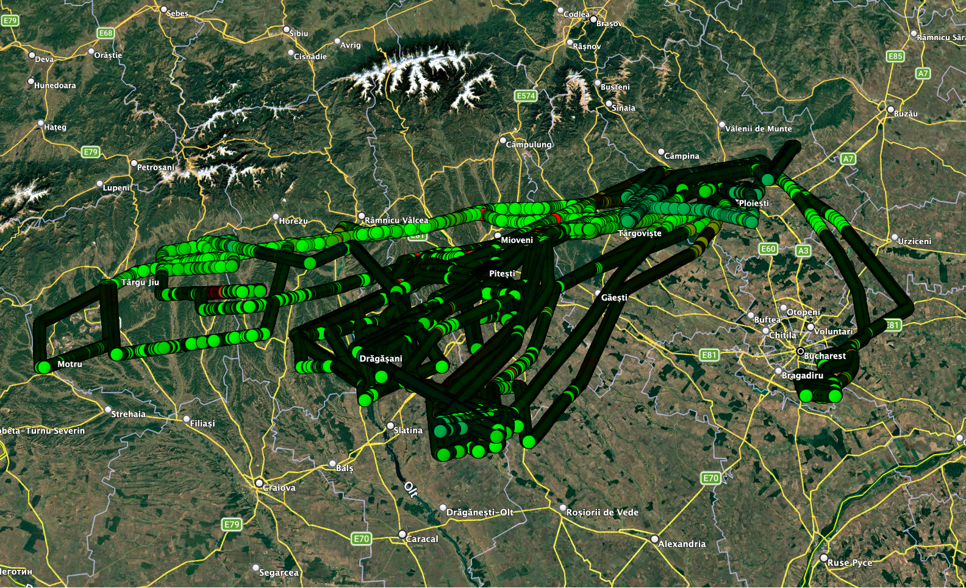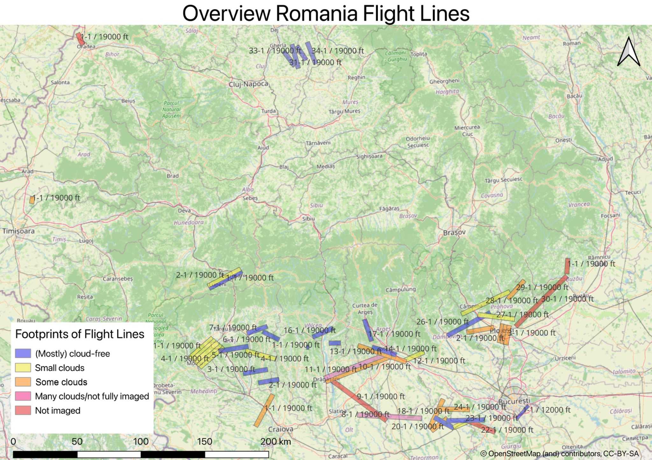
Figure 3. Flight tracks of the Dimona research aircraft (left) and the AVIRIS flight lines (right) during the the IM⁴CA-Romania campaign, illustrating the regional airborne measurement program.

Task 1.4 Site-level investigation of emission factors and their time variability (CEA, UU, CYI,
UVSQ, INCAS; M12-42; D1.3, D1.5)

In this task, we aim to characterize the temporal variability of methane emissions across a range of emission facilities, including landfills, biogas plants, LNG terminals, cattle farms, and wastewater treatment plants (WWTPs). This will be accomplished through frequent site visits and methane emission measurements using mobile ground-based approaches, such as drones and cars, as well as stationary measurement systems. To ensure broader spatial representativeness, measurements are planned across four European countries: Romania (INCAS), France (LSCE), Cyprus (CYI), and the Netherlands (UU).
Participating teams are currently developing their measurement strategies and identifying target sites, with field campaigns expected to start shortly. For example, two preliminary campaigns were conducted in France to 1) test the efficiency of the measurement equipment, 2) assess the infrastructure of methane-emitting facilities for future recurring measurement campaigns, and 3) compare quantification methods to better understand methane emission rates. The first campaign measured methane mole fraction enhancements using two different gas analyzers and covered various sites across western France, including farms, biogas plants, WWTPs, landfills, and LNG facilities (Figure 4). The second campaign took place in the Île-de-France region, focusing on a biogas/farm facility, where methane emissions were quantified using transects (for iGPM quantification) and the standing plume capture method (for OTM33A).
The outcomes of Task 1.4 work will yield site-specific emission factors that will feed into WP5 with updated and refined estimates. The results are expected to be disseminated through peer-reviewed scientific publications, informing decision-making for methane mitigation practices.

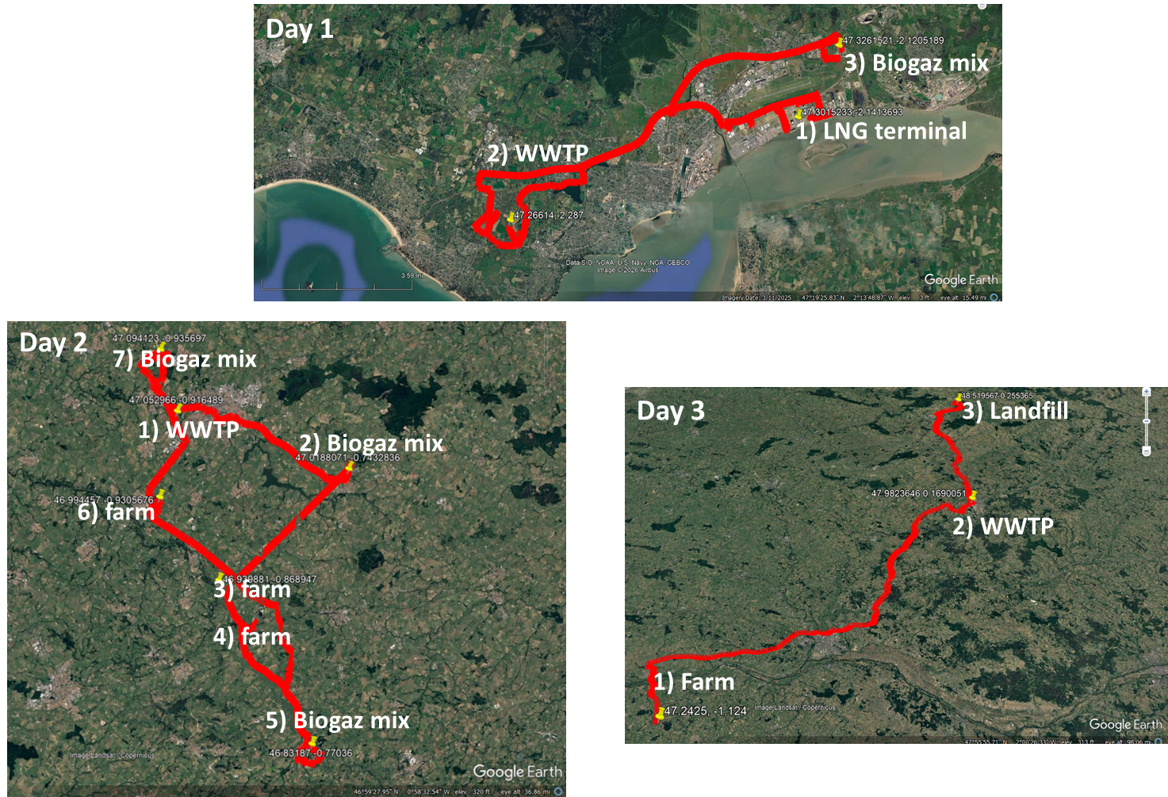
Figure 4. Map showing the location and typology of methane-emitting sites visited in France, where methane emissions were measured using two methane gas analyzers.

Task 1.5: Local emission quantification using satellites (SRON, VUA, UBremen, UniVie;
M12-42; D1.6)

Contribution per partner

CEA and UVSQ:

CEA and UVSQ contribute to the coordination of WP1 meetings, both general and task-related. CEA lead Task 1.1 and Task 1.4 and participated in Tasks 1.2 and 1.3. In Task 1.1, we organized weekly meetings prior to the Cyprus controlled release experiment, led the scientific coordination of the campaign, and followed up on data submission, results’ analysis, reporting, writing D1.1, and presenting the results at EGU. In Task 1.2, we contributed to reviewing Deliverable 1.2. In Task 1.3, we contributed to the organization of the Romanian campaign across several axes: 1) weekly meeting organization, 2) conducting car-based field measurements, 3) coordination of the intercomparison campaign, 4) sending LSCE-calibrated gas bottles and testing the equipments, 5) scientific communication support, 6) data submission organization and follow-up, and 7) data analysis for ground-based measurement. In Task 1.4, we hold regular meetings with the concerned teams, are building and organizing the research and scientific strategy, and are performing methane field measurements in France at methane-emitting facilities.

UU:
UU is co-coordinator of IM4CA, co-coordinator of WP1, leads task 1.3 and has coordinated the large IM4CA-Romania field campaign. In Task 1.1, UU developed their measurement platforms, characterized the analyzers and carried out emission quantification measurements with the mobile semi-autonomous systems. UU participated in the Cyprus controlled release experiment and leads the scientific analysis of the measurement results, which is expected to lead to a publication to be submitted in the next reporting period. Results were presented at scientific conferences. UU supported UVIE in the development of the evaluation tools in task 1.2. UU prepared and coordinated the large IM4CA-Romania campaign in June 2026. This involved a wide range of activities as described in the task 3 activities summary above. UU started emission quantification measurements from wastewater treatment plants, landfills and established contact to also measure emissions from LNG terminals in task 1.4

VUA:

INCAS:

INOE:

CYI:

UBremen:

Univie: UniVie is leading Task 1.2 which is dedicated to atmospheric transport modeling of the measurement campaigns. This task includes a deliverable, D1.2, which was due in M12 and has been submitted with a two-month delay. For the atmospheric modeling, UniVie is using the Lagrangian transport and dispersion model FLEXPART, and the simulations will be carried out when the measurements are available.

SRON;

Empa: Established 30 m mobile tower at MARS site south of Bucharest for monitoring CH4, C2H6, and d13C-CH4 (during June 26 campaign, Task 1.3). Mobile car measurements for GPM CH4 emission estimates and isotopic signatures of Vidra landfill (June 26, will be repeated to study temporal variability, Task 1.4).

….

