IM4CA Romania Campaign 2026

Campaign Implementation Plan

(CIP)

Horizon Europe Project

Authors:
H. Bovensmann, K. Gerilowski
Institute of Environmental Physics (IUP), University of Bremen (UB), Bremen, Germany

All to add

Change log

Version | Date | Status | Authors | Reason for change
Template | 30.1.2026 |  | H. Bovensmann

Table of Contents
1. Purpose of Document 4
2. Introduction and Background 4
3. Campaign Goals and Approach 5
3.1. Campaign Goals 5
3.2. Overall campaign approach 6
4. Description of campaign target area and sites 6
5. Campaign instrumentation 8
5.1. Car-based in-situ data collection 8
5.2. Drone based in-situ data collection 8
5.3. Ground based remote sensing (EM27, COCCON) 8
5.4. Aircraft based data collection 8
5.4.1. Eco-Dimona with remote sensing CH4 imager and in-situ sensor 8
Team: Univ. Bremen, Univ. Applied Science Wilhelmshaven with INCA support 8
5.4.2. XXX with in-situ sensor 11
5.4.3. XXX with hyperspectral sensor for CH4 detection 11
6. Deployment Strategy 11
7. Campaign Preparation and Execution 13
7.1. Campaign Preparation 13
7.2. Campaign Execution and Data Acquisition 14
7.3. Campaign Schedule 15
7.4. Campaign Team 16
7.5. Daily Activities (example) 17
7.6. Campaign baseline selection (example) 18
7.7. Quick look processing during campaign (to be adapted) 19
8. Other available data 20
8.1. Satellite Data 20
8.2. Wind and topography data 20
9. References 21

Purpose of Document
The purpose of this document is to provide the baseline planning for the campaign in support to the provision of observational data for top-down estimates of methane emissions by collecting remote sensing and in-situ atmospheric data in Romania.
The document describes the planning before campaign execution as of Spring 2026.

Introduction and Background
SOME GENERAL TEXT TO BE ADDED ABOUT

Campaign Goals and Approach

Campaign Goals

Overall campaign approach

Description of campaign target area and sites
In this section an overview is given about the campaign targets and their locations. The campaign target area is within Romania, as depicted in Figure 1.

Figure 1: Overview of target area.

Table 1 gives an initial list of pre-selected as starting point for the campaign. Criteria for that list where ….

The map in Figure 2 summarises the selected targets in Romania.

Target | Sector | Detected in Satellite data  TROPOMI or high res. | Pilot Studies (ROMEO etc.) | ROM Emissions  ktCH4/a (if known) | Comment
Vaida Landfill | Glencore | Source 1 | Yes
Table 1: Initial list of targets to be investigated within the campaign.

Figure 2: Map of all targets overlayed on …..

We might define regions of interest

Campaign instrumentation

Car-based in-situ data collection
Team(s)
Sensors to be deployed, with their main performance characteristics, incl. range of data collection and suggested base.

Drone based in-situ data collection
Team(s)
Sensors to be deployed, with their main performance characteristics, incl. range of data collection and suggested base.

Ground based remote sensing (EM27, COCCON)
Team(s)
Sensors to be deployed, with their main performance characteristics, incl. range of data collection and suggested base.

Aircraft based data collection

Eco-Dimona with remote sensing CH4 imager and in-situ sensor
The group at University of Bremen (UB) has more than a decade experience in executing airborne remote sensing and in-situ campaigns to characterise localised emissions of CO₂ (Krings et al. 2018) and CH₄ (Krings et al. 2013, Krautwurst et al. 2017, 2021). Most recently, UB developed a new compact airborne GHG spectrometer MAMAP2D-Light (M2DL) which fits into an underwing pod of a Dimona motor glider (Borchardt et al. 2021). M2DL will deliver column enhancements relative to the background concentration for CH₄ or CO₂. M2DL was successfully deployed in summer 2022 in an aircraft campaign in Canada, as well in 2023 in an UNEP IMEO funded campaign in Australia.

Team: Univ. Bremen, Univ. Applied Science Wilhelmshaven with INCA support

Within this campaign a Diamond Aircraft HK36TTC-ECO Dimona, a glider modified for airborne research purposes, will be deployed equipped with xxx, yyy and zzz in two underwing pods.
It is planned to operate the aircraft out of Bucarest XXXX airport as campaign base.

Figure 3: Diamond Aircraft HK36TTC-ECO Dimona, Univ. Applied Science Wilhelmshaven
Operating within a typical cruising speed range of 20 to 60 meters per second (approximately 75 to 200 km/h), the aircraft can navigate altitudes spanning from 5 meters up to 7,000 meters. Its operational range extends up to 1,000 kilometers, accompanied by an endurance capability of max. 6 hours (typically 4-5 hours).
The aircraft will be equipped with in-situ sensors and the methane imaging spectrometer MAMAP2D-Light of University Bremen.

Methane Imaging Sensor MAMAP2D-Light
Main remote sensor is the methane imaging sensor MAMAP2D-Light from University Bremen. For remote sensing of the greenhouse gas CH₄ the Methane Airborne MAPper2D-Light (M2DL) will be flown on in an underwing pod of the Eco Dimona above the boundary layer. M2DL was developed and built at the Institute of Environmental Physics in Bremen, Germany, to determine methane (CH4) and carbon dioxide (CO2) emissions from aircraft using solar absorption spectroscopy. It builds on the experience of the University of Bremen with the MAMAP instrument (see e.g. Gerilowski et al., 2011; Krings et al., 2011; Krautwurst et al., 2017, 2021; Krings et al., 2018). M2DL detects sunlight reflected from the Earth's surface in the spectral range from 1559 nm to 1690 nm with about 1.1 nm spectral resolution, about 50 m x 50 m spatial resolution, 1500 m ground track width for a flight altitude of approximately 4 km, and a signal-to-noise ratio of 300 - 600 depending on surface brightness and sun position. M2DL consists of a spectrometer unit, a front optics unit and a control and data acquisition system. The basic measurement principle is shown in Figure 4. Using the absorption spectroscopy method, the relative increase in CH4 or CO2 concentration in the atmosphere is determined from the recorded spectra. Relative increases in CH4 or CO2 concentration (or column anomalies) in the atmosphere can be determined with a precision of about 0.3% - 0.6% of the background column depending on flight/atmospheric conditions and topography. From the spatial change in concentrations, conclusions can be drawn about the emissions of CH4 (see e.g. Krautwurst et al., 2017) and CO2 (see e.g. Krings et al., 2018) sources - if the meteorological conditions are known.
Assuming a wind speed of ~ 5 m/sec, a 0.3-0.5% precision translates to a flight path and pointing accuracy dependent detection limit of this airborne imaging instrument of at approx. < a few 100 kg/hr, sufficient for large source strength expected in Romania.
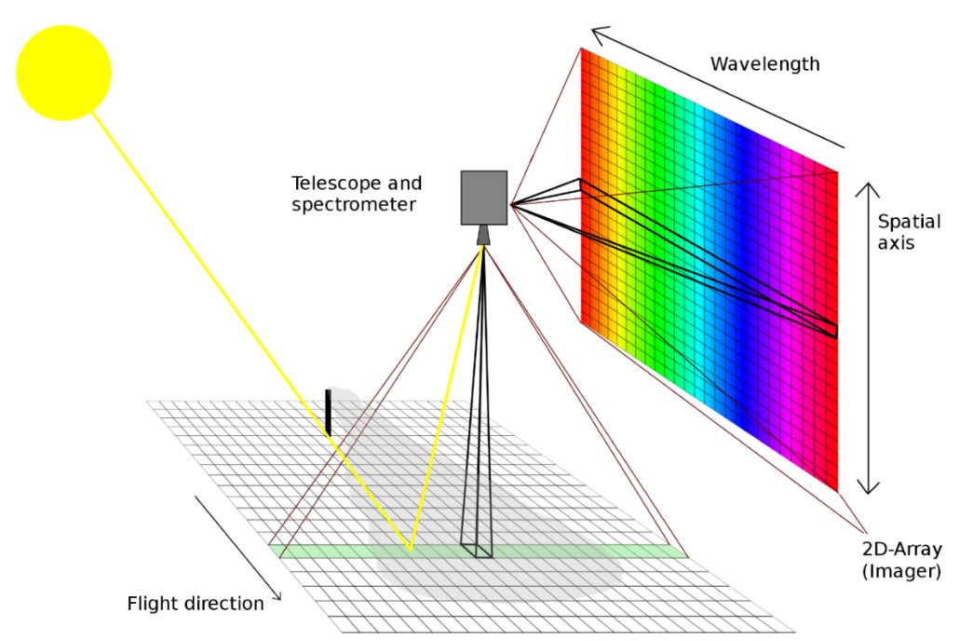
Figure 4: Scheme of imaging acquisition of spectra with MAMAP2D-Light (M2DL).
M2DL is to be deployed in an underwing pod on the ARA research aircraft EcoDimona in Australia in September 2023 as part of the UNEP funded research measurement campaign. M2DL was tested beforehand in the same underwing configuration flying with a motorglider (EcoDimona) of the Jade Hochschule Wilhelmshaven.

In-situ sensors
The so-called in-situ sensor payload consists of an 5 hole turbulence probe and a LGR UGGA In-Situ GHG analyser for CH₄, CO₂, H₂O, which is the main sensor for precise CH₄ and CO₂ in-situ measurements. The sensor will be calibrated during the campaign using special calibration gases.
Table 3: Summary of in-situ instrumentation of D-xxx.

Basic Flight Pattern
Flight patterns for remote sensing measurements (Figure 4) need to be performed at constant altitude above the plume, ideally above the PBL. The flight pattern typically consists of one leg upwind of the source perpendicular to wind direction and a number of legs with increasing spacing downwind of the source, likewise perpendicular to wind direction. Depending on spatial scales and plume extent, a few legs roughly parallel or at a small angle to wind direction may complete the pattern leading to a dense mapping of the dispersed plume. Legs have to be long enough so that the aircraft is leveled and the instrument stares nadir when crossing the plume. Turns should be done well outside the plume area for the data to be of high quality.
Optimum flight conditions from M2DL perspective are clear sky conditions, wind stable between 2-8 m/s, and flight altitude above the boundary layer. For a flight altitude of 2 km the swath width of M2Dl will be approx. 1 km with a spatial resolution of approx. 25 m. This scales with flight altitude.

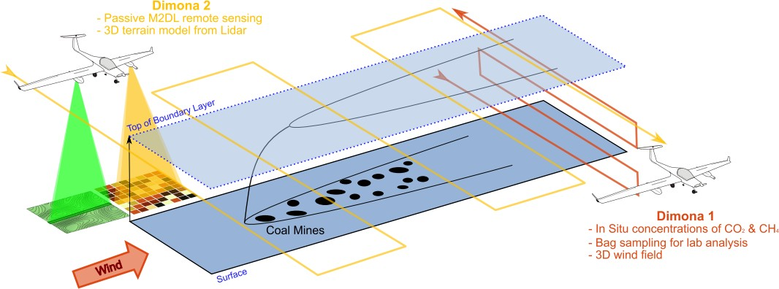
Figure 5: Schematic survey pattern of two aircraft flight strategy to be implemented (to be updated).

In-situ strategy to be added …

For the collection of in-situ data the aircraft will probe gas concentrations and wind in the plume from the lowest allowed flight level up to the PBL at 2-5 altitude layers, depending on plume and meteorology. It will be assured that also background air masses are probed.
For the interpretation of the M2DL concentration data in terms of fluxes, good knowledge of the local wind field is needed. Therefore, air masses probed by M2DL needs to also be probed by turbulence probe.

XXX with in-situ sensor

Aircraft
Sensors
Any special conditions for operations?

XXX with hyperspectral sensor for CH4 detection

Aircraft
Sensor
Any special conditions for operations?

Deployment Strategy

What are the foci of the different observation systems?
Which needs to be operated in a coordinated way, which needs to be separated?

Airborne Flight Strategy

Campaign Preparation and Execution

Campaign Preparation

Campaign Execution and Data Acquisition

Campaign Schedule
The following table summarizes the campaign schedule as of August 2023. The main acquisition phase is planned from 6.9.2023 until 5.10.2023. A data acquisition review meeting will be held in the middle of the main acquisition phase, to preliminary conclude on the main phase and assess the need for an extension.

Phase | Dates  (planned) | Location | Purpose
Campaign Preparation
Logistic planning | June/July 2023 | Bremen, Adelaide
Transfer UB equipment to | July/August 2023 | Adelaide
Arrival UB team | 22.8.2023 | Adelaide
Integration of MAMAP2DL into DIMONA | 23.-25.8.2025 | Adelaide | First test flight
Campaign Status Telecon | 25.8.2023 | Adelaide, Zoom | Campaign kick-off
Test flights and campaign planning | 28.8.-30.8.2023 | Adelaide | Test flight if possible earlier
Transfer Readiness Meeting (internal) | 30.8.2023 | Adelaide | Decide on readiness to transfer aircraft and team to the Bowen Basin, status of flight planning
Transfer team and equipment to Middlemount | 1.-4.9.2023 | Adelaide-Middlemount
Transfer DIMONA’s to Middlemount | 1.-4.9.2023 | Adelaide-Middlemount
Test Flight at Middlemount | 5.9.2023 | Middlemount
Acquisition Readiness Meeting (internal) | 6.9.2023 | Middlemount | Decide on data acquisition start (aircraft, sensor, team, weather)
Data Acquisition Phase
Begin Acquisition Phase | 7.9.2023 | Middlemount | First measurement flight
Intermediate Data Acquisition Meeting (with IMEO) | 19.9.2023 | Middlemount, virtual | Intermediate evaluation of data acquisitions so far
IMEO visits Middlemount | 25.9.-29.9.2023 | Middlemount | Stephen Harris in Middlemount, option to have other visitors too
Final data acquisition meeting | 4.10.2023 | Middlemount | Decide on end of data acquisition phase
End of Acquisition Phase | 5.10.2023 | Middlemount
Relocation and Deinstallation
Transfer Team and equipment to Adelaide | 6.-10.10.2023 | Middlemount-Adelaide
Transfer DIMONA’s to Adelaide | 6.-10.10.2023 | Middlemount-Adelaide
Deinstallation and packing for shipment (UB equipment) | 11.-13.10.2023 | Adelaide
Table 4: Overall campaign calendar - example.

Campaign Team

All to add

TEAM
Name | Function | E-Mail for main PoC | Phone for main PoC
Konstantin Gerilowski | Campaign Lead IUP,  M2DL operator
Student 1 | data analysis in-situ
Student 2 | Data analysis remote sensing
Student 3 | Data analyisis, instrument operator (tbc)
Martin Kumm | pilot, flight planning
NN | 2nd pilot, flight planning
Heinrich Bovensmann | Project Lead (Bremen)
Table 5: Campaign team and responsibilities.

Daily Activities (example)
On the late afternoon of the day before each flight, the team will meet, discuss and decide about the optimum target for the next day and the outlook for the next 2-4 days ahead. Most important input is the weather forecast which will be accessed via internet. MAMAP2DL needs clear sky conditions and preferably a neutral to stable boundary layer and calm winds (2 - 8 m/s), it is expected that measurements between 10:00 and 14:00 LT will be performed. The forecasted wind direction and cloud conditions will determine the details and direction of the basic flight patterns of the flights. In case of cloudy conditions, the in-situ aircraft might be used to assess the source strength of selected targets with expected weak emissions.
As a consequence of the forecasted weather conditions in the campaign area, the order of targets may be modified. In case of major modifications, the project team via the campaign coordinator will inform UNEP/IMEO. On the morning of every campaign day, the meteorological forecast will be analysed again before making the final flight decision.
The following table gives a summary of the daily duties during the campaign. This workflow might be adapted as needed during the campaign.

Table 5: Daily campaign schedule.

Campaign baseline selection (example)
The baseline for the campaign activities is established along the following guidelines and assumptions:
- Duration of flight per target area is 2-3 hours plus time from Middlemount to target
- This means normally 1 target area per flight day and maximum of up to 2 target areas per flight day.
- For more distant targets, a maximum of 1 target per flight day is assumed.

Concerning priorities, the following points will be used as guidance:
  - Nearby “easy” targets
  - More distant targets with expected large emissions
  - Interesting areas with unclear emission position and strengths, like degassing sites
  - Nearby complex targets
  - More distant targets with expected low-medium emissions
As there is an ongoing cooperation of IMEO with the mining companies BHP and Anglo American, priority to mines of those companies will be give, when weather permits.
In the beginning of the campaign, survey flights will be performed to get an impression on the activities in the area of interest.
For the selected open-pit mines, air samples from inside the plume will be collected with the bag sampler, for later isotopic analysis.
Also, with a focus on open-pit mines and their internal topography, dedicated laser scanner flights will be performed.
For a few selected strong targets gradient validation flights will be performed, measuring concentrations in-situ and remote sensing at same time and location in and outside a plume, ideally on the scale of satellite data (10-20 km).
The discussion within the team and with IMEO resulted in the planned flights as sketched in the figures below. They will serve as initial starting point for the first campaign week.

Figure 6: Overview of initial schematic flight pattern for the first campaign week (as of end of August 2023) consisting of a mixture of survey, mapping and emission flights.

Quick look processing during campaign (to be adapted)
After each flight, the team will perform a quality check on the raw data, normally on the same day, to determine data quality sufficiency. A quick look data analysis up to concentration maps will be performed on-site within a few days to verify data quality and to decide if the flight can be declared as successful. Criteria are the data quality and the meteorological conditions during the flight. Quick look data will be made available to all campaign participants in the agreed format. Results of the quick look data analysis will be discussed at the Data Acquisition Review two weeks after campaign start.
During measurements, M2DL data will be saved on different solid state disks of the instrument. Correct functioning of the instrument is ensured in-flight by the operator checking the recorded spectra. However, no trace gas information is available immediately in-flight.
Raw data are downloaded post flight and stored on at least two different hard drives at different locations. Quick looks in form of geo-referenced qualitative total column information using a generic radiative transfer model simulation are typically available within a few days at latest, depending on maintenance and calibration work to be conducted at the instrument.
All ARA data will be saved on different solid state flash memories (one in each pod, one in the center, one in the camera, and one in the CH₄-monitor). Only the track data of the moving map are on a hard-disk (which is less safe). It is impossible that data is lost (not written to the media) when the monitoring during the flight indicates that the systems are running. However, it is crucial that, after the flight, the operator can concentrate on a very strict data extraction and saving protocol. The principle is that all data are saved as quickly as possible on at least two additional data storage devices that are kept in different places (in the aircraft, in the personal bag of the operator, and/or in the hotel). As soon as possible, raw data are also transmitted or given to the partners in order to have a decentralized security against any loss. This is not complicated because the typical amount of raw data (without photos) is less than 100 MB per day (zipped).
Once the data are secured and there is time left in the evening, a quick look of data is possible in several stages:
- Are all data there and looking ok?
- Time series or maps of core parameters.
- Forwarding tracks and other data to the partners.
Normally, this is not a problem and a standard procedure. However, as soon as some trouble shooting for the instrumentation, the aircraft or some logistical issues occurs, priorities might lead to minimized quick-looks in order to obtain enough sleep during the campaign.
When it is not possible to take an in-depth look at data at the end of the day when it was measured, this may be done whenever the operator and/or the assistant have time.

Other available data

Satellite Data
TROPOMI data (global data set) is available at University of Bremen and will be processed for early access during the campaign within 2-4 days after sensing.

Wind and topography data
For the interpretation of the data high resolution wind fields from meteorological reanalysis and high resolution topography data from SRTM v2.1 (available at IUP-UB) will be used. For the open pit mines under operation, dedicated topography information will be collected with the topography lidar during the campaign.

References
Borchardt et al., The New Imaging Spectrometer MAMAP2D-Light – First Measurement Results, ATMOS, 22.- 26.11.2021, 2021.
Borchardt et al. 2025..
Krautwurst et al., Methane emissions from a Californian landfill, determined from airborne remote sensing and in- situ measurements, Atmos. Meas. Tech., 10, 3429–3452, 2017.
Krautwurst, S., Gerilowski, K., Borchardt, J., Wildmann, N., Galkowski, M., Swolkien, J., Marshall, J., Fiehn, A., Roiger, A., Ruhtz, T., Gerbig, C., Necki, J., Burrows, J. P., Fix, A., and Bovensmann, H.: Quantification of CH4 coal mining emissions in Upper Silesia by passive airborne remote sensing observations with the Methane Airborne MAPper (MAMAP) instrument during the CO2 and Methane (CoMet) campaign, Atmos. Chem. Phys., 21, 17345- 17371, https://doi.org/10.5194/acp-21-17345-2021, 2021.
Krautwurst et al., Observations of natural and anthropogenic CH4 and CO2 emissions by combined active, passive and in situ airborne measurements during the CoMet 2.0 Arctic mission in Canada 2022, Krautwurst et al. 2025
Krings,.T., K. Gerilowski, M. Buchwitz, J. Hartmann, T. Sachs, J. Erzinger, J. P. Burrows, H. Bovensmann, Quantification of methane emission rates from coal mine ventilation shafts using airborne remote sensing data, Atmos. Meas. Tech., 6, 151-166, doi:10.5194/amt-6-151-2013, 2013.
Krings et al., Airborne remote sensing and in situ measurements of atmospheric CO2 to quantify point source emissions, Atmos. Meas. Tech., 11, 721–739, 2018.

