Deliverable 1.1

Readiness report on sensor fleet
Authors: | XXX (XX)
Date: | XX/XX/2025
Dissemination: | Public
Work package: | 1
Version: | 1

Investigating Methane for Climate Action (IM⁴CA)
Call: HORIZON-CL5-2024-D1-01
Topic: HORIZON-CL5-2022-D1-01-01
Type of action: HORIZON Research and Innovation Actions
Granting authority: European Climate, Infrastructure and Environment Executive Agency
Project starting date: 01/01/2025
Project end date: 31/12/2028
Project duration: 48 months
Contact: Prof. dr. ir. Sander Houweling, Coordinator
Vrije Universiteit Amsterdam, The Netherlands
Document history
Version | Author(s) | Date | Changes
1 | XXXXXXX (XX) | XX/XX/2025 | First draft version
2 | XXXXXXX (XX) | XX/XX/2025 | Revisions following the internal review
Internal review: XXXX (XX), XXXX (XX), XXX (XX)
Table of Contents
List of Figures 1
List of Tables 2
List of Acronyms and Abbreviations 3
Executive Summary 4
Introduction 4
1 Principle of anthropogenic methane emission quantification 5
1.1 Mole fraction measurement 5
1.2 Methane quantification 5
1.3 Inverse model 6
2 Vehicle-based methane measurement 7
2.1 Principle 7
2.2 Intercomparison approach 7
3 Drone-based methane measurement 8
3.1 Principle 8
3.2 Intercomparison approach 8
3.2.1 Field study 9
3.2.2 Control release system design 10
3.2.3 Wind and weather measurements 11
3.2.4 Safety considerations 11
3.2.5 Results 11
4 Aircraft-based methane measurement 12
5 Fixed ground-based methane measurement 12
6 Conclusion and recommendation 12
References 13
Appendix 1 Vehicle platforms for methane measurement-Protocol 14
Appendix 2 Drone platforms for methane-controlled release experiment in Cyprus 14
CYI drone system 14
AGH drone system 16
UU drone system 16
INCAS drone system 16

List of Figures
Figure 1. Schematic figure of a Gaussian plume. The effective stack height He and the crosswind and vertical deviation of the profile are the key parameters of the model (Leelőssy et al., 2014) 6
Figure 2. Controlled methane-release experiment site (A), layout of the USRL runway (B), and schematic illustration of the experimental design and instrumentation (C). 9
Figure 3. Illustration of the methane release setup during the controlled-release experiment 10
Figure 4. Simulated Computational Fluid Dynamics in the study site of controlled methane release experiment 11
Figure S1. UAS platform equipped with sensors for methane and auxiliary measurements (a); Ground-based anemometer 14
Figure S2. USRL Ground control station (a); pre-definition of flight plan and live mole fraction data (b) 15
Figure S3. Satellite map view (a) and 3D view of the of the UAS flight track (b). Projected CH₄ data points are interpolated on the flight plane to calculate the flux (c). Colours indicate the CH₄ mole fraction above background. 16

List of Tables
Aucune entrée de table d'illustration n'a été trouvée.

List of Acronyms and Abbreviations
CH₄ | Methane
O&G | Oil and Gas
ppm  ppb | part per million  part per billion
m | meters

Executive Summary
[To be written at the end
……………………………………………………………………………………………………………………………………………………………………………………………………………………………………………………………………………………………………………………………………………………………………………………………………………………………………………….]

Introduction
Methane is estimated to have a global warming potential of 27 to 30 over 100 years. Approximately 60 % of global methane emissions are attributed to human activities, with roughly one-third of them resulting from the oil and gas (O&G) sector. Methane emissions will have to be mitigated drastically to meet the goals of the Paris agreement, as acknowledged by the European Methane Strategy and the Global Methane Pledge to reduce anthropogenic methane emissions by at least 30% in 2030 compared to 2020. For developing effective policies and mitigation strategies, understanding and quantifying methane emissions is essential.
Although inventory estimates have been widely used to quantify methane emissions, their effectiveness is limited, as they often rely on outdated and generic emission factors. To better quantify methane emissions, top-down or bottom-up approaches can be implemented. Top-down approaches use ambient methane mole fraction measurements from aircraft, tall towers, weather stations, or satellites combined with models to estimate the total methane flux rate at different scales. Bottom-up approaches involve direct measurements of emissions usually at the source or component level, which are then extrapolated to larger scales using statistical methods.
Methane measurement technologies are deployed globally using satellites, aircraft, drones, vehicles, and fixed ground-based systems. Measurements fall into three categories: (1) in-situ mole fraction, (2) active imaging, and (3) passive imaging. In-situ sensors measure local methane mole fractions on various platforms. Active imaging systems use lasers at methane-absorbing wavelengths. Passive imaging relies on backscattered sunlight at methane-absorbing wavelengths, using aircraft, satellites, or fixed cameras. After measuring methane enhancements in the atmosphere, algorithms ranging from physical transport models to artificial intelligence estimate emission rates from gas plumes.
Despite the availability of numerous techniques for measuring methane, the absence of standardized methods poses a challenge for quantifying methane emissions. The standardization process is further challenged by several factors: (a) the distinct characteristics of each emission source—such as spatial and temporal emission pattern, intermittency, emission rate, and associated infrastructure, (b) the differing scales of analysis, ranging from individual sites to regional and national levels, and (c) the specific monitoring tools used, which vary in spatial and temporal coverage as well as accuracy. These complexities require the development of harmonized method to methane measurements.
Accordingly, and to address this challenge, the following deliverable propose a harmonized method that will serve as the foundation for upcoming IM⁴CA anthropogenic methane measurement campaigns (Work Package 1). In addition, the outcomes of this deliverable are also suitable for supporting third-party measurement efforts.

Principle of anthropogenic methane emission quantification

Concentration measurement
The measurement of methane concentration is based on the interaction of methane molecules with light where methane molecule absorbs electromagnetic radiation at specific infrared wavelengths and sensitive sensors detect this absorption. The amount of light absorbed is directly proportional to the methane concentration in the air. The optic laser-based spectroscopy techniques such as Tunable Diode Laser Absorption Spectroscopy (TDLAS), Cavity Ring-Down Spectroscopy (CRDS), Differential Absorption Lidar (DIAL), and Fourier Transform Infrared Spectroscopy (FTIR) are favored in comparison with non-optic techniques in terms of precision and selection for methane measurement.
In top-down approach to estimate methane emissions, the sensors of methane are mounted to either mobile or immobile platforms that are in turn either ground, airborne, or space-based platforms observing the area around methane emission source.

Methane quantification
Quantifying methane emission fluxes requires the continuous sampling of atmospheric winds, coupled to absolute methane mole fraction measurements. Unfortunately, practical limitations usually necessitate trade-offs between the temporal coverage and spatial resolution of measurements. Methane measurement data must typically be interpolated, assimilated or extrapolated, often by making use of models which simulate atmospheric dispersion and transport. The latter refers to the processes that govern how methane, once emitted into the atmosphere, spreads and moves through the air. After release from sources, methane molecules mix with surrounding air masses and are carried by wind patterns across varying distances. Atmospheric turbulence, temperature gradients, and pressure systems all influence how methane disperses vertically and horizontally. This atmospheric dispersion is widely modeled using Gaussian plume model (Figure 1) of the formula Eq 1. The model uses two-dimensional normal distribution to estimate the methane mole fraction in air. The normal distributions are centered around the main plume axis, which itself is determined by the effective source height, wind speed and wind direction at the effective source height. The standard deviations of the normal distributions are called horizontal and vertical dispersion parameters. These parameters depend on the distance from the source and the atmospheric stability class.
$$C\left(x,y,z\right)= \frac{Q}{2πuσ_{y}σ_{z}}\exp\left(-\frac{y^{2}}{2σ_{y}^{2}}\right)*\left[exp\left(-\frac{{\left(z-h\right)}^{2}}{2σ_{z}^{2}}\right)+\exp\left(-\frac{{\left(z+h\right)}^{2}}{2σ_{z}^{2}}\right)\right]$$ | Eq 1
where C is the mole fraction enhancement above background value, u is the wind speed, where the main wind direction defines the coordinate x. y is the horizontal distance perpendicular to the wind direction, z is the vertical direction, H is the effective height of the plume, and $σ_{y}$ and $σ_{z}$are the width parameters of the normal distributions in y and z directions, the simplest way to estimate these dispersion coefficients is to use the Pasquill–Gifford stability classes and their associated dispersion tables (Ref).

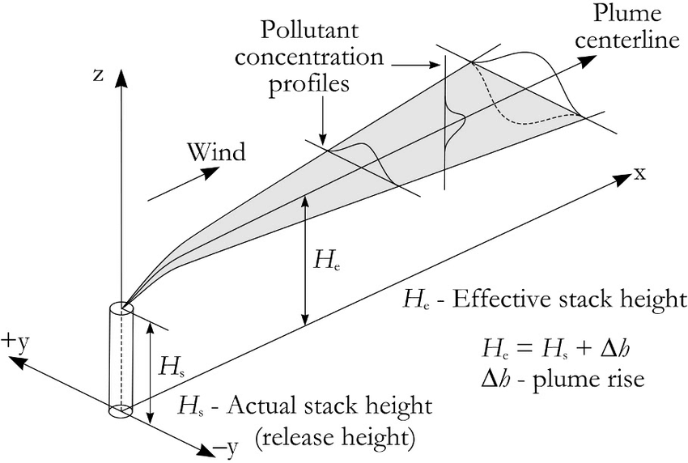
Figure 1. Schematic figure of a Gaussian plume. The effective stack height He and the crosswind and vertical deviation of the profile are the key parameters of the model (Leelőssy et al., 2014)

Inverse model
Because atmospheric mole fraction measurements are combined with modeled atmospheric transport to infer emissions, the resulting top-down estimates of regional- to global-scale emissions are referred to as inverse models. An example of such an inverse approach is the use of the inverted form of the Gaussian plume equation to estimate methane emission rates (Q) from observed downwind mole fractions. Measurements for within-site estimates are taken closer to sources, producing stronger but more variable signals. In contrast, whole-site approaches use measurements farther away, where plumes are more uniform but weaker and harder to distinguish from background levels. The key challenge is to find an optimal balance between proximity (signal strength and heterogeneity) and distance (signal weakness and homogeneity) that minimizes overall uncertainty in total emission estimates.

Vehicle-based methane measurement

Principle
Ground-based vehicle measurement offers effective temporal and spatial coverage of methane plumes. It involves mounting a methane gas analyzer on a road-going vehicle that is driven around a potential methane source. The inlet of the measurement device is connected to the outside air, allowing it to continuously sample atmospheric methane mole fractions. As the vehicle moves around the source, the analyzer records methane levels in real time, enabling detection and mapping of methane emissions.
For the vehicle-based measurements of methane emissions, transects are performed downwind of the investigated source. Transect locations are chosen to be ideally perpendicular to the wind direction and at an appropriate distance so that the entirety of the emitted plume can be captured, but that at the same time, the methane excess is high enough to be relevant to the analysis. The road infrastructure is usually the main limiting factor for the choice of the transect path, but the minimum distance to the source should be 20 m at least, and more if the source is elevated compared to the ground. Once an appropriate location is found, transects are repeated at low speed (< 30 km/h) ideally until at least 10 suitable measurements can be done. Wind conditions should be stable and measured on site or extracted from nearby meteorological station. Vehicle-based methane measurement systems can be equipped with a variety of sensor technologies, each offering different levels of precision and sensitivity. Near-infrared, mid-infrared, and cavity-based laser absorption systems are commonly used. These technologies provide high accuracy for detecting methane mole fractions in real time with the recommended frequency of data recording (10 HZ), response time (10 HZ), and measuring range between (1 ppb-100 ppm). Non-dispersive infrared (NDIR) sensors, on the other hand, are more cost-effective but offer lower precision, making them less suitable for quantifying small methane fluxes.
All quantification methods require a robust background calculation. Depending on the site investigated, either an upwind transect will be performed, or the lower 20-th percentile of the downwind measurements is used, depending on the possibilities.
In Appendix 1 , we provide a detailed description on the commonly used protocol to measure methane emissions using vehicle-based platforms.

Intercomparison approach
[……TADI………………………………………………………………………………………………………………………………………………………………………………………………………………………………………………………………………………………………………………………………………………………………………………………………………………………………………………………………………………………………………..]

Drone-based methane measurement

Principle
Unmanned Aerial Vehicles (UAVs), often referred to as drones, provide a versatile platform for monitoring methane mole fractions both in situ and through remote sensing. These platforms can measure methane in two primary ways: by collecting air samples during flight around a source for subsequent ground-based analysis or by using onboard sensors for continuous, real-time monitoring. Drones are particularly effective for monitoring methane emissions at local scales (typically less than 1 km), making them ideal for tracking emissions from small facilities or specific sources like landfills, industrial sites, or agricultural operations.
Similar to the vehicle-based methane measurements described, the same sensor technologies (section 2.1) can be mounted on drone platforms. In addition, other techniques such as thermal imaging and solid-state sensors are sometimes employed; however, these methods often face limitations in sensitivity and accuracy, which makes them less suitable for precise flux quantification.
The used drones for methane measurement come in a range of sizes and weights, from small drones weighing around 100 g to larger platforms that can carry payloads of up to 20 kg. These drones can be powered by either batteries or fuel, depending on the operational needs and the duration of the flight. In terms of supporting sensors, wind sensors are recommended for more accurate measurement of wind speed and direction, with the data sampling rate synchronized to match that of the methane sensors. To minimize interference from the drone’s propellers, wind sensors should be carefully mounted at locations sufficiently distant from the propeller airflow. Additionally, GPS integration is essential for recording the precise location of the measurements (latitude, altitude, and longitude), which helps in methane quantification and inverse modeling efforts. By combining these features, drones can provide reliable, real-time data for mapping methane emissions and supporting environmental monitoring efforts.

Intercomparison approach
The aim of WP1 in IM⁴CA is to measure methane emissions from various industrial and agricultural sources across different locations in Europe by different research groups. Harmonizing the drone-based measurement protocol is crucial to ensures that all parties involved follow consistent procedures. This is essential for generating comparable and reliable results. This consistency not only facilitates meaningful comparisons of methane emissions but also enables the fine-tuning of techniques to enhance the accuracy of the reported methane fluxes.
One of the key harmonization approaches involves the intercomparison of different drone-based methane measurement platforms through a controlled-release experiment simulating a point-source methane emission. During this experiment, multiple drone systems will be evaluated and compared in terms of their design characteristics, operational procedures, and methane quantification methodologies.
The controlled methane release experiment is scheduled to take place in December 2025 at the Unmanned Systems Research Laboratory (USRL) runway located in Orounda, Cyprus. USRL is a part of the Climate and Atmosphere Research Center (CARE-C) of The Cyprus Institute (CYI) and offers on-site facilities and related infrastructure for research, development, and testing of technologies related to Drones.
In this approach, the participants measuring the methane emissions will use their own drone platforms described in Appendix 2, on which their measuring instrument will be mounted. Emissions rates from the controlled release are unknown to participants.

Field study
Orounda (Figure 2A) is a rural area in the central plain of Cyprus, characterized by flat terrain, sparse population, and predominantly agricultural land, mainly used for vegetable cultivation. The USRL located on a plateau between Orounda and Peristerona, about 40 km from Nicosia, the airfield features a main runway (200 m × 12 m) and a secondary runway (90 m × 6 m). The USRL infrastructure, includes a private paved runway with a hangar and dedicated airspace as shown in Figure 2B-C.
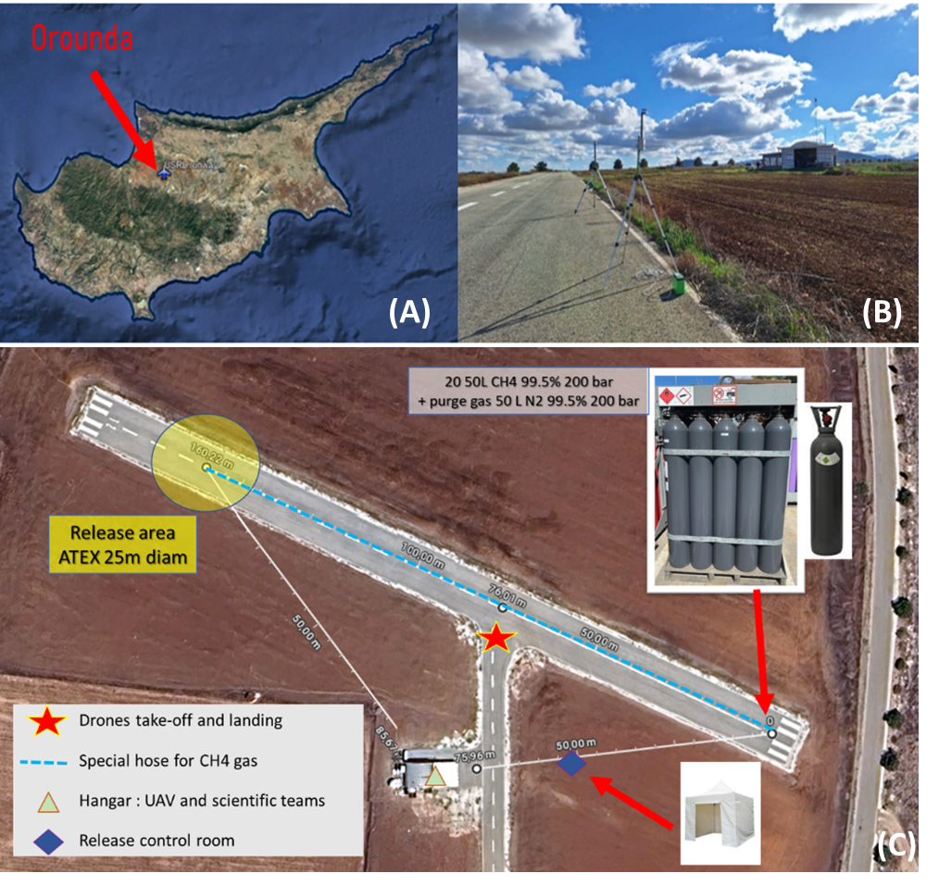
Figure 2. Controlled methane-release experiment site (A), layout of the USRL runway (B), and schematic illustration of the experimental design and instrumentation (C).

Control release system design
High purity methane gas will be released from a bundle (20 bottles of 50 litres connected to each other’s, filled by 99.5% of methane at 200 bars), which will be installed at one end of the runway (Figure 2B). The aerial view of the Figure 2C shows how the equipment will be arranged. A mass flow controller (MFC) will be used to meter and regulate the release of methane during the duration of the experiment. A specific hose for transporting methane gas is selected with an internal diameter of 25 mm and OMEGA electrical conductivity. To ensure that the gas will be at ambient temperature and that the release point is far away from any equipment (for safety reasons), the total length of the hose is 180 m. Safety conditions were considered by incorporating a suitable gas regulator, a flashback arrestor (methane bundle explosion protection), a pressure relief valve (to prevent overpressure in the gas line), and a line cleaning system (to prevent methane residues). The gas outlet will be at 2 m above ground and located on a tripod.
The area surrounding the release point will be designated as an Atmosphères Explosives (ATEX) zone. Careful considerations are planned to avoid the presence of an ignition source that can cause combustion or explosion since methane is classified as an explosive gas with an explosive range in air between about 4% and 17% by volume. Figure 3 illustrates the setup of the methane release system.
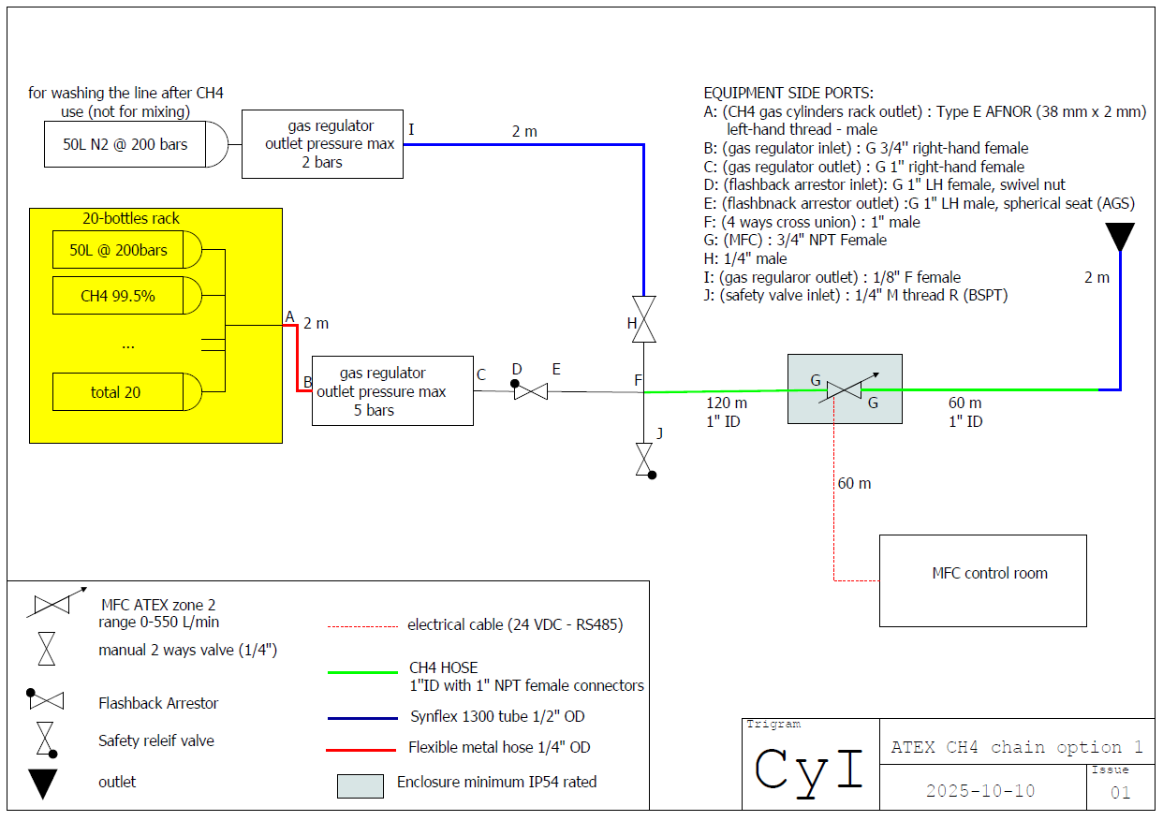
Figure 3. Illustration of the methane release setup during the controlled-release experiment

Wind and weather measurements
Wind and weather measurements play a key role both during operations and in post-processing. All collected data will be accessible and shared with participants. An integrated weather sensor and two 3D sonic anemometers will be used. The compact weather sensor, installed on a 13-m mast above the hangar, combines ultrasonic and radar technologies to measure 2D wind, precipitation, solar radiation, and key atmospheric parameters such as temperature, humidity, and pressure. The two 3D sonic anemometers will be placed in unobstructed areas near the runway and CH₄ release point, at heights of 8 m and 2 m on stable tripods. During the experiment, real-time data will be displayed in the hangar, supporting participants in flight planning and organizers in flight authorization.

Safety considerations
In addition to ensuring that the equipment used in the experiment complies with the ATEX conditions, zoning and safety instructions will be applied in accordance with the instructions of the risk assessment that was conducted by the Health and Safety Officer of the Cyprus Institute. Computational Fluid Dynamics (CFD) simulation was also performed to validate the experimental setup and to assess and verify the ATEX ground limits area (Figure 4). The model numerically resolves the flow field and dispersion patterns by solving the Navier-Stokes equations over a discretized domain. By the known concentration of the source (g.m⁻³) then we apply the % factor to get the real mole fraction in Parts Per Million (PPM).
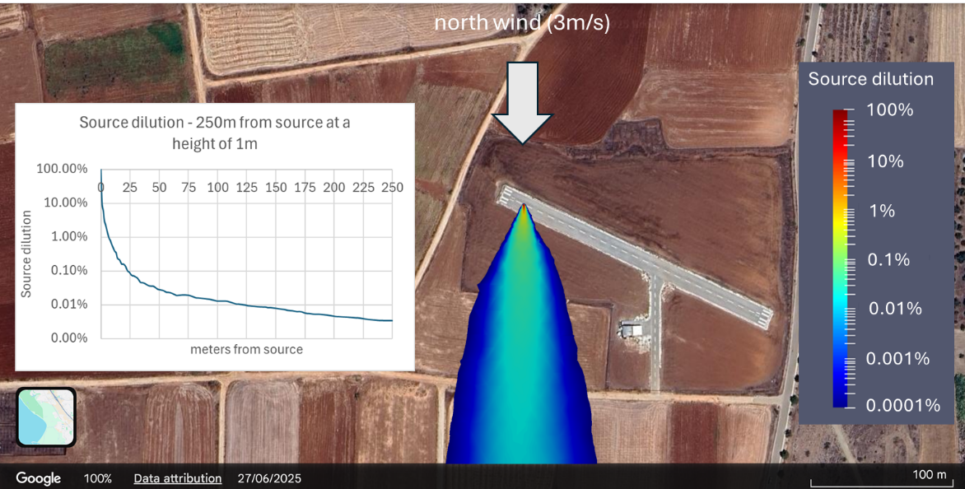
Figure 4. Simulated Computational Fluid Dynamics in the study site of controlled methane release experiment

Results
The results from the methane controlled-release experiment, including the comparative performance of different drones’ platforms and methane quantification methods deployed by multiple participating teams, will be presented in the upcoming project deliverables. These results are expected to enable more reliable comparisons of methane fluxes across different sites by accounting for potential biases arising from differences in measurement tools and methodologies.

Aircraft-based methane measurement
[……………………………………………………………………………………………………………………………………………………………………………………………………………………………………………………………………………………………………………………………………………………………………………………………………………………………………………………………………………………………………………..]

Fixed ground-based methane measurement
[……………………………………………………………………………………………………………………………………………………………………………………………………………………………………………………………………………………………………………………………………………………………………………………………………………………………………………………………………………………………………………..]

Conclusion and recommendation
[To be written at the end
……………………………………………………………………………………………………………………………………………………………………………………………………………………………………………………………………………………………………………………………………………………………………………………………………………………………………………….]

References
Leelőssy, Á., Molnár, F., Izsák, F., Havasi, Á., Lagzi, I., & Mészáros, R. (2014). Dispersion modeling of air pollutants in the atmosphere: A review. Open Geosciences, 6(3). https://doi.org/10.2478/s13533-012-0188-6

Appendix 1 Vehicle platforms for methane measurement-Protocol
[……………………………………………………………………………………………………………………………………………………………………………………………………………………………………………………………………………………………………………………………………………………………………………………………………………………………………………………………………………………………………………..]

Appendix 2 Drone platforms for methane-controlled release experiment in Cyprus

CYI drone system
The Unmanned Aerial System (UAS) used by The Cyprus Institute (CyI) is custom-made in-house and made of composite materials to achieve a lighter “heavy lifter” platform.
An array of instruments for the measurement of CH₄ and meteorological parameters are installed on-board the UAS. CH₄ mole fraction measurements are made with the ABB LGR-ICOS™ UAV-Microportable Analyzer, GLA133-GGA Model sampling air at a rate of 10 Hz (~3kg, accuracy: +/- 1%, instrument CH₄ precision: 0.9 ppb (1 s) / 0.3 ppb (10 s), Flow time response = 2.5 Hz (1/e)). The 3D wind vector component (Ux, Uy, Uz) at 10 Hz is derived from a LI-550P TriSonica™ Mini anemometer mounted on a carbon fibre pole approximately in the centre of the UAS and 1m higher than the level of the propellers to avoid air turbulence and mixing (Figure S1a).
The same model of anemometer is also running on ground mounted on a steady tripod at a height of approximately 3m above ground level (Figure S1b).
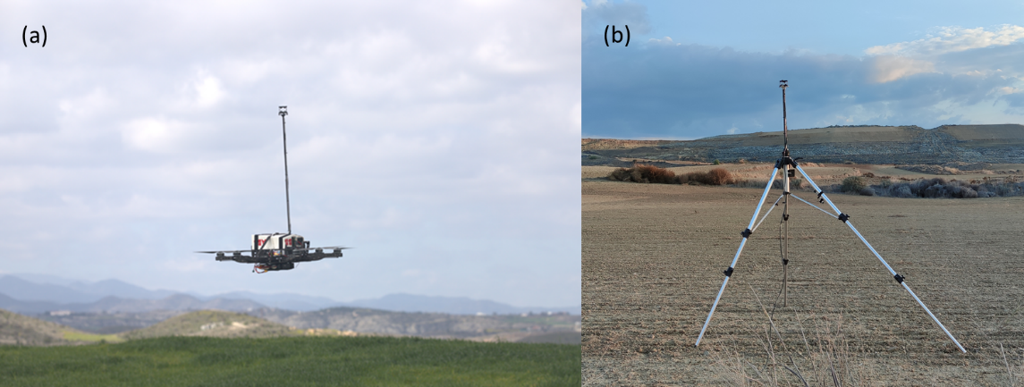
Figure S1. UAS platform equipped with sensors for methane and auxiliary measurements (a); Ground-based anemometer
In the case of a remote area with no power source, we use a mobile ground control station (Figure S2a) equipped with a fuel generator and technology that enables a reliable communication link with the UAS for long-range missions and stable data streaming (Figure S2b). The UAS flight plan is predefined in the software to follow horizontal transects downwind of the emission source at constant altitudes, ranging from low to high, and oriented perpendicular to the wind direction, creating what are known as curtain measurements.
Transects are typically up to 1 km long, depending on the terrain, wind variability, source distribution, and downwind distance. For higher measurement resolution, the horizontal velocity of the UAS is kept low, ranging from 5 to 15 km/h, while the total flight duration varies between 20 and 27 minutes depending on the battery set used. Each set of batteries supports a single flight, and currently eight sets are available. With charged batteries, approximately five minutes are required between consecutive flights to replace the batteries and prepare the system for take-off. Once all batteries are used, a full recharge cycle takes about three hours.
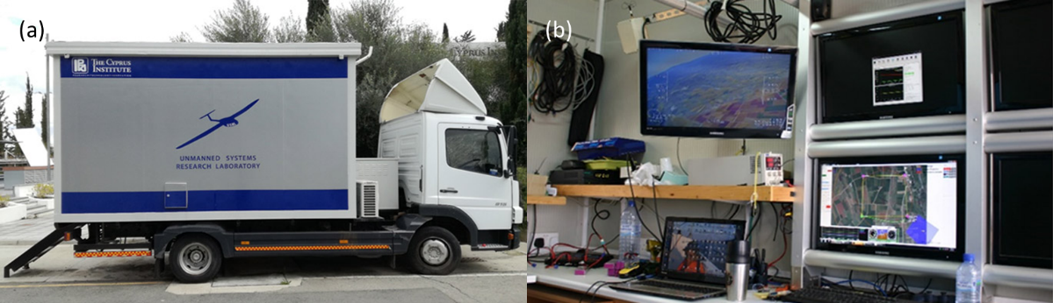
Figure S2. USRL Ground control station (a); pre-definition of flight plan and live mole fraction data (b)
To estimate the emission fluxes, we employ the mass balance box method that considers the conservation of CH₄ mass within a system (or volume), usually conceptualized as a box. Emission ﬂux is quantiﬁed as demonstrated by:

$$F=\int_{z1}^{z2}{\int_{x1}^{x2}{({[CH}_{4}]-\left[{{CH}_{4}]}_{b}\right)U_{⊥}dxdz}}$$ | Eq S. 1
where F is the sum of ${CH}_{4}$ emission ﬂuxes, (${[CH}_{4}]-\left[{{CH}_{4}]}_{b}\right)$ is the ${CH}_{4}$ enhancement, U⊥ is the wind speed, perpendicular to the vertical plane upon which the plume is projected. These values are integrated over both the horizontal extent (between x1 and x2), and the vertical extent (between z1 and z2), of the emission plume (Trainer et al., 1995). We consider ${CH}_{4}$ enhancement as the 5th percentile of the CH₄ mole fractions measured for the duration of the flight.
Figure S3 shows a typical example of a UAS flight (Figure S3a-b) and steps towards emission quantification of Kotsiatis Landfill in Cyprus. Following the projection of data set on the flight plane, we calculate y as the distance travelled by the UAS. Then we interpolate the data on the plane (Figure S3c) and calculate the flux using Eq S. 1.
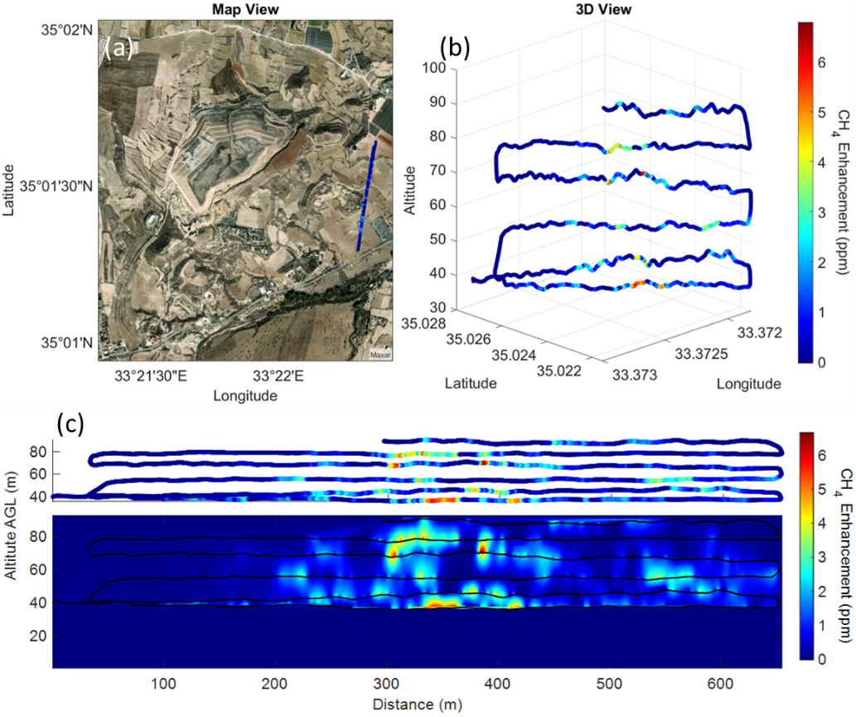
Figure S3. Satellite map view (a) and 3D view of the of the UAS flight track (b). Projected CH₄ data points are interpolated on the flight plane to calculate the flux (c). Colours indicate the CH₄ mole fraction above background.

AGH drone system
[……………………………………………………………………………………………………………………………………………………………………………………………………………………………………………………………………………………………………………………………………………………………………………………………………………………………………………………………………………………………………………..]

UU drone system
[……………………………………………………………………………………………………………………………………………………………………………………………………………………………………………………………………………………………………………………………………………………………………………………………………………………………………………………………………………………………………………..]

INCAS drone system
[……………………………………………………………………………………………………………………………………………………………………………………………………………………………………………………………………………………………………………………………………………………………………………………………………………………………………………………………………………………………………………..]

