The Music360 Project

Assessing the True Value of Music

https://music-360.eu/
White paper
Draft 9th July 2024
Music360 focusses on the value of background music for all stakeholders: music creators, music users and policy makers. Our goals are (1) to measure the value that background music brings to music users, including venues such as shops, bars, restaurants, shopping malls, but also hospitals; (2) to provide a one-stop shop for musicians for information about remuneration for authors- and neighbouring rights based on this usage; (3) to provide aggregated insights via our platform to various stakeholders, such as policy makers.

Background music

Background music is not just ambiance. For venues such as shops, bars, and restaurants it is a crucial factor in creating value. It improves customer experience, defines brand identity, improves employee experience and drives revenue. Music may contribute value in unexpected ways, such as when music is used to assist the healing process in hospitals.
When companies use music in public, and when radio & television stations play background music to the public, they are obliged to pay a license fee to the rightsholders of the intellectual property, i.e. the creators. Creators are the composers and lyricists of the work (who have author rights) and the performers and record producers who created a recording of the work (who have neighboring rights). Creators may delegate the management of their IP rights to others, e.g.to publishers or to agents.
License fee collection is a fair exchange, as venues create value with background music and the music creators receive a fair remuneration for this. License fees for background music are collected by national Collective Management Organizations (CMOs), when authors- and neighboring rights are incorporated in national legislation. National legislation and implementation of collection and distribution can differ per country. For example, CMOs may license on behalf of and distribute towards all right owners and for all rights, or a towards subset of rightsholders or for a subset of rights (authors, neighbouring).
CMOs often use reference playlists based on television and radio broadcasts and data from commercial background music providers to calculate the remuneration to which a right holder is entitled. CMOs collect nationally, but distribute globally, by transferring remuneration to the rightsholder via the CMO of which the rightsholder is a direct member (i.e. the CMO is mandated to collect on behalf of the right holder in that specific territory). Details on the actual use of background music on which distribution is exchanged is often not transferred and therefore not available for the rightsholder. We aim to further improve transparency and distribution of remuneration of background music to rightsholders by measuring the value of music more granularly and by providing a single portal where the rightsholder can see the collections and the actual usage for both authors- and neighbouring rights from all territories. We also aim to provide aggregated insights to relevant stakeholders such as policy makers.

Our goals

Our first goal is to create a transparent distribution mechanism of neighboring and author rights based on the actual use of music. To this end, we will use audio recognition technology that can measure which track is being played as background music when and where. In addition, we will create an infrastructure to share data about background music across CMOs in Europe, which will provide transparency about their music use to musicians.

Our second goal is to develop a method to value music, such that it can be used to motivate a fair compensation for the use of music. We will develop this method by measuring the contribution of background music to customer experience, employee experience, and revenue of venues. Data collected in experiments is confidential, but the conceptual framework and experimental method will be published. Our experiments will also clarify the value of music for the investigated venues.

Our third goal is to make aggregate information about the value of music available widely and transparently, respecting confidentiality requirements. For example, policy makers often lack insight into the effect of new legislation for both music creators and users. Policy makers at the national and EU level need more data too, as the importance of cultural heritage at the local level is not measured. Also, during the Covid-19 pandemic almost all venues closed and royalties from background music significantly dropped. Without data about which music is created, distributed, or used where, policy makers were in the dark about what the impact of this on musical heritage was.

Our Solution

The solution we are developing consists of a conceptual framework to measure the value of music and a corresponding software platform to provide insight into the value of music for artists and venues.

Conceptual framework to measure the value of music

The conceptual framework consists of definitions of monetary and non-monetary value of music, recommendations for measuring them, and experiment protocols to measure the impact of music on the monetary and non-monetary business goals of venues.
The monetary value of music consists of its impact on the revenue of a venue. We do experiments to measure the monetary impact of music by identifying the music played in a venue and correlating this with changes in revenue. We also provide research designs that allows experimenters to hypotheses about causality between the kind of music played and factors such as revenue, and customer & employee satisfaction.
The non-monetary impact of music consists of its impact on social and cultural aspects of the listeners. We investigate the impact on the healing process in hospitals.
The conceptual framework is currently tested in a set of real-world experiments performed by the CMOs in the project.

Platform to provide insight into the value of music

The platform will support music users; e.g. venues, to help use music in an effective way and provide information to authors, performers, producers, decision makers, and industry observers. Music users can use marketing researchers, academic researchers, CMOs, and others to support them in their investigation on the value of music. Authors and performers and other IP holders such as producers receive information about when and where their songs are played. Examples of decision makers and industry observers are policy makers, journalists and other stakeholders interested in the music ecosystem.
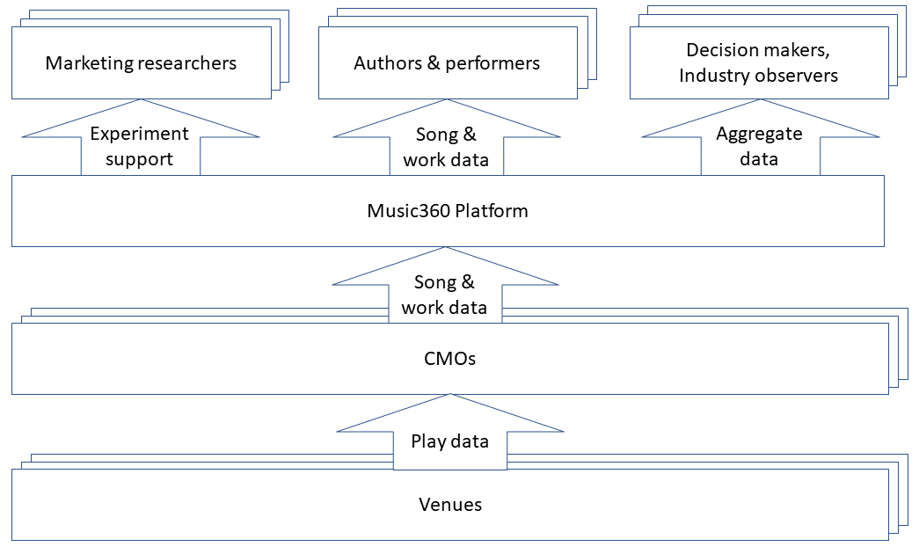
To build the platform, we are designing a federated database architecture that will collect and integrate playlist data from different CMOs in a secure way, respecting confidentiality requirements on the data. Using techniques from secure multiparty computing, we are able to compute aggregate data without revealing secrets.
Authors (and their publishers), performers, and producers registered with a CMO will be able to use the Music360 platform. By using the platform we are able to, for the first time, relate and integrate data about works (authors rights) and recordings (neighbouring rights) maintained by different CMOs. This relationship is currently lacking in data sets about music.
We will test the platform with stakeholders from the music industry.
In addition to the software platform, we are developing a business model and governance structure that will allow the platform to sustain itself after Music360 is finished. The business model will define the revenue and expense streams of the platform, and the conditions under which CMOs and their members can use the platform. The governance model will define ownership and decision rights about the platform.

More information

Public deliverables, news, blog posts and other dissemination material are available from our web site https://music-360.eu/. For more information, please contact contact@music-360.eu.

Acknowledgment
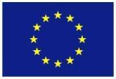
The project Music360 has received funding from the European Union’s Horizon Europe research and innovation programme under grant agreement No 101094872.
The opinions expressed in this document reflect only the author’s view and in no way reflect the European Commission’s opinions. The European Commission is not responsible for any use that may be made of the information it contains.

