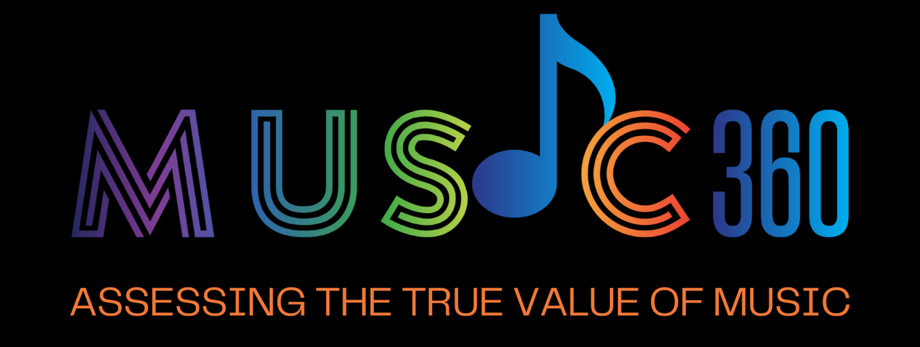

POLICY BRIEF #1
May 2024

INTRODUCTION

Since 2017, the online music streaming economy has become the largest source of revenue for the music industry. While this evolution started slowly, it accelerated during the COVID pandemic to represent 67,3% of the global recorded music revenues by 2023 (IFPI Global Music Report 2024).

Despite the enormous macro-economic boost for the industry, the shift from analogue to digital has pushed the debate about fair remuneration of musicians and the value of music to the fore. Providing access to the world’s catalogue for 9,99€ a month has proven not to be a sustainable business method to provide the artists behind this music with a proper remuneration. The recent increase to €10.99 has made no meaningful difference and in real terms the cost of a subscription has in fact declined since the advent of streaming. This pricing strategy has added to a general devaluation of the value of music, putting other sources of revenue equally under pressure.

Concerns regarding the value of music are not limited to the business model behind streaming only. They arise without a doubt regarding other forms of exploitation that are a source of income for musicians. One such source is background music, essential to the economic existence of musicians.

Background music isn't just ambiance. Background music played in shops, bars, restaurants and other venues contributes to their revenue, increases the well-being of customers, enhances brand identity and ultimately is an important source of revenue for the artist that makes the music. Background music contributes significantly to their professional income, frequently more than streaming platforms.
The MUSIC 360° project aims at generating information about the usage of background music and providing a model to conceptualise and measure the economic and societal value of music. The platform developed will collect data at a fine-grained level through five national Living Labs and a European one and make it available to different stakeholders*.

Providing quantitative, qualitative, and statistical analyses at national and EU levels will enable assessment of the economic and societal value of music in order to develop a competitive, fair, and sustainable European music ecosystem.
* Stakeholders are researchers (academia), professional users of background music (private and public sector), the right holders (CMOs and musicians), and policy makers (public institutions such as the EC)
KEY FINDINGS


At the core of the MUSIC 360° project are the five living labs where precise music usage data is collected in venues by installing audio recognition devices equipped with music fingerprinting technology. This music fingerprinting is followed by data matching and metadata pairing and data enrichment allowing to measure the impact of background music on revenue and measure aspects of social, cultural and therapeutical value.

- The Finnish , Irish and Dutch labs investigate the effect of music on staff and customer emotions in differing venues, each for a specific type of user.
- The Spanish lab explores the cultural and sociatal values of music.
- The Portuguese lab concentrates on the fair distribution of revenues based on detailed music usage data.

With the labs set up and collecting, creating and comparing data, two findings are key.

- At the level of the right holders there is a variety of players – authors, composers, performers, producers - each with their own specific type of right, their own terminology and their own organisation with their own licensing practices. The lack of harmonisation of regulations surrounding background music throughout the EU is a challenge to the comparison of acquired data and the development of an accurate ecosystem design.

- Data on the actual value of music and the precise usage is created. For what concerns the data on the actual value of music this is new and previously unknown. For what concerns data on the actual music usage, a large amount of data exists, yet remains unavailable for the research. Digital music services are increasingly becoming a primary source used for background music purposes. While fingerprinting techniques are accurately tracking the music played within certain timeframes, the suppliers of the music services used, possess the same data, covering all timeframes, but do not make it available.

PRELIMINARY POLICY RECOMMENDATIONS

The creation of a level playing field and access to data is key for the effectiveness of the ecosystem design and the development of a competitive, fair, and sustainable European music ecosystem.

- Awareness of the cultural and societal value of music must be increased.
- There is a need for harmonisation of the legal provisions that the different types of rightholders in the music sector are given.
- There is a need for an EU wide policy on the unlocking of data created but retained by digital music service providers.

PROJECT IDENTITY

FUNDING SCHEME: Horizon Europe

PROJECT NAME: MUSIC 360°

CONSORTIUM: The MUSIC360° consortium consists of four Collective Management Organisations (CMOs): SENA and BUMA (Amsterdam, the Netherlands), GDA (Lisbon, Portugal), and IMRO (Dublin, Ireland) as well as the European Association of Performer CMO’s (AEPO-ARTIS), two research universities: Vrije Universiteit Amsterdam and Universitat Politécnica de Valencia, a fingerprinting company: BMAT (Barcelona, Spain) and a company on ecosystem design: The Value Engineers (London, UK).

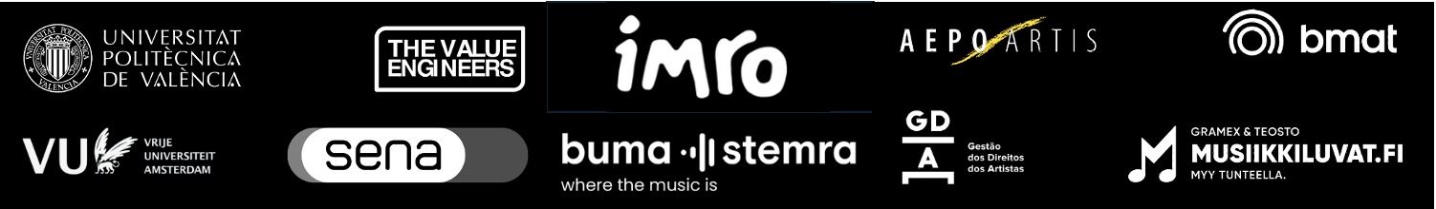

Coordinators: Jaap Gordijn, VU, Amsterdam, Netherlands: j.gordijn@@vu.nl
and Roel Wieringa, TVE, Amsterdam, Netherlands: roel@thevalueengineers.nl

Project lead: Kohestani Lima: l.kohestani@vu.nl

Website : https://music-360.eu

