Music360
A 360 DEGREES PERSPECTIVE ON THE VALUE OF MUSIC


 | Disclaimer  The Music360 project has received funding from the European Union’s Horizon Europe research and innovation action under grant agreement number 101094872.
The opinions expressed in this document reflects only the author`s view and in no way reflect the European Commission’s opinions. The European Commission is not responsible for any use that may be made of the information it contains
Deliverable 1.1
< A framework to quantify and qualify the value of music – version 1 >

Project Title | 360 DEGREES PERSPECTIVE ON THE VALUE OF MUSIC
Project Number | 101094872
Project Start-End Date | 01/03/2023 - /1/03/2026
Work Package | WP1
Deliverable | D1.1 A framework to quantify and qualify the value of music – version 1
Status | <draft_v1>
Date of this version | 05/01/2024
Due Date | 07/01/2024
Deadline for comments | 15/01/2024
Submitted | 25/01/2024
Dissemination Level | PUBLIC
Deliverable Responsible | UPV
Author(s) | B. de Miguel Molina | UPV
Author(s) | M. de Miguel Molina | UPV
Author(s) | D. Catalá Pérez | UPV
Author(s) | C. Carrascosa | UPV
Author(s) | V. Pillay | VU
Author(s) | G. Giachetti | UPV
Author(s) | O. Pastor | UPV
Author(s) | P. Verlegh | VU
Author(s) | I.J.C. Leijen | VU
Reviewer(s) | J. Gordijn | VU
 | R.J. Wieringa | TVE
 | L. Ogawa | GTM
 | Piia Moore | GTM

<update table of contents before you release the document>
Contents
Figures 4
Tables 4
Introduction 5
The concept of value 5
Objectives of this deliverable 5
Structure of this document 5
Dimensions to measure the value of music 7
Recorded vs live music 7
Outdoor vs indoor music venues 7
Background vs foreground music 8
Types of values in music 8
Types of values from the Total Economic Value approach 8
Types of values from the Theory of Consumption Values 9
Types of value from the literature about music 10
Summary of types of values 12
Stakeholders: value, for whom? 14
Measuring Cultural Value of music 16
Measuring Social Value of music 17
Measuring Therapeutic Value of music 18
Measuring Behavioural and Emotional Value of music 20
Measuring Economic Value of music 23
Summary of the framework 25
The Music Value Matrix 26
The four groups in the matrix. Dimensions from the literature 26
Classifying cases through the Music Value Matrix 31
Conclusions 33
Bibliography 34

Figures

Figure 1. Music value chain 14
Figure 2. Affective, behavioural and economic effects of background music on customers and employees in a retail setting 24
Figure 3. Research questions proposed 25
Figure 4. Music Value Matrix, version 1 26
Figure 5. Music, value, and other keywords from the literature 27
Figure 6. Music Value Matrix, version 2 31

Tables

Table 1. Values in TEV applied to music events 9
Table 2. Values in the Theory of Consumption Values 9
Table 3. Values of music by Levinson 10
Table 4. Main categories of values according to literature 12
Table 5. Cultural value of music 16
Table 6. Social value of music 17
Table 7. Therapeutic value of music. Values and descriptions 18
Table 8. Therapeutic value of music. Values, pathologies and benefits from music 19
Table 9. Values by stakeholder 25
Table 10. Dimensions from the literature and group in the matrix 30
Table 11. Values by group found in the literature 32

Introduction
This section presents the approach to measuring value in Music360, the objectives set according to the project proposal, and the structure of the document.

The concept of value
Value represents, from a business viewpoint, the utility a buyer receives from an offering and its features (Meehan et al., 2011). This utility can be economic and intangible, the former represents the price/value for money (Sweeney & Soutar, 2001), while the latter is individualistic in nature and, thus, more customers’ needs must be considered to fix a price and value proposition able to capture value (Meehan et al., 2011; Osterwalder & Pigneur, 2010).

Objectives of this deliverable
The description of D1 in the project’s proposal indicates that it will involve a conceptual framework:
- To measure the monetary and non-monetary value of music,
- in a quantitative and qualitative way,
- firmly founded in economic and social theory,
- that be multi-stakeholder: it will define the value of music for various stakeholders such as creative entities, music user, and policy makers,
- Also, will include the methods and techniques to measure the various rubrics.
Therefore, the general objective and the specific objectives of deliverable D1 have been set as follows:
The general objective is to present the conceptual framework defined in the project Music360 to measure the monetary and non-monetary value of music.
To reach the general objective, four specific objectives are set as follows:
O1. To analyse the literature related to measuring value both in a general sense and focused on music.
O2. To develop a framework supported by the literature review which includes the types of values to involve and scales to measure these values.
O3. To organise the cases analysed in the literature in a multidimensional model which involves values, venues, environment, and stakeholders.
O4. To connect the multidimensional model with the living labs proposed in the WP6.

Structure of this document
This document is organised into eleven sections. After this introduction section, the second section comprises a review of the dimensions of music that appear in the literature, including the types of values. Section 3 refers to stakeholders analysed by previous studies, while sections 4 to 8 focus on each type of value and the main ideas in the literature related to them. Section 9 centres on the framework proposed in this D1, which connects customers’ values with outputs such as customers’ behaviour and performance of companies in the music ecosystem. Section 10 presents the Music Value Matrix, our matrix that connects dimensions to organise cases from the literature review into four groups. This matrix and the framework will be a support for living labs selection in WP6. Finally, Section 11 presents the main conclusions of the deliverable.

Dimensions to measure the value of music
Analysing the value of music requires to consider all the dimensions that might be involved in such analysis, which would include the environment where the music is played, the technology, the venue, if music is the main purpose of the venue or a secondary element, and the values of music by stakeholder. Taking into account that music is a multidimensional phenomenon, it is important to recognize that several of these dimensions are intimately linked to various music values. The next sections explore these dimensions.

Recorded vs live music
From the perspective of the music industry, which is the focus of interest of the Music360 project, there are two fundamental dimensions linked to the production and distribution of music that Pizzolitto (2023) explains as follow:
- the production and distribution of recorded music through physical and digital support networks, as guided by record companies; and
- the production and distribution of live music, which is controlled by world-famous artists but is characterized by many minor professional musicians, sound technicians, and other workers.
Related to this, a systematic literature review of the most recent papers discussing the numerous connections between music, business, and management (Pizzolitto, 2023) states that at present there are, among others, two main research themes in the field (that are related to the way in which music can be valuated):
- Digitally revolution and music industry: have things changed?
- Live music events and performance: a renovated and segmented phenomenon.
In this sense, Pizzolitto (2023) concludes that “music comprises a dynamic, complex, and chaotic environment in which futuristic management styles and co-creation, co-innovation, and post co-creation logics should be considered in planning and operationalizing strategies at every level of competition. Although the digital revolution has transformed many aspects of the music business and management, several issues continue to limit its evolution. […] in the future, a considerably relevant role will be played by events, festivals, and concerts whereby innovative managerial styles can overcome the complex conditions of minor artists and labels and allow them to flourish.”
In addition, we must consider two more pairs of dimensions linked to the commented that, as will be analysed later, are related to the way in which music is valued.

Outdoor vs indoor music venues
On the one hand, regarding the venues, we can differentiate between outdoor and indoor music venues.
Outdoor and indoor music venues offer distinct experiences for performers and audiences due to variations in ambiance, acoustics, logistics, and overall atmosphere that are, logically, much more controllable indoor than outdoor. That is important in terms of the effects of the music. In any case, as Oakes & Warnaby (2011) state “although most existing studies of music in service or retail contexts have involved background music in indoor environments, it is acknowledged that music is capable of transforming perceptions of any space, regardless of whether it is passively heard as a prerecorded servicescape element or actively listened to as a live concert performance. The concept of heterogeneity (drawn from the services marketing literature) provides useful theoretical grounding to link and discriminate between live, pre-recorded, indoor, and outdoor music. Live concerts are high in heterogeneity due to the inevitable unpredictability of live performance, whereas pre-recorded servicescape music is low in heterogeneity.”

Background vs foreground music
On the other hand, we are referring to background music and foreground music, which serve distinct purposes within various contexts, and their differences mainly lie in their intended roles and levels of prominence.
As Young (2007) states, background music functions primarily to support narrative and expressive content. With the advent of recording, the role of background music expanded, with almost-unnoticed music accompanying a shopping trip, creating a specific mood, and, some believe, predisposing a listener toward making purchases and being part of the passive user experience. Background uses of recorded sound also include music for such performing arts as theatre, opera, and dance, in which expressive music accompanies the portrayal of specific emotional states; and the soundtracks of movies, in which the quality of the music indicates suspense to a viewer and the exciting parts of a narrative are matched with agitated-sounding music. In all these examples the music is secondary to the story that is being told: in some sense, the music assists in the communication of extramusical content.
Foreground music, by contrast, maintains the primary emphasis on the actual sound heard by the listener. Foreground music requires a more aware approach to listening, an open-minded imaginative attitude that involves the listener in actively completing the experience. This attentive listening is expected in most concert halls or outdoor live music and was also the assumed model for high-end home stereo systems, where the best site for listening is a comfortable chair placed midway between two speakers. It is assumed that foreground listening is the primary activity taking place in each of these cases.

Types of values in music
To measure value in music, studies use three main literature backgrounds as support: the Total Economic Value (TEV) framework, the Theory of Consumption Values (TCV), and the previous literature focused on music.

Types of values from the Total Economic Value approach
The Total Economic Value (TEV) approach differentiates between use and non-use value, and it is a cost-benefit method. TEV aims to measure benefits beyond market values, which are related to externalities. Frey (2003, 2019) applied this approach to measure value of cultural goods and services, and Andersson et al. (2012a) used TEV to measure use and non-value of music festival visitors and local residents. The values included in the TEV approach, and its description are presented in Table 1. This approach allows to measure the value of a music event for both participants and residents in the city.
Table 1. Values in TEV applied to music events
Types of values | Description
Use value
Direct use value | Value related to the direct expenses of visitors within the festival area (the entrance fee).
Indirect use value | Value related to the indirect expenses of visitors but not within the festival area (hotels, transport costs, meals).
Option value | Value is related to the guarantee that people could attend a festival in the future, even if they do not participate at the present time.
Non-use value
Bequest value | Value for residents related to the provision of culture and entertainment for younger residents.
Existence value | Value for residents related to the effect of the festival on the image and development of the city or town.
Source: Frey (2019), Andersson et al. (2012a)

Types of values from the Theory of Consumption Values
The Theory of Consumption Values (TCV) is defined by Sheth et al. (1991) and considers five values which influence consumer choice behaviour: functional value, conditional value, social value, emotional value, and epistemic value. Some values of this theory are present in several studies analysing values of music, although they do not cite Sheth’s model.

Table 2. Values in the Theory of Consumption Values
Types of values | Description
Functional value | Value is related to the functional, utilitarian and physical attributes of a product or service acquired.
Social value | Value is related to the association of a product or service acquired with stereotyped demographic, socioeconomic, and cultural-ethnic groups.
Emotional value | Value is related to the association of a product or service acquired with specific feelings (emotional responses).
Epistemic value | Value is related to the association of a product or service acquired with curiosity, novelty, and satisfying a desire for knowledge.
Conditional value | Value is related to the association of a product or service acquired with the presence of antecedent physical or social contingencies (specific situation or circumstances).
Source: Sheth et al. (1991)
Sweeney & Soutar (2001) use TCV to analyse willingness to pay for item in retails. They define a 19-items scale which involves emotional and social values, and functional value (divided into two values named quality/performance and price/value for money). The quality/performance value is related to the perceived quality and expected performance of the product, while the price/value for money type is related to the product’s reduction of its perceived short-term and longer-term costs. In contrast to Sheth et al. (1991), Sweeney & Soutar (2001) consider that the distinct types of values are not independent and define multidimensional constructs for the four values. The values defined by Sweeney & Soutar (2001) are also frequently used in papers analysing the value of music.
Turel et al. (2010) also use the TCV to conduct an analysis of values related to the use of ringtones in mobile phones. They include social value and value-for-money as Sweeney & Soutar (2001) and add two more values named visual/musical appeal and playfulness. The visual/musical appeal refers to value related to aesthetic elements of the good analysed, while playfulness is the value related to engagement, and allows users to gain two additional values, escapism (from the daily tasks) and enjoyment (emotional gain). They say that most of the values are independent, thus, values might be correlated to some extent.
TCV has been applied recently to measure value in examples related to music. Yoon et al. (2021) study values that explain users’ intention to watch online TV clips and use the five types of values defined by Sheth et al. (1991). Besides, Saha et al. (2023) use functional, social and emotional values to analyse satisfaction with music festivals.

Types of value from the literature about music
Literature focused on music offers an extensive application of different types of values to measure events attendance and the effects of music on customers’ behaviour. In this section, Levinson (2014) is used as the main reference as he offers a complete classification of values of music, summarized in Table 3 and explained afterwards. Additional references are provided in the subsequent sections centred on measuring every type of value.

Table 3. Values of music by Levinson
Types of values | Description
Intrinsic vs instrumental values | Intrinsic: value of engagement with music for its own sake.  Instrumental: value of music to some good beyond that residing in the very engagement with music.
For an individual vs for a group/ community | For an individual: private value of music.  For a group: public value of music.
Artistic vs non-artistic values | Artistic: Value that music has as music because it is an art. This value is considered both intrinsic and instrumental.  Non-artistic: Value of music beyond its artistic value. This value is considered as instrumental.
Artistic values | Intrinsic & artistic: aesthetic value, experiential value, and hedonic value.  Instrumental & artistic: symbolic value, self-affirmation value, idiosyncratic value, mood-enhancement value, and accompaniment value.
Non-artistic values | Economic value: music as a commodity.  Practical value: social value, entertainment value, therapeutic value, distraction value, relaxation value, mnemonic-improvement value, mobility-enhancement value, seduction-facilitating value.  Not purely practical: cognitive value, ethical value.
Source: Levinson (2014)

The first classification given by Levinson (2014) differentiates between intrinsic values of music and instrumental values of music. This differentiation has normally served public authorities to justify the public policies for supporting arts and culture by implying that instrumental value is a set of positive effects (e.g. economic growth, mental health, urban regeneration and civic pride) (Behr, Brennan, and Cloonan, 2016a).
Secondly, he differentiates between the value of music for an individual and the value of music for a group or community (Levinson, 2014). These categories can be explained by the difference between private values and public values cited in the report elaborated by Deloitte Access Economics (2011) to explain “The economic, social and cultural contribution of venue-based live music in Victoria”. In the report, they use four main categories to illustrate the difference between private and public values of music: culture, community, quality of the environment, and health and social wellbeing:
- “Private values are those experienced by individuals directly involved in the ‘live music transaction’ – such as performers and patrons – whereas public values are those experienced by the broader community. Public values will in many cases reflect the accumulation of private values – in which case it is difficult to classify these values as purely private or public in nature.
- Public values are not restricted to the individuals who attend or are involved in live music performances. This means that individual community members cannot be excluded from the enjoyment of these values (non-excludable) and the feeling of wellbeing generated in one person does not impact the amount of wellbeing felt by another (non-rivalrous). Though this public good nature cannot be effectively captured by markets, it does not diminish the justification these values provide for future support of the live music industry.”
Thirdly, Levinson (2014) distinguishes between the artistic value and the non-artistic value of music. It is important to point out that for this author, the artistic value of music, “includes its intrinsic value, but also arguably certain of its instrumental values”, but all non-artistic values are instrumental. Regarding the artistic values of music, Levinson includes influence value, originality value, and accomplishment value as values appreciable for those who have an understanding engagement with the specific music work. But the largest part of music’s artistic value is music’s aesthetic value, that is the value that music has as an object of aesthetic appreciation and which can be roughly equated with its intrinsic value for listeners (Levinson 2014).
Close related to the aesthetic value of music, the author talks about different values, linked to the forms and qualities of music and experiences when perceiving and contemplating music (e.g. experiential value, hedonic value). In addition, the author identifies more artistic values, most of them instrumental: symbolic value (related to emotions, moods, attitudes, and other states of mind or spirit); self-affirmation value (music as a reflector of self and a definer of identity); idiosyncratic value (the way some music speaks to someone in a completely individual way, resonating with his or her specific memories, associations, history, and physiology); mood-enhancement value (a marked potential that music possesses for quickly bringing about a lightening of spirits); accompaniment value (as facilitator of other activities, such as religious ritual, military parade, aerobic exercise, or dance in all its forms).
Regarding the non-artistic values, the most obvious one is the economic value when considering music “as a commodity, a service, or a skill” (Levinson, 2014). But for the author social value, “is probably the most important of its extra-artistic values. Music is of undeniable value as a sort of social glue and agent of solidarity, helping to create, maintain, and strengthen a sense of community”. Taylor (2015) gets the same conclusion after analysing the Irish traditional music sessions. In any case, it seems that economic and social values emerge as two of the most relevant classes of music values. In addition, as we know that some of the artistic values of music can be instrumental values, those values related to self-affirmation, or identity (idiosyncratic), among others, could be included as social values.
Among all these non-artistic values, there is another very important value universally recognized since ancient times: its therapeutic value. The American Music Therapy Association (2005) defines Music Therapy as “the clinical and evidence-based use of music interventions to accomplish individualized goals within a therapeutic relationship by a credentialed professional who has completed an approved music therapy program. Music therapy interventions can address a variety of healthcare and educational goals: promote wellness, manage stress, alleviate pain, express feelings and more”. This definition emphasises the importance of music and its therapeutic value. Music has therapeutic properties and can exert a positive influence on physiological and psychological responses in people (Murrock, 2016). Musical interventions are proposed as an important contribution to nursing and health care due to their multiple and multidimensional positive effects on people (Gallagher, 2011).
Some of the artistic and non-artistic values defined by Levinson (2014) and linked to moods, attitudes, states of mind and spirit, emotions in general, have similar effects. Thus, they might be equivalent to the emotional value defined by Sheth et al. (1991) in the TCV.
Regarding aesthetic value, Levinson (2014) considers it in intrinsic-artistic values and other authors categorise it as cultural value (Van der Hoeven & Hitters, 2019; Van der Hoeven et al., 2021). For Behr, Brennan, and Cloonan (2016a) intrinsic value is extremely difficult to quantify, and they state that “while individual expressions of value are hard to fit into more pragmatic language – this can be ameliorated with a shift of emphasis towards the experiences of participants, away from a conception of ‘value’ as an abstract good contained within live music to a greater or lesser degree. In the end, rather than trying to quantify intrinsic value, it may be more fruitful to seek to understand how various actors perceive it; in other words, how people have perceptions and beliefs about the intrinsic value of music”. In this sense, these authors also define the intrinsic value of music as a kind of cultural value. Additionally, Levinson (2014) includes in his analysis other artistic values that fit on this category such as, for example, experiential value and hedonic value.

Summary of types of values
To summarise the main groups of values in music obtained from the literature review, they are organised into four main categories in Table 4. For each category, the description and equivalence of values in previous works are provided.

Table 4. Main categories of values according to literature
Types of values | Description | Equivalent values in theories
Cultural value | Value is related to the artistic qualities of live music, the meanings expressed through the performance of an artist, creativity as reflected in a rich diversity of genres, and artistic experimentation (Behr et al. 2016b, Van der Hoeven and Hitters, 2019) | Functional and Epistemic values defined by Sheth et al. (1991).  Quality/performance, type of Functional value defined by Sweeney & Soutar (2001).  Visual/musical appeal defined by Turel et al. (2010).  Intrinsic & artistic values defined by Levinson (2014).
Social value | Value is related to the contribution of music to the social relationships between people (van der Hoeven et al., 2021b). | Social value defined by Sheth et al. (1991).  Social value defined by Levinson (2014).
Emotional/ Therapeutic value | Value is related to the profound impact that music can have on the emotions and subjective experiences of individuals (Cowen et al., 2020), including its therapeutic value (Rodriguez-Rodriguez et al., 2023). | Emotional value defined by Sheth et al. (1991).  Playfulness value (escapism and enjoyment) by Turel et al. (2010).  Therapeutic value and related values (distraction value, relaxation value, mood-enhancement) defined by Levinson (2014).
Economic value | Value is related to the financial benefits and the relevance of music in monetary terms (van der Hoeven et al., 2022). | Price/value for money, type of Functional value defined by Sweeney & Soutar (2001).  Economic value defined by Levinson (2014).
Source: various authors

Stakeholders: value, for whom?
Although the literature reviewed tends to analyse music value from a customer perspective, some works incorporate values associated with other stakeholders. As van der Hoeven et al. (2022) say, the music industry is composed of a network of actors that are interconnected, creating an ecology of music. However, the values among actors might differ and even turn into negative values in some circumstances. In their work, they add an additional value, the spatial value as the relationship between live music and the city.
Among the actors analysed in the music literature besides end customers (i.e. music listeners, events visitors), are the artists (van der Hoeven et al., 2022), the residents in a city or town (Andersson et al., 2012a), the cities (van der Hoeven and Hitters, 2020; van der Hoeven et al., 2021), the venues and festivals (van der Hoeven et al., 2022; Ouazzani et al., 2022), streaming platforms (Ouazzani et al., 2022), and retailers (Hracs & Jansson, 2020). When Levison (2014) talks about the value of music for individuals, he includes individual listeners, performers and composers.
From a business point of view, other stakeholders can be included in the music industry to define its value chain and ecosystem. UNESCO (2022) has recently proposed the music streaming value chain including creators, labels and publishers, distributors, rights organizations, public sector and intergovernmental bodies and users/consumers. Figure 1 shows the music ecosystem (Music360 project, 2023) adapted to the information analysed about stakeholders.

Figure 1. Music value ecosystem
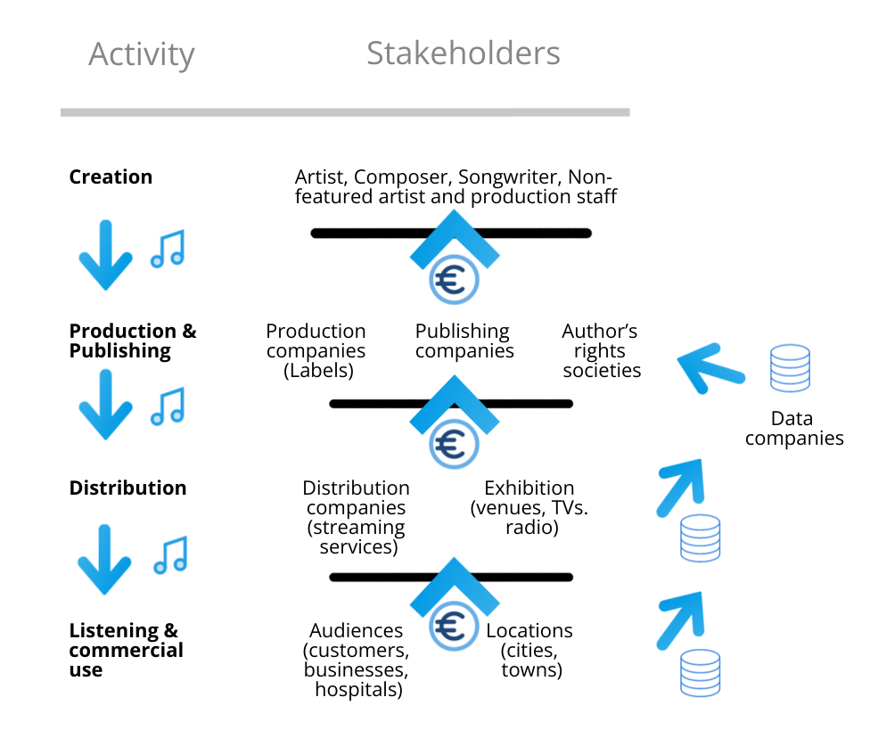
Source: Music360

Levison (2014) also considers more actors when he differentiates between the value of music for an individual and the value of music for a group or community, although he connects the idea of group with music genres. Regarding this idea, he differentiates between the value of music as a whole and the value that attaches to individual pieces or occasions of music. In this context, some music values, for example the social value of music “provides a clear example of the divergence between a value of music in general and the comparative value of an individual piece of music. Let us understand the social value of music as consisting centrally in the opportunity that music affords to bring people together in a public context for shared experience, interaction, coordination, and mutual affirmation. So understood, social value does not serve to any extent as a differentiating value of individual pieces or occasions of music, since it is possessed by virtually all pieces or occasions of music and yet remains a value of music generally” (Levison, 2014). As we will see later, this is relevant when proposing formulas for the measurement of the different values of music.

Measuring Cultural Value of music
This section presents a review of the cultural value and the items defined in the papers analysed. To organise the information, the music value chain in Figure 1 is also considered. Table 5 shows the different values analysed and afterwards the most important results are explained.

Table 5. Cultural value of music
Stakeholder | Authors | Product/ sector | Types of cultural value | Method & Items
Artist | Van der Hoeven et al. (2022) | Live music | Opportunity to perform, enjoyment | Interviews; then, thematic analysis
Venues | Van der Hoeven et al. (2022) | Live music | Symbolic value, artistic performance, entertainment | Interviews; thematic analysis
Cities | Van der Hoeven and Hitters (2020); van der Hoeven et al. (2021); Van der Hoeven et al. (2022) | Live music | Aesthetic experience, symbolic and narrative value, musical creativity, talent development, and cultural vibrancy | Van der Hoeven et al. (2022): interviews; thematic analysis
Local residents | Andersson et al. (2012a) | Festival | Option value, bequest value | Survey
Audiences | Chen et al. (2017) | Streaming platform | Functional, experiential, instrumental | Survey (7 items, 9 items, 8 items)
Audiences | Heredia-Carroza et al. (2021) | Flamenco | Cognitive, aesthetic, | Interviews
Audiences | Krause et al. (2021) | Listening to music | Appreciation, cognitive, narrative, purpose, study | Survey (2 open questions)
Audiences | Mulder & Hitters (2021) |  | Artistic, setting | Survey (9 items, 6 items)
Audiences | Ouazzani et al. (2022) | Opera in an opera house | Epistemic, functional | Survey (7 items)
Audiences | Saha et al. (2023) | Festival | Functional | Survey (4 items)
Source: various
Although Krause et al. (2021) find that, in general, in listening to music cultural value is more important than social value, the other papers analysed in Table 5 indicate that the most important values depend on the stakeholders and venues studied.
Regarding the stakeholders, some differences are found about what value is more important. For example, Van der Hoeven et al. (2022) find that for some artists, the cultural value is more important than the economic value, while for others the two values can go hand in hand. For the cities, they find that the most important value is not the cultural but the social, economic and spatial. For commercial developers, the most important is the economic value.
With respect to venues/products analysed, differences are found between values. For example, Mulder & Hitters (2021) find that cultural value is more important in concerts than in festivals. However, Saha et al. (2023) find that social and emotional value are more important than cultural value.

Measuring Social Value of music
This section presents a review of the social value and the items defined in the papers analysed. To organise the information from the analysis, the music value chain in Figure 1 is also considered besides the literature analysed. Table 6 shows the different values analysed in the reviewed papers. After the table, the most important results from the values analysed are explained.

Table 6. Social value of music
Stakeholder | Authors | Product/ sector | Types of social value | Method & Items
Artist | Van der Hoeven et al. (2022) | Live music | Recognition, interaction with audience, network of peers | Interviews; then, thematic analysis
Venues | Van der Hoeven et al. (2022) | Live music | Social bonding | Interviews; thematic analysis
Cities | Van der Hoeven and Hitters (2020); van der Hoeven et al. (2021); Van der Hoeven et al. (2022) | Live music | Social capital, public engagement, sense of identity | Van der Hoeven et al. (2022): interviews; thematic analysis.
Audiences | Chen et al. (2017) | Streaming platform | Psychosocial benefit | Survey (6 items)
Audiences | Krause et al. (2021) | Listening to music | Identity | Survey (2 open questions)
Audiences | Mulder & Hitters (2021) | Pop concerts and festivals | Personal (status), social | Survey (3 items, 5 items)
Audiences | Saha et al. (2023) | Festival | Social value | Survey (4 items)
Source: various

As it is explained for the measuring of cultural value, when listening to music is studied in a general sense, Krause et al. (2021) find that cultural value is more important than social value. However, in the rest of the papers in which the social value is analysed (Table 6), differences are obtained depending on stakeholders and the venues or products involved.
Regarding the stakeholders, some differences are found about what value is more important. For example, Van der Hoeven et al. (2022) find that for cities, the most important value is not the cultural but the social, economic and spatial.
With respect to venues/products analysed, Mulder & Hitters (2021) find that social value is more important in festivals than in concerts. Also, Saha et al. (2023) explain that in festivals social value is more important than cultural value.

Measuring Therapeutic Value of music
Music therapy is a form of expressive arts therapy that uses music to address physical, emotional, cognitive, and social needs of individuals (Dunphy, 2014). The therapeutic values of music therapy are diverse and can have positive effects on various aspects of a person's well-being. One of the positive effects is the integration of music as a complementary adjuvant to medical treatments. It helps patients and caregivers manage some of the physical, emotional, social, and spiritual needs that arise with illness or hospitalization (Bernatzky et al., 2011).
In this section, the existing literature is reviewed to analyse the significance of music therapy as a supportive element in diverse medical treatments administered within hospital settings. The constructive impacts of music therapy within hospitals and its connection to enhancing the health of patients, caregivers, and healthcare professionals are regarded as highly valuable. These advantageous aspects will be collectively referred to as values since they address various dimensions of well-being.
Table 7 and 8 present the types of values considered in the literature. In Table 7 its description is provided and in Table 8 they are organized according to the types of pathologies to which they contribute and the positive therapeutic benefits provided by music therapy. There are selected 23 papers that refer to studies conducted in European countries: 6 in Spain, 4 in Germany, 4 in the Netherlands, 2 in Italy, 2 in UK, 1 in Denmark, 1 in Finland, 1 in Hungary, 1 in Norway, and 1 in Sweden.
Table 7. Therapeutic value of music. Values and descriptions
Type of value | Description | Authors
Psychological value | Value is related to the range of positive effects on individuals' mental and emotional well-being. | Holmes et al. (2006), Burrai et al. (2014), Auge et al. (2015), Warth et al. (2016), Rodríguez et al. (2017), Ramirez et al. (2018), Toccafondi et al. (2018), Van der Heijden et al. (2018), Bro et al. (2019), Teckenberg-Jansson et al. (2019), Serrano Soliva et al. (2020), Odell Miller (2021), Van der Wald-Huisman et al. (2021), Madso et al. (2022), Wijk et al. (2022).
Quality of life value | Value is related to the ability to enhance the quality of life across various populations and contexts. | Holmes et al. (2006), Warth et al. (2015), Warth et al. (2016), Rodríguez et al. (2017), Ramirez et al. (2018), Toccafondi et al. (2018), Van der Heijden et al. (2018), Van Dokkum et al. (2020), Kobus et al. (2021a), Odell Miller (2021), Madso et al. (2022), Serrano Soliva et al. (2022), Wijk et al. (2022), Mata Ferro et al. (2023).
Cognitive development value | Value is related to the positive effects on cognitive development across various age groups and populations. | Holmes et al. (2006), Odell Miller (2021), Madso et al. (2022), Wijk et al. (2022).
Physiological value | Value is related to the positive effects on various physiological aspects of humans, contributing to overall health and well-being. | Burrai et al. (2014), Auge et al. (2015), Warth et al. (2016), Ramirez et al. (2018), Van Dokkum et al. (2020), Kobus et al. (2021b), Meder et al. (2021), Odell Miller (2021), Span et al. (2021), Van der Wald-Huisman et al. (2021), Mata Ferro et al. (2023).
Source: various

Table 8. Therapeutic value of music. Values, pathologies and benefits from music
Type of value | Pathologies | Therapeutic benefits obtained
Psychological value | Burnt patients, cancer, cognitive impairment, haemodialysis, palliative care, pregnant women, and surgery. | - Coping and Resilience.  - Emotional Expression and Regulation.  - Enhanced Mood and Positive Affect.  - Stress Reduction and Relaxation.
Quality of life value | Burnt patients, cancer, cognitive impairment, haemodialysis, newborn ICU, paediatric ICU, palliative care. | - Emotional Well-Being.  - Pain Management.  - Relaxation.
Cognitive development value | Cognitive impairment. | - Memory Enhancement.  - Neurological Plasticity.
Physiological value | Cancer, cognitive impairment, newborn ICU, paediatric ICU, surgery, palliative care. | - Cardiovascular Health.  - Endocrine System Modulation.  - Prenatal and Neonatal Health.  - Respiratory Function.
Source: various

The results shed light on the use of live music therapy in hospitals to improve various emotional aspects, such as psychological, related with quality of life, cognitive and even some physiological aspects related to different pathologies or situations and, to the extent possible, alleviate their symptoms. The findings described in these studies demonstrate the value of the benefits provided by music therapy at emotional level, being psychological, of live quality, cognitive and physiological sublevels. Finally, it is concluded that the positive values they provide, without any side effects, are always well-received not only by patients of all ages but also by their caregivers and even hospital staff, as they help create a more pleasant and humanized hospital environment.

Measuring Behavioural and Emotional Value of music
In this section, the behavioural and emotional value of music is discussed, in the context of a retail environment. Contrary to the previously mentioned categories of value, such as social and cultural, this value concentrates on the effect of music on the individual.
People constantly encounter overwhelming sensory input in most environments, but especially in retail. Those in the service and retail industries greatly value making the shopping experience as beneficial as possible for all people involved. Because of this, a great deal of research has been (and is being) conducted on the ideal “servicescape”. The servicescape, defined as the physical setting and surroundings that impact customers and employee is a crucial element of this, as many individual elements come together to contribute the overall customer experience (Bitner, 1992). Specifically, background music has been shown to affect customer behaviour due to its’ many different properties present in music, such as volume, tempo, and familiarity amongst many others (see Figure 1 for an overview of this). Knowledge of these effects is particularly useful to retailers, as they may be able to use this information to alter the servicescape and give customers a pleasant shopping experience. By improving this experience, they may be able to ensure atmospheric fit with the rest of the store and successfully reflect their ideal brand image.
There are two key groups exposed to background music: consumers, and instore employees. However, as already identified in Bitner (1992), the effect on employee behaviour is seldom investigated, with most research focusing only on customer experience. This is unfortunate as the employee experience is significantly related to a successful customer experience, as customers are exposed to staff on a recurring basis and have the capability to regularly influence their behaviour. In Wolter, Bock, Mackey, Xu, and Smith’s 2019 original empirical research, they establish that in companies with significant employee-customer interaction, employee satisfaction trajectories (growth patterns over time) strongly influence customer satisfaction. In addition, the trajectories also influence re-patronage intentions for frequent customers.
When examining music as the chosen condition, it is particularly useful to studying employees, as employees are constantly and continuously exposed to background music, unlike consumers who are only exposed to this music for short periods at a time and can leave the environment at any moment (Skandrani, Ben Dahmane Mouelhi & Malek; 2011). Inspired by the unfortunate gap in research on this topic and how valuable it is in understanding environment-user relationships, we aim to further examine the effect of background music on how employees affect customer behaviour. Specifically, we by looking at the interaction of customer and employee behaviour, as the two groups have been shown to influence each other. The groups are uniquely different and although they are both exposed to the same stimuli, this may lead to varied behavioural results. Their distinct behavioural responses may interact with each other to produce wholly new results than expected.
Background music has both direct and indirect effects on consumer behaviour, with affect and cognition mediators and moderators influencing the indirect relationship. Affect is defined according to Mehrabian and Russel’s pleasure, arousal, and dominance dimensions (P-A-D), (Mehrabian & Russell, 1974). Cognition refers to higher-order cognitive responses based on consumers’ associations with music that is played that influences their perception of the store’s attributes.
Research on the effects of music on consumer behaviour can be divided into two categories: (1) research on the absence/presence of background music, and (2) research on the impact of music properties. The presence of background music is significantly and positively related to pleasure, satisfaction, and behavioural intentions. They believe this relationship is moderated by both substantive and methodological influences ​(Roschk, Loureiro, & Breitsohl, 2017)​. To further specify these behavioural intentions, atmospheric fit was seen to be a moderator between the relationship of the store’s background music and customer response. Here, presence of music shows that presence of such music has been seen to increase the amount of money spent by customers ​(Areni & Kim, 1993). Exploring an extra dimension to this, the presence/absent of “pleasant” music is shown to have a significant effect on overall sales due to the relationship being mediated by mental depletion, as well as being moderated by both time of the day, and day of the week ​(Ahlbom, Roggeveen, Grewal, & Nordfalt, 2022)​.

When looking at genres and properties of the music, atmospheric fit between the store and background music is suggested as a mediator for multiple customer behaviours, including overall higher levels of sales and number of specific items sold​ (Areni & Kim, 1993; ​(North, Hargreaves, & McKendrick, 1999)​ ​(Jacob, Gueguen, Boulbry, & Sami, 2009)​;​ (Biswas, Lund, & Szocs, 2019)​). Volume moderates the relationship with atmospheric fit, increasing positive effects and misfit increasing negative effects ​(Beverland, Lim, Morrison, & Terziovski, 2006)​;​(Witt C. L., 2008)​. Executive attention, defined as, “the ability to manage what we pay attention to”, has been seen as a moderator when music has either vocals in it or is instrumental. In consumers with a low working memory capacity, vocal music leads to a decrease in both cognitive and attitudinal outcomes, with the main negative response being lower purchase intention ​(Kang & Lakshmanan, 2017)​.
Little research has been done on music-induced employee behaviour, one of which is a small qualitative study where 13 employees are interviewed, where it was found that relationships between the sales force team influences employees' reactions (Skandrani, Ben Dahmane Mouelhi, & Malek, 2011). They suggest that music should be congruent with the moment of day, non-repetitive, and should suit employees’ tastes. The interviews also suggest that music helps break routine, and disguises background noise. Music influenced their emotional responses, with many describing feelings of arousal or relaxation depending on the music played, and how their behavioural differed according to the task performed. Cognitive responses were also reported to be affected, with decreased time perception helping time pass faster for employees, which they in turn believe provides a positive energy transfer to both their fellow team-mates, as well as customer purchase intention. The two main behavioural responses reported were “motivation and stimulation”, which can cause stress in some. Continuous exposure to music, as well as being exposed to a forced music schedule as a moderator, seemed to generate boredom and monotony in employees (Skandrani, Ben Dahmane Mouelhi & Malek, 2011).
In an in-store experiment conducted in Filipa K stores, it was established that when music is chosen by employees themselves, there was a negative effect of a significant decrease in sales of women’s clothing (Daunfeldt, Moradi, Rudholm, & Öberg, 2021). Interviews with employees reveal that other employees music choices where not the only issue, but also tempo and repetition if it does not correlated to the tasks they are expected to perform. This process is seemingly mediated by the tiredness and mood of the employees involved. However, employees also attempted to regularly adjust the music to appeal to customers (e.g. playing “nonstress music on a rainy day” (Daunfeldt, Moradi, Rudholm, & Öberg, 2021).
Consumer behaviour in relation to their interactions with store employees has also been investigated. It was shown that background music with a positive valence had an indirect effect on consumer behaviour by increasing time spent in-store (Vida, Obadia, & Kunz; 2007). This relationship was shown to be mediated by the customer’s positive evaluative judgement of both the store and the personnel. Dubé & Morin (2001), show that varying pleasure intensity of the store’s background music indirectly positively influences customers’ store evaluation, as well as strengthening the relationship between this store evaluation and sales personnel. Similarly, Kniffin et al., (2007) finds that music conveying a “happy mood” had an indirect positive effect on the relationship between customers and employees. When mediated by a higher mood, happy music increases co-operative behaviour, as well as strengthening the bond between customers and employees. However, Chebat & Vaillant (2001) found that when exposed to soothing music with a low level of arousal, customers’ attitude towards employees & global assessment of the store is heavily affected, due to the moderation of increased cognitive weight caused by depth of information processing.
These results show that background music plays a significant effect on the affect, cognition, and behaviour of (1) customers, (2) employees, and (3) the interaction between the two, which make up the behavioural value of music in a retail context.

Measuring Economic Value of music

Music is an important part of the servicescape and has an influence on both customers and employee behaviour. Presence of instore background music has been shown to have a significant (and mostly positive) direct effect on consumer behaviour, which clearly shows an inherent economic value (Yalch & Spangenberg, 1990). Research includes Garlin & Ownes’ 2006 meta-analytic review of the topic reveals that differences in background music, including tempo, volume, genre and others, have resulted in financial gains such as sales, patronage, and evaluation as well as others. A decade later, Roschk’s (2017) meta-analysis confirms that these financial gains are achieved when music has a positive behavioural and cognitive impact on consumers.
The effects on revenue, sales, time perception, store evaluation, attraction/detraction, and many other many other actions have a directly affect the financial status of both the consumer and the seller (Yalch & Spangenberg, 1990; Areni & Kim, 1993; Kang & Lakshmanan, 2017)​.
Shih, Huang & Chiang (2012) examine lyric presence which showed a greater effect on attention, as well as a significant decrease in performance score between a baseline without music and when listening to music containing lyrics. When mediated by positive affect, which enhances customers’ perception of product quality and store attitude, famous music increases buying intention, and enhanced perception and evaluation of brand quality​ (Petruzzellis, Chebat, & Palumbo, 2018)​. Customers’ evaluative judgement of both store offering and sales personnel acts as a mediator between music valence and time spent shopping ​(Vida, Obadia, & Kunz, 2007)​.
These actions also have an economic effect on employees, as their music-induced feelings and thoughts may have an impact on their motivation, time perception, and task performance (Skandrani, Ben Dahmane Mouelhi, & Malek, 2011). In addition to this, the interaction between employees and customers can even affect customer purchase intention, time spent in-store and sales amongst others (Vida, Obadia, & Kunz, 2007; Skandrani, Ben Dahmane Mouelhi, & Malek, 2011; Daunfeldt, Moradi, Rudholm, & Öberg, 2021). This has an overwhelming effect on stakeholders as music as a stimulus can affect overall economic results.
Through examining this existing literature, it is evident that background music has an inherent economic value, through the behavioural affect and cognition felt by both consumers and employees. Both the behavioural and economic results of music found in this literature study is condensed in the following Figure:

Figure 2. Affective, behavioural and economic effects of background music on customers and employees in a retail setting
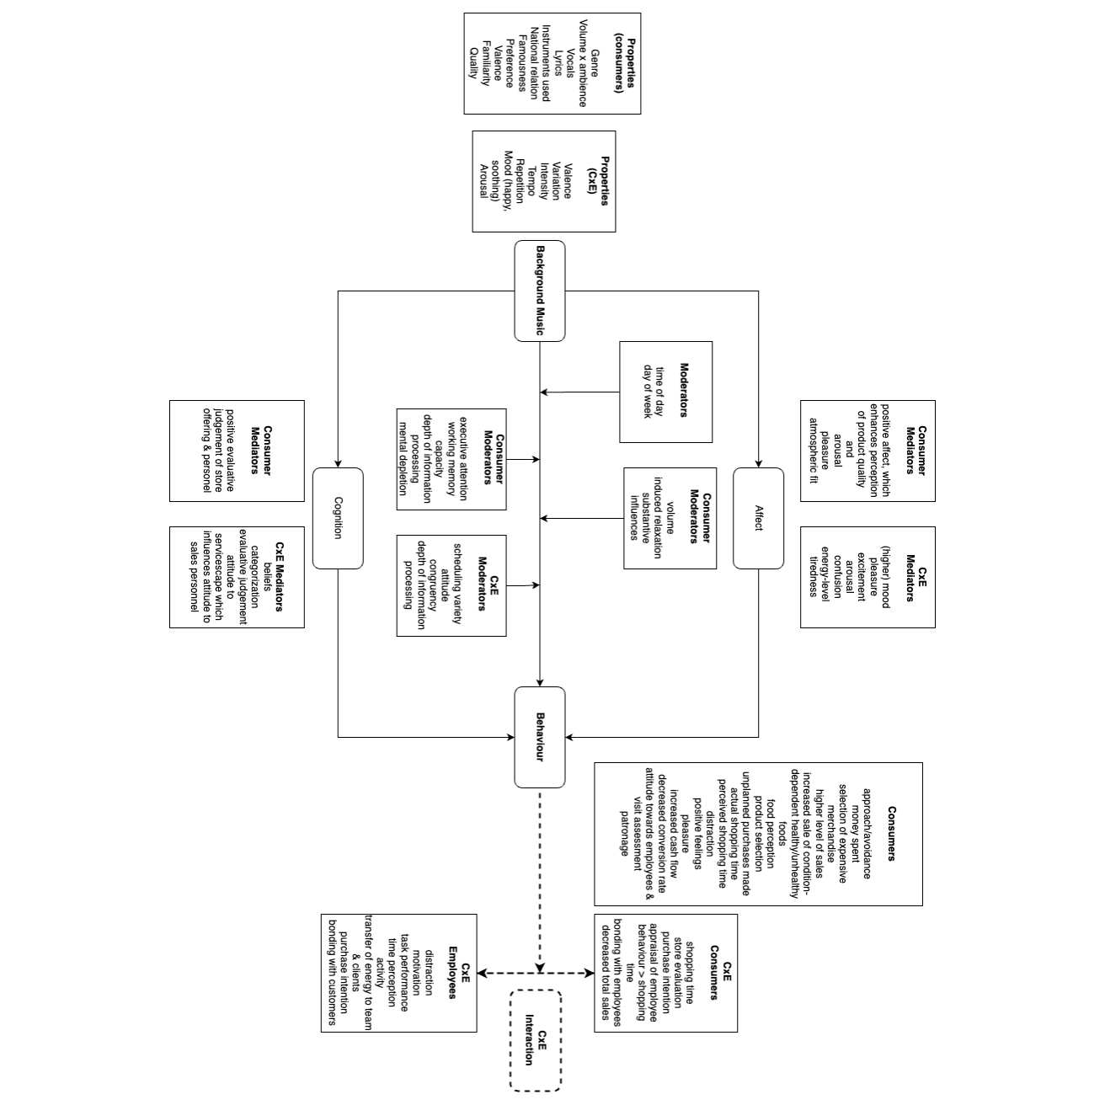

Summary of the framework
After analysing the types of values obtained from the literature review, Table 9 presents a summary of the values that are crucial to each stakeholder in the ecosystem (Figure 1), while Figure 2 shows the main research questions that might be answered in the living labs (WP6). It is evident that literature focuses on stakeholders for which authors can evaluate various types of values. However, when a stakeholder does not appear directly in the literature, it can be inferred that values for audiences and their behaviour may be value for stakeholders such as labels, publishing companies, and authors’ rights societies. Table 9 makes this assumption for stakeholders for which only the economic value is considered. Regarding the research questions, arrows in Figure 3 indicate relationships between variables that can be analysed through data collected in the living labs.

Table 9. Values by stakeholder
Activities related to music | Stakeholder | Values
Creation | Artist | Cultural, social, economic
Production & Publishing | Production companies (labels) | Economic
Production & Publishing | Publishing companies | Economic
Production & Publishing | Authors’ rights societies | Economic
Distribution | Distribution companies | Economic
Distribution | Exhibition | Economic
Listening (customers and commercial use) | Audiences (customers, retail, hospitals, etc.) | Cultural, social, therapeutic/emotional, economic
Listening (customers and commercial use) | Locations (cities, towns) | Cultural, social, economic
Source: own elaboration

Figure 3. Research questions proposed
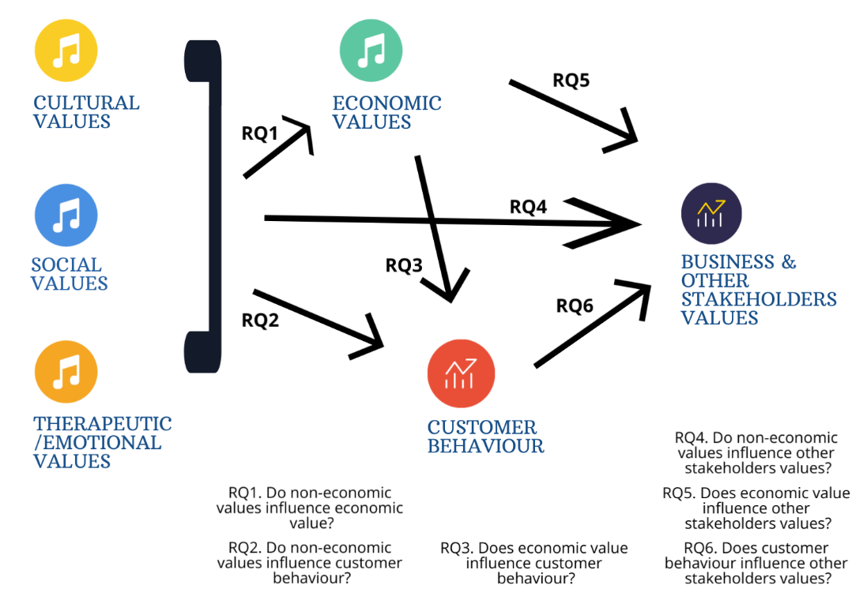
Source: own elaboration

The Music Value Matrix
The revision of the literature about measuring value in music reveals that it is multidimensional task, and dimensions can involve types of values, stakeholders, venues, and environment, among others. Figure 4 presents the first version of the Music Value Matrix, which tries to organise the cases found in the subsequent literature review to a two-dimensional diagram based on the music environment and the type of venue.

Figure 4. Music Value Matrix, version 1
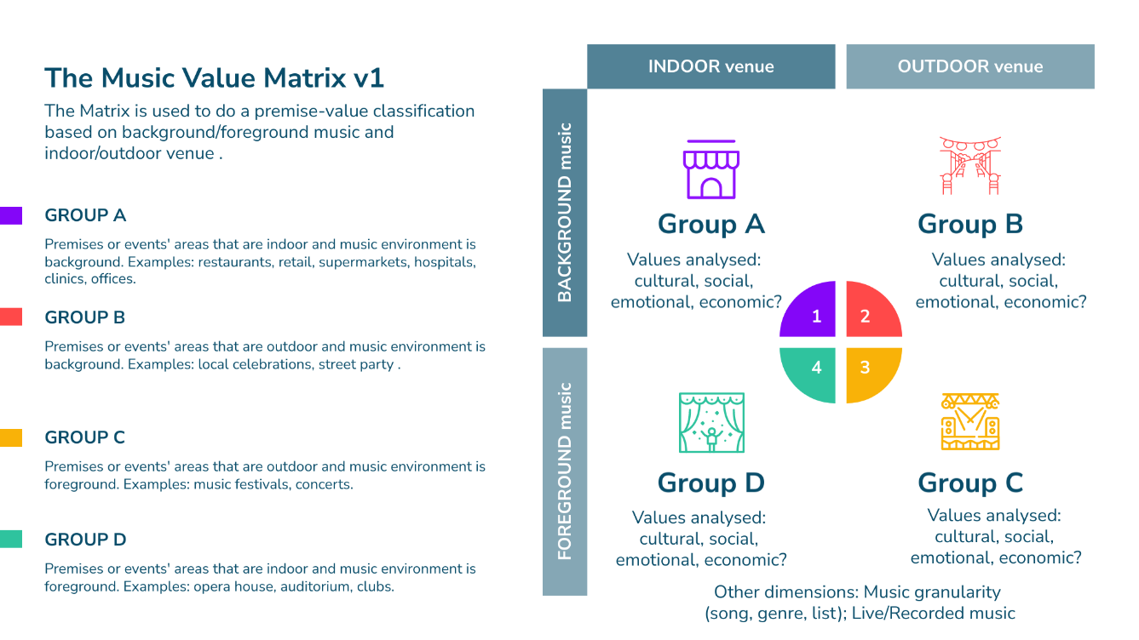
Source: own elaboration

Four groups of premises or events’ areas are defined in the matrix, A to D, for which the following literature review allows to include the location in the matrix of specific examples. Table 10 shows in which group would be located every paper analysed. Although the purpose of the Music360 project is background music, Groups A and B, the literature involves studies found for the four groups. Groups A and B in the matrix will be the centre for cases to select in living labs to cover enough alternatives.

The four groups in the matrix. Dimensions from the literature
Does the type of venue influence the value of music? According to Michel et al. (2017) the same design of in-store music has diverse effects depending on the service setting (restaurants, supermarkets, banks...). And Mulder & Hitters (2021) differentiate the effects of outdoor live music in festivals and concerts.
Moreover, for Levinson (2014) we could distinguish value to listeners from value to performers from value to composers, although listener value takes priority over the others because, at the end, all of them are listeners. Even genres can be valued differently by performers, such as Bull and Scharff (2021) demonstrate for classical music and labour positions. For example, being a soloist is perceived as the most prestigious. However, in the case of Flamenco, Heredia-Carroza et al. (2021) don’t find differences between spectators and experts for “feelings” value (“ability to produce emotions,” “generate reflection in spectator,” “ability to feel flamenco,” and “make others feel flamenco”).
In general, it is said that sensory elements, such as background music, non-consciously influence behaviours (Biswas, 2019). Moreover, during daily activities, emotion is strongly related to most people’s primary motives for listening to music indoors or outdoors (Juslin & Laukka, 2004; Lonsdale & North, 2011). In contrary, the impact of other disturbing noises could be more significant than music, as Hynes and Manson (2016) notice in some supermarkets in UK. Also, Han et al. (2022) perform some experiments to differentiate pleasant sounds, such as music, water or birds, and disturbing noises. And Krause et al. (2021), for a group of students in Australia determine that reasons for not listening to music are related to the interference with activities that required focus or concentration, by environmental context, affective responses, music engagement and a preference for silence or other auditory stimuli.
Literature agrees on the necessity of congruence between background music and product (GEMA, 2023; Jacob et al., 2019; Jain & Bagdare, 2010; Kauppinen-Räisänen et al., 2020; North et al., 2016; Toldos et al., 2019) what also highlights the importance of a selection of music based on systematic customer research rather than on employees’ personal tastes (Vida et al., 2007).
For adding information to the matrix, we have performed another literature search using Scopus as database with the keywords “value AND music”, limiting the results from 2009 and selecting other specific keywords, which results in 723 records (Figure 5). This figure helps us to observe different factors that have been studied around the value of music. Paying attention to its cultural and social dimensions, we can observe some elements such as gender, memory, popular music, or festivals.

Figure 5. Music, value, and other keywords from the literature
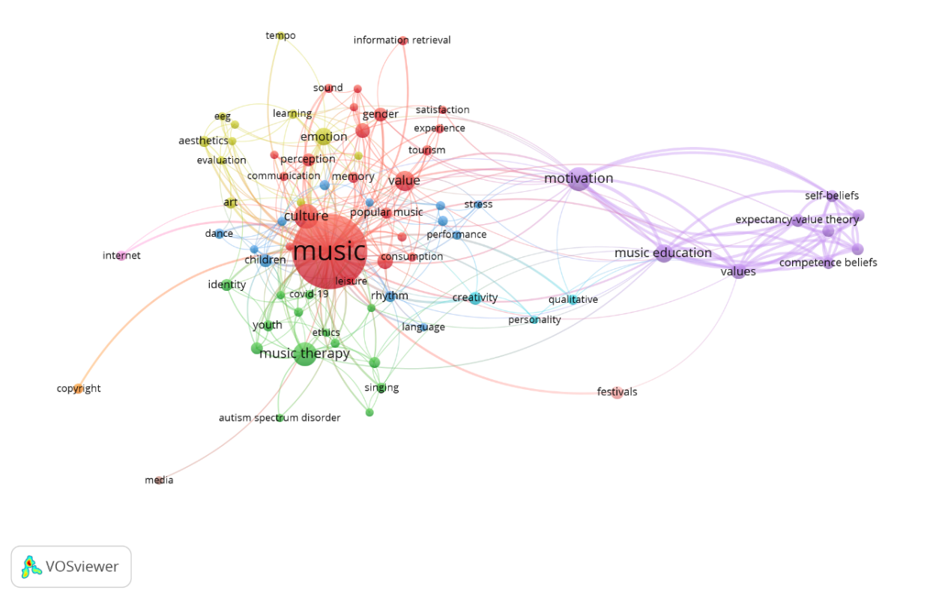
Source: own elaboration with VOSviewer (Van Eck & Waltman, 2020).
Some authors, such as Van der Hoeven and Hitters (2019), define cultural and social values. In this case, they understand social value as the contribution of (live music) to the social relationships between people, a sense of belonging and collective identity. And cultural value as the contribution to the artistic qualities of (live) music, the symbolic meanings and creativity (diversity of genres and artistic experimentation).
In the case of indoor background music (Group A), the literature provides different factors that should be considered in the retail sector, although some of them are not empirically confirmed because, depending on the study, the results have been opposite.
Regarding cultural value, North et al. (2016) stress the influence of language, from an experiment conducted with undergraduate university students from the UK. And, regarding the content of the music, Spangenberg et al. (2005) confirm in North America that consumers’ evaluations are more favourable when the Christmas scent is in the presence of Christmas music.
From the point of view of social value, the reasons for listening to music may change as people grow older. Music is particularly important for adolescents and young adults, but less important for participants aged over 30 (Lonsdale & North, 2011). For North et al. (2016), hearing a specific genre of music activates related concepts in memory, which influences the memory for, perception of, and choice of products.
Besides, for some authors, gender can be influenced in a different manner. Andersson et al. (2012b), in the case of retailing in Sweden, discover that females prefer slow-tempo music. And Herter et al. (2014) find that positive emotions in the retail environment affect the shopping experience in university bookshops more for men, while negative emotions affect it more for women. But return intentions have no difference. Conversely, Jha and Singh (2013) find, despite the gender, the same effect of background music on the shopping experience for a big store in India.
Finally, Srivastava (2013) explains how music could influence the repeat visits of consumers and can generate extra crowd to a Hypermarket in India due to word-of-mouth publicity.
In the case of outdoor venues, the literature considers foreground music (Group C), but not background music (Group B). Music festivals, concerts and urban live music in general are included in this group of studies, but we should highlight that, in general, they analyse the whole experience of the music venue.
Urban live music has been studied by Van der Hoeven in various works and for different countries. More than cultural and social value, he provides the concept of spatial value. For Van der Hoeven and Hitters (2020), the spatial value is the relationship between live music and the city, and it is composed by three dimensions: performing (how a city is physically used to stage concerts and create musical pathways); redeveloping (how live music makes and regenerates the space); and narrating (live music as part of the stories told about cities). And that is because, if the principal actors are concerned with cultural values, local governments expect to generate social, spatial, and economic values (Van der Hoeven et al., 2022).
Andersson et al. (2012a) compare the value for visitors and for residents. In this case, they take the music festival Way Out West (WOW) in Sweden as a case study. The festival includes rock, electronic and hip-hop music. The city has had a positive experience for many years as visitors go home with their memories expanding a positive image of it. And for the part of the local community, it has communicated a positive social image of a profitable and environmental-friendly festival.
Saha et al. (2023) analyse an annual rock music festival in Norway and, among others, examine the social value of the music festival translated in: social approval from others, feel acceptable to others, gain popularity among friends and family, and be recognized by other people. However, in this case visitors do not seek social recognition or approval from others, what they prefer is to spend time with family, friends and/or other visitors that share their interests.
For live pop music in The Netherlands, Mulder & Hitters (2021) distinguish festivals, that people visit for social and personal reasons (known group and/or external socialisation, atmosphere), in line to Saha et al. (2023), and concerts, that people attend for artistic and user experience reasons (new music or live versions of existing material).
Another social aspect to consider is visitors’ intent to repeat attendance and engage in positive word-of-mouth recommendation. Kruger and Saayman (2017) refer to it for a jazz festival in South Africa and demonstrate that music festivals have the potential, not only to create recognition of a specific music genre, but also to encourage the sharing of experiences.
In general, Van der Hoeven et al (2021; 2022) observe that there is a lack of holistic works that put together the views from musicians, industry, academia and policy makers to integrate economic, cultural and social values, as well as long-term strategies to achieve a sustainable development (Van der Hoeven & Hitters, 2023).
Finally, indoor venues with foreground music (Group D) are related to opera, festivals or concerts in theatres (Behr et al., 2016b) or streaming services (Chen et al., 2017; Bridge, 2023; Gallarza et al., 2022; Ouazzani et al., 2022) or pubs (Whiting, 2021).
In this kind of venue, Behr et al (2016b) stress that audiences in UK think not only about the music (artist or genre), but also about the place due to its intimacy, character and uniqueness. However, when they are virtual venues the socialization value decreases (Gallarza et al, 2022).
In the case of small local venues, Whiting (2021) goes further and enhances their cultural and social value in Australia for musicians and listeners, as social hubs that contribute to the foundation of a city’s live music ecology. The same could be said around record shops. In Sweden, Harcs and Jansson (2020) explain that these record shops also stage a variety of events and experiences: live shows, artist visits, record signings, and live DJ sets.
Another type of value is introduced by Ouazzani et al (2022), who add epistemic value in the case of streaming opera, considering that it is watched by opera lovers to increase their knowledge on opera performances. This type of value could be also related to the online music participation of music learning groups during the global pandemic crisis. In the case of a cathedral choir in the UK, Bridge (2023) proves its positive results not only in the learning process, but also in social capital and connectedness, sense of belonging, pride, affinity and prestige.
Anyway, more and more we notice that people are listening to music in their own spaces through music platforms, and specially through mobile devices like smartphones (Jiang et al, 2021). Besides, they can join digital spaces that create new social values (Allington et al., 2015).

Table 10. Dimensions from the literature and group in the matrix
Author | Sample | Venue | Matrix
Abassi et al (2019) | 436 videogame consumers (teen students) | Universities/college (Malaysia) | A
Andersson et al (2012b) | 150; 400 consumers | Home electronics retail store (Sweden) & large supermarket store | A
Aylott and Mitchell (1999) | 29 focus groups (239 respondents) | Grocery of Sunderland city (UK) | A
Badgaiyan and Verma (2015) | 508 respondents | Malls in capital city (India) | A
Biswas (2019). Intro to Special Issue | 23 consumers (22–34 years) | Retailing (Germany) | A
Cheng and Huang (2022) | 509 participants | Virtual Museum (Taiwan) | A
Daunfeldt et al (2021) | 4626 observations | Fashion stores (Stockholm) | A
Franjković et al (2022) | 226 respondents | Large retail grocery stores (Poland) | A
GEMA (2023) | Literature review | Stores | A
Herter et al (2015) | 200 participants | Book store (unclear location) | A
Hynes and Manson (2016) | 37 customers and 8 staff/managers | 2 supermarkets in Birmingham (UK) | A
Jacob et al (2019); North et al (2016) | 120 customers; Around 400 undergraduate university students | Flower shop (France); Experiment in research rooms (UK) | A
Jain and Bagdare (2010) | Literature review | Retail stores | A
Jha and Singh (2013) | Consumers | Big store (India) | A
Juslin and Laukka (2004); Lonsdale and North (2011) | 141 music listeners; Undergraduate students | Daily activities (Sweden); Daily activities (UK) | A
Kauppinen-Räisänen, Mühlbacher & Taishoff (2020) | 98 informants (average age of 35. Mainly women) | Luxury stores (Monaco) | A
Kemp et al (2011) | Performing rights organizations | Small business and retailers (US and India) | A
Liu et al (2022) | 800 participants | Online advertisement (MTurk, Amazon) | A
Michel et al (2017) | Literature review | In-store (supermarkets, bars, banks…) | A
Price (2010), Hwang and Oh (2020) | 200 participants;51 males and 197 females | e-retailing; Undergraduate university students (US) | A
Spangenberg, Grohmann & Sprott (2005) | 130 undergraduate students | Mock retail store/lab (North America) | A
Srivastava (2013) | Customers | Hypermarkets (India) | A
Toldos et al (2019) | 241 shoppers | Apparel store (Mexico) | A
Vida, Obadia and Kunz (2007) | 332 shoppers, mean age of 31.4 years | High-end Supermarket (EU) | A
Andersson et al (2012a) | 719 Festival visitors and 648 local residents | Music festival (Sweden) | C
Kruger& Saayman (2017) | 311 visitors | Jazz festival (South Africa) | C
Mulder & Hitters (2021) | 1131 participants | Live music (festival and concert) (The Netherlands) | C
Van der Hoeven & Hitters (2019) | Literature review | Urban live music (different countries) | C
Van der Hoeven & Hitters (2020) | Policymakers, festival organizers and venue owners | Urban live music stages | C
Van der Hoeven et al (2021) | Literature review | Live music (models) | C
Van der Hoeven et al (2022) | 21 Musicians, 14 chief executives of venues & festivals | Pop urban live music (The Netherlands) | C
Van der Hoeven & Hitters (2023) | Literature review | Impact of urban live music  on social relationships | C
Behr et al (2016b) | Not defined, 6 venues x 900 pax | Indoors live music (UK) | D
Bridge (2023) | 72 Choirs/music participants | Online music for education (UK) | D
Chen et al (2017) | 463 participants | Music streaming services (Taiwan) | D
Gallarza et al (2022) | 246 attendees | Virtual Music Festival | D
Ouazzani et al (2022) | 213 viewers | Streamed Opera | D
Whiting (2021) | 34 participants | Small live music venues (Australia) | D
Juslin and Laukka (2010) | 141 listeners (trained and untrained) | Listening to music (Sweden) | A+B
Harcs and Jansson (2020) | 10 owners/clerks and 10 key informants of marketplace (industry, streaming, labels, venues, radio) | Independent record stores (Stockholm) | A+D
Han et al (2022) | 30 participants | Lab experiment with different sounds (China) | C+D
Source: own elaboration

Classifying cases through the Music Value Matrix
The analysis in Table 10 is used to review the Value Matrix for music and include the cases analysed by the literature. It indicates that there are 24 examples for Group A, 8 examples for Group C, 6 examples for Group D, 1 example that can be assigned to both groups A and B, 1 case that is both in groups A and D, and 1 case that is both in groups C and D. The result of the matrix revised is presented in Figure 6.

Figure 6. Music Value Matrix, version 2
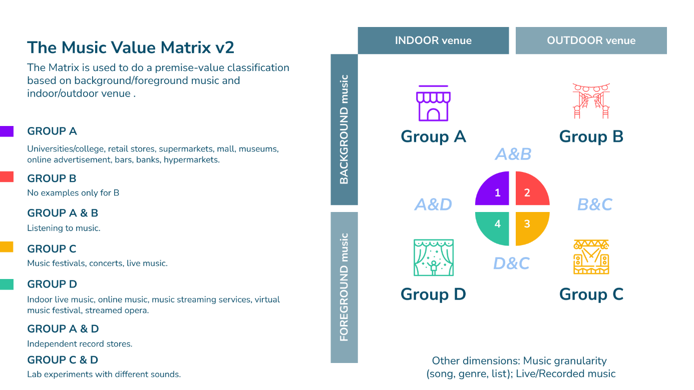

Source: own elaboration

Matching the framework and the matrix (Table 11), we can observe which literature gaps could be considered, both for the project and for future works.

Table 11. Values by group found in the literature
Group | Cultural value | Social value | Therapeutic value | Emotional value | Economic value
A | √ | √ | √ | √ | √
B | X¹ | X | X | √ | X
C | √ | √ | X | √ | X
D | √ | √ | √ | √ | √
¹ Only 1 work A+B
Source: own elaboration

Conclusions
This deliverable D1 has presented an analysis of the literature related to measuring the value of music, and the main conclusions obtained are the next six.
The first conclusion is that classifications of value used nowadays to measure music value follows theories that were defined for goods different to music, like the Theory of Consumption Value (Sheth et al., 1991). These theories have evolved until conforming an extensive list of items that can be used to measure value. This implies a challenge as every main type of value (economic, social, therapeutic, emotional, and economic) is composed of many others.
The second conclusion is that music analysis needs a multidimensional approach, because other dimensions are linked to the types of values, and those dimensions are related to the listener experience (outdoor/indoor venues, background/foreground music). This multidimensionality amplifies the challenges for measuring music value.
The third conclusion is that music industry is composed of a network of actors that are interconnected, creating an ecosystem of music (van der Hoeven et al., 2022). However, the review conducted indicates that it is not easy to determine the most important value for each stakeholder as the results depends on the stakeholder and venues studied. For example, some studies find that the cultural value is more important than social value (Mulder & Hitters, 2021), while others find the opposite (Saha et al., 2023).
The fourth conclusion is about the therapeutical value and the results of the literature review indicate that music can be a complementary adjuvant to medical treatments, offering psychological and physiological value in the cases of cancer, haemodialysis, paediatric ICU, and palliative care.
The fifth conclusion refers to the link between emotional value and background music. Use of products and services are a daily need and usually are obtained from a physical retailer/service provider. Within those physical stores, background music is largely prominent and is constantly influencing listeners, and therefore we are constantly exposed to its behavioural value through our own actions. The results of the review show that background music affects behaviour directly, or through the means of affect (feeling) or thinking (cognition), and that this behaviour plays a significant effect on (1) customers, (2) employees, and (3) the interaction between the two. These elements make up the behavioural value of music in a retail context. This behavioural value contributes greatly to various retail servicescapes, which in turn better individuals’ shopping experience and employees’ working experience, as well as their encounters with each other.
Behavioural value has a direct influence on economic value, as many behavioural responses result in financial gains or losses for stakeholders. These background music-induced behaviours include time spent shopping, purchase intention, and amount and selection of products bought, amongst many others. Various types of background music result in financial outcomes directly, and through affect and cognition, attributing an economic value to said music.
The last conclusion is that the analyses conducted in the deliverable, through the Music Value Matrix, indicates the lack of studies related to some of the groups defined in the matrix, like the groups formed by background music in outdoor venues. Therefore, besides the gap found, it is observed that values related to these events need further analyses to cover the gap detected. Results from this deliverable are the bases for selecting the cases in the WP6 (living labs).

<Update the bibliography before you release the document>

Bibliography
Agres, K. R., Dash, A., & Chua, P. (2023). Affect Machine-Classical: a novel system for generating affective classical music. Frontiers in Psychology, (14), 1158172.
Ahlbom, C. P., Roggeveen, A. L., Grewal, D., & Nordfalt, J. (2022). Understanding How Music Influences Shopping on Weekdays and Weekends. Journal of Marketing Research.
Allington, D., Dueck, B. & Jordanous, A., (2015). Networks of value in electronic music: SoundCloud, London, and the importance of place. Cultural Trends, 24(3): 211-222, DOI: 10.1080/09548963.2015.1066073
American Music Therapy Association, 2005. https://www.musictherapy.org/about/musictherapy/ (Consulted 2-1-24)
Andersson, P.K., Kristensson, P., Wästlund, E. and Gustafsson, A. (2012b). Let the music play or not: The influence of background music on consumer behavior. Journal of Retailing and Consumer Services, 19(6): 553-560. DOI: 10.1016/j.jretconser.2012.06.010
Andersson, T.D., Armbrecht, J. & Lundberg, E. (2012a). Estimating Use and Non-use Values of a Music Festival. Scandinavian Journal of Hospitality and Tourism, 12(3): 215-231, DOI: 10.1080/15022250.2012.725276
Areni, C. S., & Kim, D. (1993). The influence of background music on shopping behavior: classical versus top-forty music in a wine store. ACR North American Advances.
Bakker, I. V. (2014). Pleasure, arousal, dominance: Mehrabian and Russell revisited. Current Psychology, 405-421.
Beverland, M., Lim, E. A., Morrison, M., & Terziovski, M. (2006). In-store music and consumer-brand relationships: Relational tranformation following experiences of (mis)fit. 59(9), 982-989.
Behr, A., Brennan, M. & Cloonan, M. (2016a). Cultural value and cultural policy: some evidence from the world of live music. International Journal of Cultural Policy, 22(3): 403-418. DOI: 10.1080/10286632.2014.987668
Behr, A., et al., (2016b). Live concert performance: an ecological approach. Rock Music Studies, 3 (1): 5–23.
Bernatzky, G., Presch, M., Anderson, M., & Panksepp, J. (2011). Emotional foundations of music as a non-pharmacological pain management tool in modern medicine. Neuroscience & Biobehavioral Reviews, 35(9): 1989-1999.
Biswas, D. (2019). Sensory Aspects of Retailing: Theoretical and Practical Implications. Journal of Retailing, 95(4): 111-115. DOI: 10.1016/j.jretai.2019.12.001
Biswas, D., Lund, K., & Szocs, C. (2019). Sounds like a healthy retail atmospheric strategy: effects of ambient music and background noise on food sales. Journal of the Academy of Marketing Science, 37-55.
Bitner, M. J. (1992). Servicescapes: The impact of physical surroundings on customers and employees. Journal of marketing, 56(2): 57-71.
Bless, H. C. (1996). Mood and the use of scripts: Does a happy mood really lead to mindlessness?. Journal of personality and social psychology, 71(4): 665., 665.
Bridge, S.K. (2023). The social value of music during the COVID-19 pandemic: exploring the benefits of online music participation for social capital, education, belonging and wellbeing. Journal of Beliefs & Values. DOI: 10.1080/13617672.2023.2263723
Bro, M. L., Johansen, C., Vuust, P., Enggaard, L., Himmelstrup, B., Mourits-Andersen, T., ... & Gram, J. (2019). Effects of live music during chemotherapy in lymphoma patients: a randomized, controlled, multi-center trial. Supportive care in cancer, 27, 3887-3896.
Bull, A., & Scharff, C. (2021). Classical music as genre: Hierarchies of value within freelance classical musicians’ discourses. European Journal of Cultural Studies, 24(3): 673-689. DOI: 10.1177/13675494211006094
Burrai, F., Micheluzzi, V., & Bugani, V. (2014). Effects of live sax music on various physiological parameters, pain level, and mood level in cancer patients: a randomized controlled trial. Holistic nursing practice, 28(5): 301-311.
Chebat, J. C., Chebat, C. G., & Vaillant, D. (2001). Environmental background music and in-store selling. Journal of Business Research, 54(2): 115-123.
Chen, Y.M., Liu, H.H. and Chiu, Y.C. (2017). Customer benefits and value creation in streaming services marketing: a managerial cognitive capability approach. Psycholy & Marketing, 34: 1101–1108. DOI: 10.1002/mar.21050
Clarke, E., DeNora, T., & Vuoskoski, J. (2015). Music, empathy and cultural understanding. Physics of life reviews, 15, 61-88.
Cowen, A. S., Fang, X., Sauter, D., & Keltner, D. (2020). What music makes us feel: At least 13 dimensions organize subjective experiences associated with music across different cultures. Proceedings of the National Academy of Sciences of the United States of America, 117(4): 1924–1934. https://doi.org/10.1073/PNAS.1910704117/SUPPL_FILE/PNAS.1910704117.SM01.MP4
Dash, A., & Agres, K. R. (2023). AI-Based Affective Music Generation Systems: A Review of Methods, and Challenges. ACM, 2301.06890.
Daunfeldt, S. O., Moradi, J., Rudholm, N., & Öberg, C. (2021). Effects of employees’ opportunities to influence in-store music on sales: Evidence from a field experiment. Journal of Retailing and Consumer Services, 59, 102417.
Deloitte Access Economics. (2011). Economic, Social and Cultural Contribution of Live Music in Victoria. Deloitte.
Denizet-Lewis, B. (2006). The man behind Abercrombie & Fitch: Mike Jeffries turned a moribund company into a multibillion-dollar brand by selling youth, sex and casual superiority. Not bad for a 61-year-old in flip-flops. Salon. Retrieved August 11, 2023.
Dubé, L., & Morin, S. (2001). Background music pleasure and store evaluation: intensity effects and psychological mechanisms. Journal of business Research, 54(2): 107-113.
Dunphy, K. (2014). The effectiveness of expressive arts therapies: A review of the literature. Psychotherapy and counselling journal of Australia, 2(1).
Ferreira, D. C., & Oliveira-Castro, J. M. (2011). Effects of background music on consumer behaviour: behavioural account of the consumer setting. The Service Industries Journal: 2571-2585.
Fiegel, A., Meullenet, J. F., Harrington, R. J., Humble, R., & Seo, H. S. (2014). Background music genre can modulate flavor pleasantness and overall impression of food stimuli. Appetite, 144-152.
Frey, B.S. (2003) Arts & Economics. Analysis & Cultural Policy. Springer Berlin, Heidelberg.
Frey, B.S. (2019) The Social Value of Art. SpringerBriefs in Economics, 15-20. Springer, Cham, https://doi.org/10.1007/978-3-030-15748-7_2
Gallagher, M. (2011). Evaluating a protocol to train hospice staff in administering individualized music. International Journal of Palliative Nursing, 17(4): 195-201.
Gallarza, M.G., Tubillejas-Andrés, B. & Samartin, K. (2023). Consumer value of virtual music festivals. International Journal of Consumer Studies, 47(5): 2012–2030. DOI: 10.1111/ijcs.12978
Garlin, F. V., & Owen, K. (2006). Setting the tone with the tune- A meta-analytic review of the effects of background music in retail settings. Journal of business research, 59(6): 755-764.\
GEMA (2023). The influence of in-store music on sales at the stationary point of sale. MUSIK IST UNS WAS WERT, www.gema.de
Graakjær, N. J. (2012). Dance in the store: on the use and production of music in Abercrombie & Fitch. Critical discourse studies, 9(4): 393-406.
Han, Z., Kang, J. and Meng, Q. (2022). The effect of foreground and background of soundscape sequence on emotion in urban open spaces. Applied Acoustics, 199: 109039. DOI: 10.1016/j.apacoust.2022.109039.
Haugtvedt, C. P., Herr, P. M., & Kardes, F. R. (2018). Handbook of Consumer Psychology. Routledge.
Heredia-Carroza, J., Palma Martos, L., & Aguado, L. F. (2021). How to Measure Intangible Cultural Heritage Value? The Case of Flamenco in Spain. Empirical Studies of the Arts, 39(2): 149-170. DOI: 10.1177/0276237420907865
Herter, M., dos Santos, C.P., and Costa, D. (2014). “Man, I Shop Like a Woman!” Effects of Gender and Emotions on Consumer Shopping Outcomes and Perceptions of Retail Environments. Developments in Marketing Science: Proceedings of the Academy of Marketing Science, p. 34. DOI: 10.1007/978-3-319-10951-0_19
Holmes, C., Knights, A., Dean, C., Hodkinson, S., & Hopkins, V. (2006). Keep music live: music and the alleviation of apathy in dementia subjects. International Psychogeriatrics, 18(4): 623-630.
Hong, J. W., Fischer, K., Ha, Y., & Zeng, Y. (2022). Human, I wrote a song for you- an experiment testing the influence of machines’ attributes on the AI-composed music evaluation. Computers in Human Behavior, 131: 107239.
Hracs, B.J., & Jansson, J. (2020). Death by streaming or vinyl revival? Exploring the spatial dynamics and value-creating strategies of independent record shops in Stockholm. Journal of Consumer Culture, 20(4): 478-497. DOI: 10.1177/1469540517745703
Hwang, A. H. (2020). Interacting with background music engages E-Customers more: The impact of interactive music on consumer perception and behavioral intention. Journal of Retailing and Consumer Services, 101928.
Hynes, N. and Manson, S. (2016). The sound of silence: Why music in supermarkets is just a distraction. Journal of Retailing and Consumer Services, 28: 171-178. DOI: 10.1016/j.jretconser.2015.10.001
Jacob, C., Guéguen, N., Boulbry, G. and Sami, S. (2009). 'Love is in the air': Congruence between background music and goods in a florist. International Review of Retail, Distribution and Consumer Research, 19(1): 75-79. DOI: 10.1080/09593960902781334
Jain, R. and Bagdare, S. (2010). Music and consumption experience: A review. International Journal of Retail and Distribution Management, 39 (4): 289-302. DOI: 10.1108/09590551111117554
Jha, S. and Singh, B. (2013). Impact of ambient music and affability of salespersons on consumer behavior in a real retail setting with emphasis on gender difference. Indian Journal of Marketing, 43 (4): 5-11. DOI: 10.17010/ijom/2013/v43/i4/36373
Jiang, M., Lin, L., Zhang, W., Zhuang, W., Jin, M. and Lin, Y. (2021). A Study on the Influencing Factors of Mobile Digital Music Selection in Subhealthy People Based on Perceived Value Theory. Wireless Communications and Mobile Computing, 5547044. DOI: 10.1155/2021/5547044
Juslin, P.N. & Laukka, P. (2004). Expression, Perception, and Induction of Musical Emotions: A Review and a Questionnaire Study of Everyday Listening, Journal of New Music Research, 33(3): 217-238. DOI: 10.1080/0929821042000317813
Kang, E., & Lakshmanan, A. (2017). Role of executive attention in consumer learning with background music. Journal of Consumer Psychology, 35-48.
Kauppinen-Räisänen, H., Mühlbacher, H. & Taishoff, M. (2020). Exploring consumers’ subjective shopping experiences in directly operated luxury brand stores. Journal of Retailing and Consumer Services, 57(102251). DOI: 10.1016/j.jretconser.2020.102251
Kniffin, K. M., Yan, J., Wansink, B., & Schulze, W. D. (2017). The sound of cooperation: Musical influences on cooperative behavior. Journal of organizational behavior, 38(3): 372-390.
Kobus, S., Diezel, M., Dewan, M. V., Huening, B., Dathe, A. K., Felderhoff-Mueser, U., & Bruns, N. (2021). Music therapy is effective during sleep in preterm infants. International Journal of Environmental Research and Public Health, 18(16): 8245.
Kobus, S., Diezel, M., Huening, B., Dewan, M. V., Felderhoff-Mueser, U., & Bruns, N. (2021). Parents’ Perception of Family-Centered Music Therapy with Stable Preterm Infants. International Journal of Environmental Research and Public Health, 18(23): 12813.
Krause, A.E., Glasser, S., & Osborne, M. (2021). Augmenting Function with Value: An Exploration of Reasons to Engage and Disengage from Music Listening. Music & Science, 4. DOI: 10.1177/20592043211022535
Kruger, M. and Saayman, M. (2017). Segmenting beyond behavioural intentions: Fine tuning music festival visitors’ music appreciation. International Journal of Event and Festival Management, 8(2): 204-223. https://doi.org/10.1108/IJEFM-09-2016-0064
Levinson, J. (2014). Values of Music. In, Handbook of the Economics of Art and Culture (Editor(s): Victor A. Ginsburgh, David Throsby), Cahpter 5, Volume 2, 101-117. Elsevier. DOI: 10.1016/B978-0-444-53776-8.00005-2
Lonsdale, A.J. and North, A.C. (2011), Why do we listen to music? A uses and gratifications analysis. British Journal of Psychology, 102: 108-134. DOI: 10.1348/000712610X506831
Madsø, K. G., Molde, H., Hynninen, K. M., & Nordhus, I. H. (2022). Observing music Therapy in dementia: Repeated single-case studies assessing well-being and sociable interaction. Clinical Gerontologist, 45(4): 968-982.
Mata Ferro, M., Pegueroles, A. F., Lorenzo, R. F., Roy, M. Á. S., Forner, O. R., Jurado, C. M. E., ... & Alcaraz, A. B. (2023). The effect of a live music therapy intervention on critically ill paediatric patients in the intensive care unit: A quasi-experimental pretest–posttest study. Australian Critical Care.
McGee, R. W. (2023). Using Artificial Intelligence (AI) to Compose a Musical Score for a Taekwondo Tournament Routine: A ChatGPT Experiment.
Meder, U., Tarjanyi, E., Kovacs, K., Szakmar, E., Cseko, A. J., Hazay, T., ... & Jermendy, A. (2021). Cerebral oxygenation in preterm infants during maternal singing combined with skin-to-skin care. Pediatric Research, 90(4): 809-814.
Meehan, J. M., Simonetto, M. G., Montan, L., & Goodin, C. A. (2011). What is value and why ıs ıt so difficult to measure? Pricing and profitability management: A practical guide for business leaders. John Wiley & Sons (Asia) Pte. Ltd.
Mehrabian, A., & Russell, J. A. (1974). The basic emotional impact of environments. Perceptual and Motor Skills, 38(1): 283-301.
Michel, A., Baumann, C. & Gayer, L. (2017). Thank you for the music – or not? The effects of in-store music in service settings. Journal of Retailing and Consumer Services, 36: 21-32. DOI: 10.1016/j.jretconser.2016.12.008
Mulder, M. & Hitters, E. (2021). Visiting pop concerts and festivals: measuring the value of an integrated live music motivation scale. Cultural Trends, 30(4): 355-375. DOI: 10.1080/09548963.2021.1916738
Murrock, C. J. (2016). Concept analysis: Music therapy. Research and theory for nursing practice, 30(1), 44.
North, A. C., Hargreaves, D. J., & McKendrick, J. (1999). The influence of in-store music on wine selections. Journal of Applied psychology, 84(2), 271.
North, A.C., Sheridan, L.P. and Areni, C.S. (2016). Music Congruity Effects on Product Memory, Perception, and Choice. Journal of Retailing, 92(1): 83-95. DOI: 10.1016/j.jretai.2015.06.001
Oakes, S., & Warnaby, G. (2011). Conceptualizing the management and consumption of live music in urban space. Marketing Theory, 11(4): 405–418. https://doi.org/10.1177/1470593111418798
Odell-Miller, H. (2021). Embedding music and music therapy in care pathways for people with dementia in the 21st Century—A position paper. Music & Science, 4, 20592043211020424.
Osterwalder, A., & Pigneur, Y. (2010). Business model generation: a handbook for visionaries, game changers, and challengers. John Wiley & Sons.
Ouazzani, Y., Calderón-García, H. & Tubillejas-Andrés, B. (2022). Opera streaming: perceived value as an explanatory factor for loyalty and intention to attend an opera in an opera house. Journal of Marketing Management, 39(5-6): 414-442. DOI: 10.1080/0267257X.2022.2105936
Petruzzellis, L., Chebat, J. C., & Palumbo, A. (2018). Paradoxical effects of famous in retail venues. Journal of Consumer Behaviour.
Pham, M. T. (2008). The Lexicon and Grammar of Affect as Information in Consumer Decision Making. Social psychology of consumer behavior.
Pizzolitto, E. (2023). Music in business and management studies: a systematic literature review and research agenda. Management Review Quarterly 2023, 1–34. https://doi.org/10.1007/S11301-023-00339-3
Ramirez, R., Planas, J., Escude, N., Mercade, J., & Farriols, C. (2018). EEG-based analysis of the emotional effect of music therapy on palliative care cancer patients. Frontiers in psychology, 9, 254.
Rodgers, W., Yeung, F., Odino, C., & Degby, W. Y. (2021). Artificial intelligence-driven music biometrics influencing customers’ retail buying behavior. Journal of Business Research, 126, 491-414.
Rodríguez, P. R., Barba, M. S., & del Barco Morillo, E. (2017). Investigación en musicoterapia sobre la relajación, estado emocional y reducción del dolor en el enfermo oncológico/Research in music therapy on relaxation, emotional states and pain reduction in oncology patients. Revista de Investigación en Musicoterapia, 1, 32-47.
Rodríguez-Rodríguez, R. C., Noreña-Peña, A., Chafer-Bixquert, T., De Dios, J. G., Gutiérrez García, A. I., & Solano Ruiz, C. (2023). The Value of Music Therapy in the Expression of Emotions in Children with Cancer. European Journal of Cancer Care, 2023. https://doi.org/10.1155/2023/2910350
Roschk, H., Loureiro, S. M., & Breitsohl, J. (2017). Calibrating 30 years of experimental research: a meta-analysis of the atmospheric effects of music, scent, and color. Journal of retailing, 93(2): 228-240.
Saha, P., Nath, A. and Sit, K.J. (2023), Re-examining the roles of experience quality at festivals: a comparative analysis using SEM and fsQCA. International Journal of Contemporary Hospitality Management, 35(5): 1802-1823. DOI: 10.1108/IJCHM-03-2022-0408
Serrano Soliva, M., & Carrascosa López, C. (2020). Hemodiálisis musical para mejorar la ansiedad y depresión. ITAMAR (Online), (6), 302–316. http://hdl.handle.net/10251/163278
Serrano Soliva, M., Salvador, I. R., Testal, A. G., López, C. C., Ramón, R. O., Coca, J. V., & Maset, R. G. (2022). Estudio de intervención para comprobar el efecto de la música clásica en directo durante hemodiálisis sobre la calidad de vida de pacientes con enfermedad renal crónica. Nefrología, 42(5): 559-567.
Sheth, J. N., Newman, B. I., & Gross, B. L. (1991). Why we buy what we buy: A theory of consumption values. Journal of business research, 22(2): 159-170.
Shih, Y. N., Huang, R. H., & Chiang, H. Y. (2012). Background music: Effects on affect performance. Work, 42(4): 573- 578.
Skandrani, H., Ben Dahmane Mouelhi, N., & Malek, F. (2011). Effect of store atmospherics on employees' reactions. International Journal of Retail & Distribution Management, 39(1): 51-67.
Span, L. C., van Dokkum, N. H., Ravensbergen, A. G., Bos, A. F., & Jaschke, A. C. (2021). Combining kangaroo care and live-performed music therapy: Effects on physiological stability and neurological functioning in extremely and very preterm infants. International Journal of Environmental Research and Public Health, 18(12): 6580.
Spangenberg, E. R., Grohmann, B., & Sprott, D. E. (2005). It's beginning to smell (and sound) a lot like Christmas: the interactive effects of ambient scent and music in a retail setting. Journal of Business Research, 58(11): 1583-1589.
Srivastava, R.K. (2013). Role of music on perceived price in retail stores. Indian Journal of Marketing, 43(3): 14-23. DOI: 10.17010/ijom/2013/v43/i3/36367
Sun, D., Wang, H., & Xiong, J. (2023). Would You Like to Listen to My Music, My Friend? An Experiment on AI Musicians. International Journal of Human-Computer Interaction, 1, 11.
Sweeney, J. C., & Soutar, G. N. (2001). Consumer perceived value: The development of a multiple item scale. Journal of retailing, 77(2): 203-220.
Taylor, T. D. (2015). World Music, Value, and Memory. In Speaking in Tongues (pp. 103–118). https://doi.org/10.1515/9783839432242-007/XML
Teckenberg-Jansson, P., Turunen, S., Pölkki, T., Lauri-Haikala, M. J., Lipsanen, J., Henelius, A., ... & Huotilainen, M. (2019). Effects of live music therapy on heart rate variability and self-reported stress and anxiety among hospitalized pregnant women: A randomized controlled trial. Nordic Journal of Music Therapy, 28(1): 7-26.
Tigre Moure, F., & Maw, C. (2021). Artificial intelligence became Beethoven: how do listeners and music professionals perceive artificially composed music? Journal of Consumer Markteting, 38(1): 137-146.
Toccafondi, A., Bonacchi, A., Mambrini, A., Miccinesi, G., Prosseda, R., & Cantore, M. (2018). Live music intervention for cancer inpatients: The Music Givers format. Palliative & Supportive Care, 16(6): 777-784.
Toldos, M.P., González, E.M. and Motyka, S. (2019). Exploring international atmospherics: The impact on shopping behaviors based on the language of the lyrics of music played in global apparel retailers’ stores. International Journal of Retail and Distribution Management, 47(4): 368-383. DOI: 10.1108/IJRDM-12-2017-0297
Turel, O., Serenko, A., & Bontis, N. (2010). User acceptance of hedonic digital artifacts: A theory of consumption values perspective. Information & management, 47(1): 53-59.
UNESCO. (2022). Revenue distribution and transformation in the music streaming value chain. United Nations Educational, Scientific and Cultural Organization.
Van der Heijden, M. J., Jeekel, J., Rode, H., Cox, S., van Rosmalen, J., Hunink, M. G., & van Dijk, M. (2018). Can live music therapy reduce distress and pain in children with burns after wound care procedures? A randomized controlled trial. Burns, 44(4): 823-833.
Van der Hoeven, A., & Hitters, E. (2019). The social and cultural values of live music: Sustaining urban live music ecologies. Cities, 90, 263–271.
Van der Hoeven, A., & Hitters, E. (2020). The spatial value of live music: Performing, (re)developing and narrating urban spaces. Geoforum, 117, 154-164.
Van der Hoeven, A., & Hitters, E. (2023). Live music and the New Urban Agenda: Social, economic, environmental and spatial sustainability in live music ecologies. City, Culture and Society, 32, 1–10.
Van der Hoeven, A., Behr, A., Hamilton, C., Mulder, M., & Rozbicka, P. (2021). 1-2-3-4! Measuring the values of live music: methods, models and motivations. Arts and the Market, 11(2): 147,166.
Van der Hoeven, A., Everts, R., Mulder, M., Berkers, P., Hitters, E., & Rutten, P. (2022). Valuing value in urban live music ecologies: Negotiating the impact of live music in the Netherlands. Journal of Cultural Economy, 15(2): 216–231.
Van der Wal-Huisman, H., Heineman, E., & van Leeuwen, B. L. (2021). Live bedside music in daily clinical practice of a surgical hospital ward among older patients: A controlled study design of an innovative practice. Journal of Geriatric Oncology, 12(6): 960-963.
Van Dokkum, N. H., Jaschke, A. C., Ravensbergen, A. G., Reijneveld, S. A., Hakvoort, L., De Kroon, M. L., & Bos, A. F. (2020). Feasibility of live-performed music therapy for extremely and very preterm infants in a tertiary NICU. Frontiers in Pediatrics, 665.
Van Eck, N. J. and Waltman, L. (2020), VOSviewer Manual version 1.6.14. Universiteit Leiden. Retrieved from https://www.vosviewer.com/documentation/Manual_VOSviewer_1.6.14.pdf
Vida, I., Obadia, C. and Kunz, M. (2007). The Effects of Background Music on Consumer Responses in a High-end Supermarket. The International Review of Retail, Distribution and Consumer Research, 17(5): 469-482. DOI: 10.1080/09593960701631532
Warth, M., Kessler, J., Hillecke, T. K., & Bardenheuer, H. J. (2016). Trajectories of terminally ill patients' cardiovascular response to receptive music therapy in palliative care. Journal of pain and symptom management, 52(2): 196-204.
Warth, M., Keßler, J., Hillecke, T. K., & Bardenheuer, H. J. (2015). Music therapy in palliative care: A randomized controlled trial to evaluate effects on relaxation. Deutsches Ärzteblatt International, 112(46): 788.
Whiting, S. (2021). The Value of Small Live Music Venues: Alternative Forms of Capital and Niche Spaces of Cultural Production. Cultural Sociology, 15(4): 558-578. DOI: 10.1177/17499755211021307
Wijk, H., Neziraj, M., Nilsson, Å., & Ung, E. J. (2022). Exploring the use of music as an intervention for older people living in nursing homes. Nursing older people, 34(5).
Witt, C. L. (2008). Turn down the noise. Advances in Neonatal Care, 8(3) 137-138.
Wolter, J. S., Bock, D., Mackey, J., Xu, P., & Smith, J. S. (2019). Employee satisfaction trajectories and their effect on customer satisfaction and repatronage intentions. Journal of the Academy of Marketing Science, 47, 815-836
Yalch, R. F., & Spangenberg, E. R. (2000). The effects of music in a retail setting on real and perceived shopping times. Journal of Business Research.
Yalch, R., & Spangenberg, E. (1990). Effects of store music on shopping behavior. Journal of Consumer Marketing
Yoon, S. H., Kim, H. W., & Kankanhalli, A. (2021). What makes people watch online TV clips? An empirical investigation of survey data and viewing logs. International Journal of Information Management, 59, 102329.
Young, G. (2007). Background / Foreground Music: Listening at Festivals. World Literature Today, 81(6), 41–44. https://www.jstor.org/stable/40159541

PU= Public, CO=Confidential, only for members of the consortium (including the Commission Services), CL=Classified, as referred to in Commission Decision 2001/844/EC

