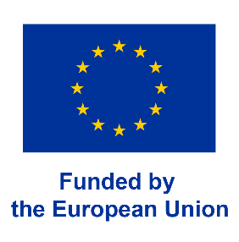
PRESS RELEASE
New Music360 platform will assess the true value of music

Funded by the European Horizon Europe program to the tune of €3million, the Music360 project aims at developing a completely new perspective on the value of music and allowing the collection of more reliable data on its use in public spaces. The project which began in March 2023, will run for 3 years.

Music360 will develop a platform to collect data that can be used to analyse and represent the value of music for professional users of background music, the right holders, and policy makers.
Music played in stores, bars, restaurants, and other public spaces positively impacts the overall customer experience and contributes similarly to the revenues made. At the same time, music is an important source of revenue for the creators, performers and other rightholders.
But at present, the various stakeholders need more accurate knowledge about the value generated by that music, while policy makers are completely in the dark about its social and economic value.
“Our goal is to create a digital platform that collects data about the value of music played in venues for different stakeholders”, explains Dr. Jaap Gordijn (VUA), principal investigator of the project.
The data collection will use fingerprint technology, cross-referencing it with the data held by Collective Management Organisations and users to make it available to all players in the European music ecosystem. Taking into account the needs of the different types of stakeholders, the platform can be used to dig into the value of specific recordings and works.
“This project aims to go beyond measuring the economic value of music. It will also pay attention to the non-monetary value of music, such as societal value and therapeutical value, offering a 360 degrees perspective on the value of music”, says Prof. Dr. María de Miguel (UPV).
The project will not remain a theoretical exercise. A digital ecosystem will be developed so that the Music360 platform will continue to exist after the project finishes.
The Music360 project features six national living labs, as well as one cross-European one.
Partners include Vrije Universiteit Amsterdam (NL, coordinator), Universitat Politechnica de Valencia (ES), CMOs SENA, BUMA (NL) IMRO (IE), and GDA (PT), the European Federation of performer CMOs AEPO-ARTIS, as well as industry players GTM (FI), BMAT Licensing (ES) and The Value Engineers (NL).
For further information
Contact Person: Jaap Gordijn
Phone: +31 20 59 87782
Email: j.gordijn@vu.nl

